Decision Support System (DSS)
FY 2012 Extracts

User Manual



Software Version 3.0
November 2011

Department of Veterans Affairs
Office of Information and Technology (OIT)
Product Development

Revision History
Date | Version | Description (Patch # if applicable) | Author
08/01/2011 |  | Manual updated for FY12 changes in Patch ECX*3.0*132 | Megan Lucas
10/15/2010 |  | Manual updated for FY2011 changes based upon the following Patches: ECX*3.0*127, LR*5.2*403 and SD*5.3*568 | Tavia Leonard
9/30/2010 |  | Updated formatting for this document based upon OED National Documentation Standards | Tavia Leonard
11/05/09 |  | Updates for FY10 changes | K Peacock
11/01/09 |  | Manual updated for FY10 changes in Patch ECX*3.0*120 | Corinne Bailey
11/01/08 |  | Manual updated for FY09 changes in Patch ECX*3.0*112 | Tom Rochford
11/01/07 |  | Manual updated for FY08 changes in Patch ECX*3.0*105 | Berry Anderson  Corinne Bailey
11/08/2006 |  | Manual updated for FY07 changes in Patch ECX*3.0*92 | Berry Anderson
11/18/2005 |  | Manual updated to include changes due to Patch ECX*3.0*84 | Berry Anderson
03/17/2005 |  | Manual updated to include changes due to Patch ECX*3.0*72  See sections:  Enter/Edit DSS Stop Codes for Clinics  DSS Identifier Non-Conforming Clinics Report | Berry Anderson
03/09/2005 |  | Manual updated to include Patch ECX*3.0*78 | Mary Ellen Gray
12/17/2004 |  | Manual updated to include changes due to Patch ECX*3.0*71 | Berry Anderson
11/15/2004 |  | Manual updated to comply with SOP 192-352 Displaying Sensitive Data | Corinne Bailey

1. Introduction 1
1.1 Related DSS Manuals 1
2. Orientation 2
2.1 Components of this User Manual 2
2.2 User Responses 2
2.3 Online Help 2
3. Before You Start Using the Software 3
3.1 Set up Required DSS Information 3
3.2 Set up QUASAR 3
4. Using the Software - Extract Manager’s Menu 5
4.1 The Security Keys Structure 5
4.2 Logon / Accessing DSS Options 5
4.3 Maintenance – Extract Manager’s Menu 6
4.3.1. Maintenance Menu 6
4.3.1.1. CBOC Activity Report 7
4.3.1.2. CPT Inquiry 7
4.3.1.3. DSS Department Management 8
4.3.1.3.1 Enter/Edit DSS Ward 8
4.3.1.4 Event Capture 8
4.3.1.4.1 Unusual Volume Report for Event Capture 9
4.3.1.4.2 Example: Report Run for a Single DSS Unit 11
4.3.1.5 Laboratory 11
4.3.1.5.1 Add/Edit Lab Results Translation Table 11
4.3.1.5.2 Lab Results Extract Untranslatable Results Report 13
4.3.1.5.3 Lab Results LOINC® Code Report 14
4.3.1.6 Nutrition Worksheets 15
4.3.1.6.1 Enter/Edit Nutrition Division Worksheet 15
4.3.1.6.2 Print Nutrition Division Worksheet 17
4.3.1.6.3 Enter/Edit Nutrition Product Worksheet 18
4.3.1.6.4 Print Nutrition Product Worksheet 19
4.3.1.7 Pharmacy 21
4.3.1.7.1 Pharmacy Edit and Edit Log 21
4.3.1.7.2 Pharmacy Extracts Incomplete Feeder Key Report 23
4.3.1.7.3 Pharmacy Extracts Unusual Volume Report 24
4.3.1.7.4 UDP/IVP Source Audit Report 27
4.3.1.8 Print Feeder Keys 28
4.3.1.9 Print Feeder Locations 30
4.3.2.0 Prosthetics 31
4.3.2.0.1 Cost by PSAS HCPC Report 31
4.3.2.0.2 Prosthetic Extracts Unusual Cost Report 32
4.3.2.0.3 Prosthetics (PRO) YTD HCPCS Report 33
4.3.2.0.4 Prosthetics (PRO) YTD Laboratory Report 34
4.3.2.1 Setup for DSS Clinic Information 35
4.3.2.1.1 National Clinic Codes for DSS List 35
4.3.2.1.2 Create DSS Clinic Stop Code File 36
4.3.2.1.3 Clinics and DSS Stop Codes Print 37
4.3.2.1.4 Enter/Edit DSS Stop Codes for Clinics 39
4.3.2.1.5 Approve Reviewed DSS Clinic Worksheet 40
4.3.2.1.6 DSS Identifier Non-Conforming Clinics Report 40
4.3.2.1.7 DSS Clinic & Stop Codes Validity Report 41
4.3.2.2 Setup for Inpatient Census Information 42
4.3.2.2.1 Trial for Setup Extract 43
4.3.2.2.2 Generate the Inpatient Setup Extract 44
4.3.2.2.3 Active MAS Wards for Fiscal Year Print 44
4.3.2.2.4 Primary Care Team Print 45
4.3.2.2 Setup for Inpatient Medications Information 46
4.3.2.2.1 Print IV Room Worksheet 46
4.3.2.2.2 Enter/Edit IV Room Division 47
4.3.2.2.3 Pharmacy NDC Lookup 47
4.3.2.3 Surgery 49
4.3.2.4.1 SUR Volume Report 50
4.3.2.4.2 Surgery Extracts Unusual Volume Report 50
4.4 Package Extracts 52
4.4.1. Admissions Extract (ADM) 52
4.4.2. BCMA Extract (BCM) 53
4.4.3. Clinic Visit Extract (CLI) 53
4.4.4. Event Capture Extract (ECS) 53
4.4.5. IV Extract (IVP) 53
4.4.6. Lab Extract (LAB) 53
4.4.7. Lab Results Extract (LAR) 53
4.4.8. Nutrition Extract (NUT) 53
4.4.9. Prescription Extract (PRE) 54
4.4.10. QUASAR Extract (ECQ) 54
4.4.11. Prosthetics Extract (PRO) 54
4.4.12. Radiology Extract (RAD) 55
4.4.13. Surgery Extract (SUR) 55
4.4.14. Transfer and Discharge Extract (MOV) 55
4.4.15. Treating Specialty Change Extract (TRT) 55
4.4.16. Unit Dose Extract (UDP) 55
4.4.17. Blood Bank Extract (LBB) 55
4.4.18. Fiscal Year Logic – DSS Testing Only 55
4.5 SAS Extract Audit Reports 57
4.5.1 SAS Extracts Audit Reports Menu 57
4.5.2 SAS Prescription Audit Report 57
4.5.3 SAS Radiology Audit Report 58
4.5.4 SAS Surgery Audit Report 59
4.6 Extract Audit Reports 60
4.6.1 Extract Audit Reports Menu 60
4.6.2 Admission (ADM) Extract Audit 62
4.6.3 QUASAR (ECQ) Extract Audit 63
4.6.4 Event Capture (ECS) Extract Audit 63
4.6.5 Laboratory (LAB) Extract Audit 64
4.6.6 Laboratory Results (LAR) Extract Audit 64
4.6.7 Laboratory Blood Bank (LBB) Audit Reports 66
4.6.7.1 Laboratory Blood Bank (LBB) Comparative Report 66
4.6.7.2 Laboratory Blood Bank (LBB) Extract Audit 67
4.6.8 Physical Movement (MOV) Extract Audit 68
4.6.8 Nutrition (NUT) Extract Audit 69
4.6.8.1 Sample Summary Report 69
4.6.8.2 Sample Detailed Report 71
4.6.9 Pharmacy (PHA) Extract Audit 74
4.6.9.1 Pharmacy Extract Menu Options 74
4.6.9.2 Sample Prescription Extract Unusual Volume Report 75
4.3.9.3 Sample IV Detail Extract Unusual Volume Report 75
4.6.9.4 Sample Unit Dose Local Extract Unusual Volume Report 75
4.6.10 Prosthetics (PRO) Extract Audit 75
4.6.11 Radiology (RAD) Extract Audit 77
4.6.11 Surgery (SUR) Extract Audit 77
4.6.12 Treating Specialty Change (TRT) Extract Audit 78
4.7 Transmission Management 78
4.7.1 Transmission Management Menu 78
4.7.2 Purge Data from Extract Files 79
4.7.2.1 Confirmation Message for IVP and UDP Purge 80
4.7.3 Recreate Extract Holding Files 81
4.7.3.1 Example of Recreate 82
4.7.3.2 Confirmation Message for Recreate 82
4.7.4 Review a Particular Extract for Transmission 83
4.7.5 Summary Report of Extract Logs 84
4.7.6 Transmit Data from Extract Files 84
5. Glossary 87
6. Index 88
Appendix A - Feeder Key Transmission 90
Appendix B - Create a LAR Translation Table 91
Appendix C - Sample of Prosthetics YTD PSAS HCPCS Report 93
Appendix D - Sample of Prosthetics Laboratory Report 95
Appendix E - Sample of Pharmacy Extracts Incomplete Feeder Key Report 97
Appendix F - Sample of Pharmacy Volume Edit Log 103
Appendix G - Sample of Summary Report of Extract Logs 104
Appendix H - Sample of Surgery Extract Unusual Volume Report 105
Appendix I - Sample of EXPORT TO TEXT FILE FOR SPREADSHEET USE 107

Introduction

Decision Support System Extracts (DSS) Version 3.0 provides a means of exporting data from selected Veterans Health Information Systems and Technology Architecture (VistA) modules to a Decision Support System (DSS) resident in the Department of Veterans Affairs (VA) Austin Information Technology Center (AITC).

This transfer is accomplished through a set of extract routines, intermediate files, audit reports, a transmission routine, and a purge routine. Data from VistA packages is stored by the extract routines in the intermediate files, where it is temporarily available for local use and auditing. The data is then transmitted to the AITC where it is formatted and uploaded into commercial software. After the data has been successfully uploaded into the commercial software, it is purged from the intermediate files.

The DSS Extracts 3.0 software includes the following functionalities:
- DSS Extract field additions and modifications
- DSS Menu additions, modifications and deletions
- New DSS reports and report modifications
- Implementation of the new and/or deleted extracts

Related DSS Manuals

Listed below are the following DSS Extract manuals that are available to view on the VA Software Document Library at the following address (http://www.va.gov/vdl/application.asp?appid=35)

File Name | Manual Name | Description
dss_3_fy2012_ef_doc | DSS Extracts V3.0 Extract Formats and Data Definitions Guide | Provides detailed information on formatting and defines the data terminology.
dss_3_fy2012_tm_doc | DSS Extract FY2012 Technical Manual | Describes the DSS Extract technical (high level) terminology
dss_3_fy2012_um_doc | DSS Extracts V3.0 Extracts User Manual | Provides an overview of the functionality and enhancements.

The DSS web site is located at the following address: http://vaww.dss.med.va.gov/.

Orientation

Components of this User Manual

The “Using the Software -Extract Manager’s Menu” section of this manual is designed to serve as reference to the user, covering vital aspects of this tool. It is broken into five components.

- Maintenance
- Package Extracts
- SAS Extract Audit Reports
- Extract Audit Reports
- Transmission Management

User Responses

In this manual, user responses are shown in bold type. In most cases, you need only enter the first few letters to increase speed and accuracy. Pressing the Return or Enter key, which is indicated by the symbol <RET>, must follow every response you enter. This symbol is not shown, but is implied, following bold type entries.

Enter a caret, indicated by the symbol (^), at almost any prompt to terminate the line of questioning and return to the previous level in the routine. Continue entering up-arrows to exit the system.

Online Help

Online help is available at almost any prompt in the software by entering a single question mark (?). This will provide information to help you answer the prompt. In some instances, entering double (??) or triple (???) question marks will provide more detailed information.

Before You Start Using the Software

Set up Required DSS Information

Use the options in the submenus of the Maintenance submenu of the Extract Manager's Options menu listed below to set up information required for using the DSS Extracts 3.0 software. Refer to the section titled "Using the Software - Extract Manager's Options" for information about using the options. Refer to the DSS Extracts Version 3.0 Installation Guide for information about installing and implementing the software.

- Setup for DSS Clinic Information
- Setup for DSS Lab Results Information
- Setup for Inpatient Medications Information
- Setup for Inpatient Census Information

Set up QUASAR

If your facility uses the QUASAR V. 2.0 software, and you wish to send Audiology and Speech Pathology data to DSS, take the following steps:

- The DSS Site Manger, in conjunction with the Event Capture and QUASAR ADPACs, should use the Event Capture option DSS Units for Event Capture (Enter/Edit) to create two entries in the DSS UNIT file (#724). These two entries are to be used exclusively for the QUASAR/DSS extract. One entry should be created for Audiology (e.g., Audiology DSS Extract), the other for Speech Pathology (e.g., Speech Pathology DSS Extract) as shown in the following example.

Select Event Capture Management Menu Option: DSS Units for Event
Capture (Enter/Edit)

Select DSS Unit: AUDIOLOGY DSS EXTRACT
Are you adding 'AUDIOLOGY DSS EXTRACT' as a new DSS UNIT
(the 54TH)? YES
DSS UNIT Service: AUDIOLOGY AND SPEECH PATHOLOGY
DSS UNIT Cost Center: 822800 Audiology & Speech Pathology
DSS UNIT Medical Specialty: AUDIOLOGY
DSS UNIT Number: <RET>
ASSOCIATED STOP CODE: 203
CATEGORY (Y/N): NO
DATA ENTRY DATE/TIME DEFAULT: <RET>
Select DSS Unit: SPEECH PATHOLOGY DSS EXTRACT
Are you adding 'SPEECH PATHOLOGY DSS EXTRACT' as a new DSS UNIT (the 55TH)? YES
DSS UNIT Service: AUDIOLOGY AND SPEECH PATHOLOGY
DSS UNIT Medical Specialty: SPEECH PATHOLOGY
DSS UNIT Number: <RET>
ASSOCIATED STOP CODE: 204
CATEGORY (Y/N): NO
DATA ENTRY DATE/TIME DEFAULT: <RET>

- In the above process, the Event Capture software automatically answers YES to the USE FOR EVENT CAPTURE field in the DSS UNIT file (#724). Use VA FileMan’s Enter or Edit File Entries option to change the answer to NO for the USE FOR EVENT CAPTURE field for the two entries created in Step 1 above.

- The QUASAR ADPAC, coordinating with the DSS Site Manager, should use the QUASAR option A&SP Site Parameters [ACKQAS SITE PARAMS] to enter data for the following two new fields in the A&SP SITE PARAMETER file (#509850.8) as shown in the example below.

AUDIOLOGY DSS UNIT LINK field – Answer with the Audiology DSS Unit created in Step 1 above.
SPEECH PATHOLOGY DSS UNIT LINK field – Answer with the Speech Pathology DSS Unit created in Step 1 above.

Select A&SP Supervisor Menu Option: SET Up/Maintenance

Select Set Up/Maintenance Option: A&SP Site Parameters
This option allows you to configure the QUASAR package to meet
facility needs.

Select A&SP SITE PARAMETERS SITE NAME: [Select your site name.]
SITE NAME: [Your site name is here.]// <RET>
USE ASP CLINIC FILE NUMBER: NO// <RET>
USE MODIFIERS: NO// <RET>
USE C&P: YES// <RET>
BYPASS AUDIOMETRICS: YES// <RET>
Select CLINIC LOCATION: SPEECH PATHOLOGY // <RET>
CLINIC LOCATION: SPEECH PATHOLOGY // <RET>
Select CLINIC LOCATION: <RET>
AUDIOLOGY DSS UNIT LINK: ?
Enter the name of the DSS unit to be used for audiology.
AUDIOLOGY DSS UNIT LINK: AUDIOLOGY DSS EXTRACT
SPEECH PATHOLOGY DSS UNIT LINK: ?
Enter the name of the DSS unit to be used for
speech pathology
SPEECH PATHOLOGY DSS UNIT LINK: SPEECH PATHOLOGY DSS EXTRACT

Using the Software - Extract Manager’s Menu

The Security Keys Structure

This KEY functionality is a function of the Kernel's Key Management functions. These simple adjustments make it possible to assign the [ECXMGR] Extract Manager's Options to a user so that they can view all DSS reporting functionality with the assignment of a single option. The security key then controls only those options that actually create/change data and as such should not be available to all DSS employees.

The ECXMGR key has been removed from the following menus:

[ECX MAINTENANCE] Maintenance
[ECX TRANSMISSION] Transmission Management

The ECXMGR key has been assigned to the following menus:

[ECXSCLOAD] Create DSS Clinic Stop Code File
[ECXSCEDIT] Enter/Edit DSS Stop Codes for Clinics
[ECXSCAPPROV] Approve Reviewed DSS Clinic Worksheet
[ECX IV DIV EDIT] Enter/Edit IV Room Division
[ECXLABRS] Link DSS Selected Lab Tests to Local Lab Tests
[ECX LAB RESULTS TRANS EDIT] Add/Edit Lab Results Translation Table

The ECXPVE key has been assigned to the following menu:

[ECX PHA VOL EDIT] Pharmacy Volume Edit

The ECX DSS TEST Security Key has been assigned for the following option:

[ECX FISCAL YEAR EXTRACT] Fiscal Year Logic – DSS Testing Only

Logon / Accessing DSS Options

Depending on your setup and permissions, you may have a short cut to the DSS menu.
This is one method for reaching the DSS Menu:

- Logon to VistA.
- On Systems Manager Menu, Select Option: Core Applications
- On Core Applications Menu, Select Option: Administrative Services Menus
- On Administrative Services Menus, Select Option: DSS Extract Manager's Options
- View the Extract Manager’s Menu and select an option.

Maintenance – Extract Manager’s Menu

The Extract Manager’s Menu [ECXMGR] is the main menu for the Decision Support System. The options listed can vary based on the user’s Security Keys settings, as described above.

Each option expands to a sub-menu giving detailed options for that area.

The remainder of this manual is organized according to the options shown on this menu and its sub-menus.

Select Extract Managers Options Option: ?

M Maintenance
P Package Extracts
S SAS Extract Audit Reports
E Extract Audit Reports Menu
T Transmission Management

Maintenance Menu

Choosing the Maintenance option from the Extract Managers Menu will display the following menu and options. Many of these will then display sub-menus and additional options.

Select Extract Manager's Options Option: M Maintenance

1 CBOC Activity Report
2 CPT Inquiry
3 DSS Department Management
4 Event capture
5 Laboratory
6 Nutrition Worksheets
7 Pharmacy
8 Print Feeder Keys
9 Print Feeder Locations
10 Prosthetics
11 Setup for DSS Clinic Information
12 Setup for DSS Lab Results Information
**> Out of Order: MENU OPTION NO LONGER USED
13 Setup for Inpatient Census Information
14 Setup for Inpatient Medications Information
- Surgery

CBOC Activity Report

This report includes information from every Clinical (CLI) record (by extract #) which has a Community Based Outpatient Clinic status of YES. The report is grouped by feeder key, division, and clinic. It lists Patient Name, SSN, and Date of Visit. Totals for unique SSNs and Visits will be printed with each clinic, division, and feeder key with an overall total for the station.

When purging a CLI extract, a check will be made to determine if the CBOC activity report has been run. If the report has not been run, the user will be told that the report has not been run and asked if they still wish to purge the data. If the report has been run, no additional prompts will be seen.

Example: CBOC Activity Report

Selectable Clinic Extracts for CBOC Activity Report Page: 1
Extract # Run Date Rec Count Date Range of Extract Division
------------------------------------------------------------------------------
1863 03/20/2003 10065 01/01/2003 - 01/31/2003 442
1881 04/03/2003 9519 02/01/2003 - 02/28/2003 442
1899 04/23/2003 9444 03/01/2003 - 03/31/2003 442
1917 08/04/2003 9546 03/01/2003 - 03/31/2003 442
Generate the CBOC Activity Report for the following extract: (1863-2104): 2104

CBOC Activity Report Page: 001
MAR 01, 2002 – MAR 31, 2002 Run Date: NOV 26, 2002
Feeder Key: ############## Division: ####### Clinic: ####################
Patient SSN VISIT DATE/TIME
------------------------------------------------------------------------------
DSSPATIENT,ONE 000456789 OCT 12, 2002 @ 10:30:01
DSSPATIENT,TWO 666456789 OCT 14, 2002 @ 10:30:01
DSSPATIENT,THREE 666543009 OCT 12, 2002 @ 10:30:01
DSSPATIENT,FOUR 000768777 OCT 14, 2002 @ 10:30:01
Total Unique for Clinic: 3 4
Total Unique for Division: ########## ############ <- When applicable
Total Unique for Feeder Key: ########## ############ <- When applicable
Total Unique (entire report): ########## ############ <- At end of report
<** Form feed on clinic, division, and feeder key **>
Use division number not name (ex: 528AB)
Truncate clinic name to 20 characters

CPT Inquiry

This inquiry allows the user to select a CPT code. It then displays the Short Name, Category, and Description for the selected code.

Example: CPT Inquiry

Select CPT: ??

Choose from:
10000 DRAINAGE OF SKIN LESION INACTIVE CODE
10001 DRAINAGE OF 2ND SKIN LESION INACTIVE CODE
10002 DRAINAGE OF SKIN LESIONS INACTIVE CODE
10003 DRAIN & TREAT SKIN LESION INACTIVE CODE
10020 DRAINAGE OF BOIL INACTIVE CODE
10021 FNA W/O IMAGE
10022 FNA W/IMAGE
10040 ACNE SURGERY
10060 DRAINAGE OF SKIN ABSCESS
10061 DRAINAGE OF SKIN ABSCESS
10080 DRAINAGE OF PILONIDAL CYST
10081 DRAINAGE OF PILONIDAL CYST
10100 DRAINAGE OF INFECTED NAIL INACTIVE CODE
10101 DRAINAGE OF INFECTED NAIL(S) INACTIVE CODE
10120 REMOVE FOREIGN BODY
10121 REMOVE FOREIGN BODY
10140 DRAINAGE OF HEMATOMA/FLUID
10141 DRAINAGE OF HEMATOMA INACTIVE CODE
10160 PUNCTURE DRAINAGE OF LESION
^
Select CPT: 10160 PUNCTURE DRAINAGE OF LESION

CPT Inquiry Date: OCT 07, 2003
------------------------------------------------------------------------------
CPT Code: 10160 Short Name: PUNCTURE DRAINAGE OF LESION
Category: INTEGUMENTARY SYSTEM
Description: PUNCTURE ASPIRATION OF ABSCESS, HEMATOMA, BULLA, OR CYST

DSS Department Management

Choosing the DSS Department Management option from the Maintenance Menu will display the following sub-menu and options.

Select DSS Department Management Option: ?
1 Enter/Edit DSS Division Identifier
- Enter/Edit DSS Ward

4.3.1.3.1 Enter/Edit DSS Ward

This option should only be used by the DSS Site Manager.

Use this option to enter or edit the DSS Department for Ward and suffix, if needed, associated with each medical center ward within your division. If the ward you selected exists in the DSS WARD file (#727.4), the DSS Department Code is displayed, and the software asks if you want to edit it. If the ward you selected does not exist in the DSS WARD file (#727.4), the software prompts you to enter a DSS Department for Ward and suffix to complete the DSS Department Code. The suffix must have at least one character, no more than three characters, and must not contain an embedded up-arrow. The hyphen character < - > should not be used unless this DSS Department code was previously established in DSS/Austin. After you enter or edit information, the new DSS Department code is displayed, and you are asked to verify its accuracy.

Example: DSS Department Management

Select WARD LOCATION NAME: C MEDICINE
Ward: C MEDICINE
Ward Bedsection: MEDICINE
Ward Specialty: GENERAL(ACUTE MEDICINE)
Ward Service: MEDICINE
Division: CHEYENNE VAMROC/442
DSS Department for Ward: UFH1//

4.3.1.4 Event Capture

4.3.1.4.1 Unusual Volume Report for Event Capture

The Unusual Volume Report for Event Capture is a tool used by managers to validate the ECS volume data similar to the use of the Surgery or Pharmacy Unusual Volume Report. It can be used to identify - volumes above a user selectable threshold, thus avoiding tedious work by the user. The report should be run prior to information being sent to the DSS database.

The example listed below depicts an example of a report when run for all DSS Units:

Example: Unusual Volume Report for All DSS Units

Select OPTION NAME: ECXMGR Extract Manager's Options

Maintenance ...
Package Extracts ...
SAS Extract Audit Reports ...
Extract Audit Reports Menu ...
Transmission Management ...

Select Extract Manager's Options Option: M Maintenance

CBOC Activity Report
CPT Inquiry
DSS Department Management ...
Event Capture ...
Laboratory ...
Nutrition Worksheets ...
Pharmacy ...
Print Feeder Keys
Print Feeder Locations
Prosthetics ...
Setup for DSS Clinic Information ...
Setup for DSS Lab Results Information ...
**> Out of order: MENU OPTION NO LONGER USED
Setup for Inpatient Census Information ...
Setup for Inpatient Medications Information ...
Surgery ...

Select Maintenance Option: Event Capture

Unusual Volume Report for Event Capture

Select Event Capture Option: Unusual Volume Report for Event Capture

ECS Extract Unusual Volume Report

This report prints a listing of unusual volumes that would be
generated by the Event Capture extract (ECS) as determined by
a user-defined threshold value. It should be run prior to
the generation of an actual extract to identify and fix, as
necessary, any volumes determined to be erroneous.

Unusual volumes are those in excess of the threshold value
defined by the user. The threshold value is 20 by default.

Note: You may set a different threshold if you opt to continue.

Run times will vary depending upon the size of the EVENT CAPTURE
PATIENT file (#721) and the date range selected, but may be at
least several minutes. Queuing to a printer is recommended.

The running of this report has no effect on the actual extracts
and can be run as needed.

You may select one or all DSS Units. If you select one unit,
the report is sorted by descending volume. If you select all DSS Units, the report is sorted by DSS Unit, then by descending volume.

Enter RETURN to continue or '^' to exit:

The default threshold volume for unusual volumes in Event Capture is 20.
Would you like to change the threshold? NO//

Do you want ALL DSS UNITs? YES

Enter the date range for which you would like to scan the
Event Capture records.

Starting with Date: 6/1 (JUN 01, 2010)
Ending with Date: 6/30 (JUN 30, 2010)

This report is formatted for 132-column line width.

Enter 'Q' to queue report to TaskManager, then select printer.
DEVICE: HOME//;132; TELNET TERMINAL

CS Extract Unusual Volume Report
Page: 1
Start Date: JUN 01, 2010
Report Run Date: SEP 14, 2010
End Date: JUN 05, 2010
Threshold Value: 20

SSN FACILITY DSS UNIT DATE/TIME PROCEDURE VOLUME PROVIDER
-------------------------------------------------------------------------------------------------------------------------

XXXXXXXXX 442 AU61 Chronic Hmls HCHV 6/5/2010@16:57 HM002N 28 Provider,One
XXXXXXXXX 442 AU61 Chronic Hmls HCHV 6/5/2010@16:57 HM002N 28 Provider,One
XXXXXXXXX 442 AU61 Chronic Hmls HCHV 6/5/2010@16:57 HM002N 28 Provider,One
XXXXXXXXX 442 AU61 Chronic Hmls HCHV 6/5/2010@16:57 HM002N 28 Provider,One
XXXXXXXXX 442 AU61 Chronic Hmls HCHV 6/5/2010@16:57 HM002N 28 Provider,One
XXXXXXXXX 442 AUB1 CHYSNH 6/28/2010@10:00 SN001N 28 Provider,Two
XXXXXXXXX 442 AUB1 CHYSNH 6/28/2010@10:00 SN001N 28 Provider,Two
XXXXXXXXX 442 AUB1 CHYSNH 6/28/2010@10:00 SN001N 28 Provider,Two
XXXXXXXXX 442 AUB1 CHYSNH 6/28/2010@10:00 SN001N 28 Provider,Two

4.3.1.4.2 Example: Report Run for a Single DSS Unit

The following example listed below depicts an example of a report when run for a single DSS Units:

The default threshold volume for unusual volumes in Event Capture is 20.
Would you like to change the threshold? NO//
Do you want ALL DSS UNITs? NO
Select DSS UNIT NAME: AU
1 AU41 Alc/Drug Halfway AU41
2 AU61 Chronic Hmls HCHV AU61
3 AUA1 CHYCNH AUA1
4 AUB1 CHYSNH AUB1
5 AUC1 CHYSD AUC1
CHOOSE 1-5: 4 AUB1 CHYSNH AUB1
Starting with Date: 6/1 (JUN 01, 2010)
Ending with Date: 6/30 (JUN 30, 2010)

This report is formatted for 132-column line width.

Enter 'Q' to queue report to TaskManager, then select printer.
DEVICE: HOME// ;132; TELNET TERMINAL

ECS Extract Unusual Volume Report
Page: 1
Start Date: JUN 01, 2010
Report Run Date: SEP 14, 2010
End Date: JUN 30, 2010
Threshold Value: 20

SSN FACILITY DSS UNIT DATE/TIME PROCEDURE VOLUME PROVIDER
------------------------------------------------------------------------------------------------------------------------
XXXXXXXXX 442 AUB1 CHYSNH 6/28/2010@10:00 SN001N 28 Provider,Two
XXXXXXXXX 442 AUB1 CHYSNH 6/28/2010@10:00 SN001N 28 Provider,Two
XXXXXXXXX 442 AUB1 CHYSNH 6/28/2010@10:00 SN001N 28 Provider,Two
XXXXXXXXX 442 AUB1 CHYSNH 6/28/2010@10:00 SN001N 28 Provider,Two

4.3.1.5 Laboratory

Choosing the Laboratory option from the Maintenance Menu will display the following sub-menu and options.

Select Laboratory Option: ?

1 Add/Edit Lab Results Translation Table
2 Lab Results Extract Untranslatable Results Report
3 Lab Results LOINC Code Report

4.3.1.5.1 Add/Edit Lab Results Translation Table

This option allows the editing of existing entries or the addition of new entries in the LAB RESULTS TRANSLATION file (#727.7). Free text results (non-numeric) are stored in this file with their corresponding translation codes. See Appendix B for further information, if necessary.

Example: Add/Edit Results Transition Table

Select Maintenance Option: Add/Edit Lab Results Translation Table

ADD/EDIT LAB RESULTS TRANSLATION TABLE

This option allows the editing of existing entries or the addition of new
entries in the LAB RESULTS TRANSLATION file (#727.7). Free text results
(non-numeric) are stored in this file with their corresponding translation codes

Select LAB RESULTS TRANSLATION: ?
Answer with LAB RESULTS TRANSLATION, or NUMBER
Do you want the entire 65-Entry LAB RESULTS TRANSLATION List? Y (Yes)
Choose from:
1 NEG
2 POS
3 N
4 POSITIVE
5 NE
6 P
7 NEGATIV
8 NEGATIVE
9 NEG.
10 ND
11 NEG#
12 NONREACT
13 NR
14 NRE
15 NONREATIVE
16 NONREACTIVE
17 NON REAC
18 NOTDET
19 NON-REACT
20 POS#
21 POS.
22 WK.POS
23 R
24 REAC
25 REACT
26 REACTIVE
27 REACTIVE*
28 WK.POS.
29 WK POS
30 DETEC
31 DETECTED.
32 EQUIV
33 EQUIVOCAL
34 BDL
35 BRDLNE
36 BRDLINE
37 BORDERLINE
38 REPEAT
39 NRG
40 LSG
41 DONE
42 NEH
43 MEG
44 NGE
45 REM
46 NREACT
47 SEE COM
48 SEE RPT
49 TYPE 1
50 2B
51 3A
52 BAS
53 POD
54 N-I
55 PEND
56 RPC
57 QNS
58 FFT
59 **POS
60 ***POS
61 +/-=POS
62 =+POS
63 INCONC.
64 +
65 -
You may enter a new LAB RESULTS TRANSLATION, if you wish
Answer must be 1-30 characters in length

Select LAB RESULTS TRANSLATION: pend
...OK? Yes// <RET> (Yes)

RESULT: PEND// <RET>
TRANSLATION CODE: Result cannot be translated// ??
Numeric Translation Code that the Result will be translated to.
Choose from:
0 Negative, Non-Reactive
1 Positive, Reactive
2 Borderline, Indeterminate
3 Test Not Performed, Qty not sufficient or other reason
5 Result cannot be translated
TRANSLATION CODE: Result cannot be translated// <RET>
Select LAB RESULTS TRANSLATION:

4.3.1.5.2 Lab Results Extract Untranslatable Results Report

This report prints a listing of results that are not translatable (have no entry in the Lab Results Translation file (#727.7). It is a pre-extract type audit report and should be run prior to the generation of the actual extract. Running this report has no effect on the actual extract.

You will be prompted for the date range for which you would like to scan the LAR Extract records. Beginning and ending dates must be in the same month and year.

See Appendix B for further information, if necessary.

Example: Lab Results Extract Untranslatable Results Report

Select Maintenance Option: Lab Results Extract Untranslatable Results Report

This report prints a listing of results that are not translatable i.e. have
no entry in the Lab Results Translation File (#727.7).

This report is a pre-extract type audit report and should be run prior to the
generation of the actual extract. Running this report has no effect on the
actual extract.

Enter the date range for which you would like to scan the LAR Extract records.

Starting with Date: 1 Jan 02 (JAN 01, 2002)
Ending with Date: 31 Jan 02 (JAN 31, 2002)
DEVICE: HOME// <RET>

LAR Extract Untranslatable Results Audit Report Page: 1
Start Date: JAN 01, 2002
End Date: JAN 31, 2002 Report Run Date: JAN 02, 2003

Pat. SSN Date/Time Test Test Name Result
Name Collected Code
------------------------------------------------------------------------------

DSS1 666456789 1/24/02@09:50 27 LDLC comment
DSS2 000456789 1/6/02@23:36 2 POTASSIUM (SERUM) canc
DSS3 666999999 1/7/02@09:41 27 LDLC comment
DSS4 000768777 1/13/02@00:45 21 PROTIME canc
DSS5 000123421 1/12/02@07:44 25 FOLATE >20
DSS6 666666333 1/26/02@06:00 25 FOLATE >20
DSS7 666555321 1/25/02@11:54 32 MICROALBUMIN <0.3
DSS8 000666990 1/7/02@14:10 19 PSA (PROSTATIC SPECIFI >100
DSS9 000555678 1/22/02@14:26 25 FOLATE >20
DSS0 000878887 1/23/02@06:00 25 FOLATE >20

4.3.1.5.3 Lab Results LOINC® Code Report

This report prints a listing showing the DSS LOINC® Codes file (#727.29) and its definitions of LAR Test Numbers and the local tests assigned to them. It also compares the LOINC Code assigned by DSO for a LAR Test to the LOINC Codes found on the local database. The latter is based on the linking of Workload Codes to LOINC Codes at the particular location. Differences are marked with an asterisk following the Local LOINC Code column and must be resolved. DSO can guide the location in this.

The report displays all workload codes associated with the DSS desired LOINC code. The report prints the values in those columns even if there is no matching workload code found in file #60. The intent of the modification is to identify inexact matches and to display all workload codes associated with a DSS desired LOINC code.

The report process attempts to find a matching LOINC code between the DSS LOINC file (#727.29) and the WKLD Code file (#64). If a match is not found, an ‘*’ (asterisk) displays in the FLG column to indicate there is no local workload set-up for the desired DSS LOINC code. None of the ‘local’ fields (those fields coming from file #60 or #64) will be populated.

Example: Lab Results LOINC Report

Select Maintenance Option: Lab Results LOINC Code Report

This report requires 132-column format.

DEVICE: HOME// ;132;1000 TELNET

LAB RESULTS DSS LOINC CODE REPORT Page: 1
Report Run Date/Time: JUN 29, 2009 DSS Site: JACK C. MONTGOMERY VAMC (623)
F LOC SPEC LOC WKLD LOC WKLD
LAR TEST# LAR TEST NAME LAR UNITS LAR LOINC L LOCAL TEST NAME TYPE IEN CODE
(#727.29) (#727.29) (#727.29) #727.29) G (#64) (#64) (#64) (#64)
------------------------------------------------------------------------------------------------------------------

0001 Hemoglobin G/DL 718-7 FREE HGB BLOOD 3860 85657.0000
0001 Hemoglobin G/DL 718-7 HGB BLOOD 296 83020.0000
0002 Potassium (Serum) MEQ/L or MMOL 2823-3 TT-POTASSIUM PLASMA 499 84140.0000
0002 Potassium (Serum) MEQ/L or MMOL 2823-3 TT-POTASSIUM SERUM 499 84140.0000
0003 Sodium (Serum) MEQ/L or MMOL 2951-2 TT-SODIUM PLASMA 577 84295.0000
0003 Sodium (Serum) MEQ/L or MMOL 2951-2 TT-SODIUM SERUM 577 84295.0000
0003 Sodium (Serum) MEQ/L or MMOL 2947-0 ZSODIUM MCAL BLOOD 577 84295.0000
0004 Lithium (Serum) MMOL/L 14334-7 LITHIUM SERUM 1048 81744.0000
0005 BUN (Blood Urea Nitrogen MG/DL 3094-0 TT-BUN PLASMA 4471 82356.0000
0005 BUN (Blood Urea Nitrogen MG/DL 3094-0 TT-BUN SERUM 4471 82356.0000
0005 BUN (Blood Urea Nitrogen MG/DL 3094-0 UREA NITROGEN SERUM 643 84520.0000
0005 BUN (Blood Urea Nitrogen MG/DL 3094-0 ZZ BUN MCAL PLASMA 643 84520.0000
0006 WBC (Total WBC Count) K/UL or K/MM3 6690-2 LEUKOCYTE COUNT BLOOD 5274 88390.0000
0006 WBC (Total WBC Count) K/UL or K/MM3 6690-2 WBC BLOOD 666 85030.0000
0006 WBC (Total WBC Count) K/UL or K/MM3
0006 WBC (Total WBC Count) K/UL or K/MM3 804-5 *
0007 Digoxin NG/ML 10535-3 DIGOXIN PLASMA 890 81697.0000
0007 Digoxin NG/ML 10535-3 DIGOXIN SERUM 890 81697.0000
0008 Theophylline UG/ML 4049-3 THEOPHYLLINE PLASMA 1331 81950.0000
0008 Theophylline UG/ML 4049-3 THEOPHYLLINE SERUM 1331 81950.0000
0009 AST (Aspartate Transfera U/L 1920-8 SGOT PLASMA 101563 84455.5323
0009 AST (Aspartate Transfera U/L 1920-8 SGOT SERUM 101563 84455.5323
0009 AST (Aspartate Transfera U/L 30239-8 *
0010 Glucose (Serum) MG/DL 1558-6 Fasting GTT SERUM 101984 81633.5323
0010 Glucose (Serum) MG/DL 2345-7 GLU PLASMA 2587 81352.0000
0010 Glucose (Serum) MG/DL 2345-7 GLU SERUM 2587 81352.0000
0017 Hemoglobin A1C (Glycohe % 17855-8 *
0017 Hemoglobin A1C (Glycohe % 17856-6 *
0017 Hemoglobin A1C (Glycohe % 4549-2 *
0070 PCO2 MM HG 11557-6 *
0070 PCO2 MM HG 14003-8 *
0070 PCO2 MM HG 19212-0 *
0070 PCO2 MM HG 2020-6 *
0070 PCO2 MM HG 2021-4 *
0070 PCO2 MM HG 28644-3 *
0070 PCO2 MM HG 28645-0 *
0070 PCO2 MM HG 34705-4 *
0070 PCO2 MM HG 40619-9 *
0070 PCO2 MM HG 40620-7 *
0070 PCO2 MM HG 47599-6 *
0075 Phosphate (Serum)-pre Di mg/dl 48641-5 *
0076 Phosphate (Serum)-post D mg/dl 48617-5 *

4.3.1.6 Nutrition Worksheets

Choosing the Nutrition Worksheets option from the Maintenance Menu will display the following sub-menu and options.

Select Nutrition Worksheets Option: ?

1 Enter/Edit Nutrition Division Worksheet
2 Print Nutrition Division Worksheet
3 Enter/Edit Nutrition Product Worksheet
4 Print Nutrition Product Worksheet

4.3.1.6.1 Enter/Edit Nutrition Division Worksheet

The Nutrition Division Worksheet allows users to map divisions to Nutrition Locations. Use the Print Nutrition Division Worksheet option to determine the missing information needed to be entered.

Sample Enter/Edit Nutrition Division Worksheet

Select Maintenance Option: Nutrition Worksheets

Select Nutrition Worksheets Option: Enter/Edit Nutrition Division Worksheet

Select one of the following:

PL PRODUCTION LOCATION
DL DELIVERY LOCATION

Select location to edit?: pl PRODUCTION LOCATION
Select Production Location to edit: w bldg

Searching for a PRODUCTION FACILITY, (pointed-to by LOCATION NAME)

Searching for a PRODUCTION FACILITY
W BLDG 202 (** Inactive **)
...OK? Yes// (Yes)
Are you adding 'W BLDG 202' as
a new DSS NUTRITION DIVISION WORKSHEET (the 6TH)? No// y (Yes)

Select one of the following:

1 PALESTINE 674GA
2 BROWNWOOD 674GB
3 BRYAN 674GC
4 CEDAR PARK 674GD
5 AUSTIN 674BY
6 CENTRAL TEXAS HCS 674
7 WACO 674A4
8 TEMPLE NHC 6749AA
9 TEMPLE 674BU
10 STATE HOME TX 674DT
11 WAC-PRRTP 674PA
12 MARLIN CBOC 674GE
13 TEMPLE CWT/TR 674PB
14 LA GRANGE OUTREACH CLINIC 674HB

Select DSS Assigned Division: 674

Enter a code from the list.

Select one of the following:

1 PALESTINE 674GA
2 BROWNWOOD 674GB
3 BRYAN 674GC
4 CEDAR PARK 674GD
5 AUSTIN 674BY
6 CENTRAL TEXAS HCS 674
7 WACO 674A4
8 TEMPLE NHC 6749AA
9 TEMPLE 674BU
10 STATE HOME TX 674DT
11 WAC-PRRTP 674PA
12 MARLIN CBOC 674GE
13 TEMPLE CWT/TR 674PB
14 LA GRANGE OUTREACH CLINIC 674HB

Select DSS Assigned Division: 6 CENTRAL TEXAS HCS 674
Select Production Location to edit:

Select Nutrition Worksheets Option: Enter/Edit Nutrition Division Worksheet

Select one of the following:

PL PRODUCTION LOCATION
DL DELIVERY LOCATION

Select location to edit?: dl DELIVERY LOCATION
Select Delivery Location to edit: m trayline

Searching for a SERVICE POINT, (pointed-to by LOCATION NAME)

Searching for a SERVICE POINT
M TRAYLINE (** Inactive **)
...OK? Yes// (Yes)
Are you adding 'M TRAYLINE' as
a new DSS NUTRITION DIVISION WORKSHEET (the 7TH)? No// y (Yes)

Select one of the following:

1 PALESTINE 674GA
2 BROWNWOOD 674GB
3 BRYAN 674GC
4 CEDAR PARK 674GD
5 AUSTIN 674BY
6 CENTRAL TEXAS HCS 674
7 WACO 674A4
8 TEMPLE NHC 6749AA
9 TEMPLE 674BU
10 STATE HOME TX 674DT
11 WAC-PRRTP 674PA
12 MARLIN CBOC 674GE
13 TEMPLE CWT/TR 674PB
14 LA GRANGE OUTREACH CLINIC 674HB

Select DSS Assigned Division: 6 CENTRAL TEXAS HCS 674
Select Delivery Location to edit:

4.3.1.6.2 Print Nutrition Division Worksheet

The Nutrition Division Worksheet allows DSS to capture expensive special diets, capture patient meals, and dietary orders. This worksheet is by division. This report contains file setup information vital to extract performance. This report needs to be clean and complete with no items left under the missing PRODUCTION or DELIVERY LOCATIONS sections. This report can be run anytime and multiple times. The Nutrition Worksheets have to be correct PRIOR to running the NUT EXTRACT ----- EACH MONTH. Use the Enter/Edit Nutrition Division worksheet option to correct items.

Example: Sample Nutrition Division Worksheet

RUN DATE: 11/2/2009 PAGE 1
NUTRITION DIVISION WORKSHEET

PRODUCTION LOCATIONS

PRODUCTION PRODUCTION ASSIGNED
LOCATION # LOCATIONS DIVISION
=========== ================ ================
1 T MAIN KITCHEN 674

The following PRODUCTION are missing in the DSS Worksheets

PRODUCTION INACTIVE FLAG
---- -------------

W BLDG 202 YES
M KITCHEN YES

INSTITUTION
FILE/DIVISIONS
================
674BY
674GB
674GC
674GD
674HA
674A5
674GE
674GA
674DT
674
674PB
674PA
674A4

RUN DATE: 11/2/2009 PAGE 2
NUTRITION DIVISION WORKSHEET

DELIVERY LOCATIONS

DELIVERY DELIVERY ASSIGNED
LOCATION # LOCATIONS DIVISION
=========== ================ ================
1 T B163 TL 674
6 T DOM CF 674BU
7 Z W BLDG 91 674
8 W 202 TRAYLINE 674A4

The following DELIVERY LOCATIONS are missing in the DSS Worksheets

DELIVERY LOCATIONS INACTIVE FLAG
---- -------------

T NHCU-T YES
W CAFETERIA-202 YES
M TRAYLINE YES

INSTITUTION
FILE/DIVISIONS
================
674BY
674GB
674GC
674GD
674HA
674A5
674GE
674GA
674DT
674
674PB
674PA
674A4

4.3.1.6.3 Enter/Edit Nutrition Product Worksheet

The Enter/Edit Nutrition Product Worksheet option allows users to enter products into the appropriate DSS worksheet PD, SF, SD or SO. When updating DSS Product Worksheets, users can either use Diet Name or "`" plus number in parenthesis in the missing diet section of the Nutrition Product Worksheet Report. To obtain the missing diets, print the Nutrition Product Worksheet.
PD PRODUCTION DIET
SF SUPPLEMENTAL FEEDING
TF TUBE FEEDING
SO STANDING ORDER

Sample Enter/Edit Nutrition Product Worksheet

Select Nutrition Worksheets Option: Enter/Edit Nutrition Product Worksheet
Select DSS NUTRITION PRODUCT WORKSHEET NAME: SO STANDING ORDER

IEN from file #118.3 can be used with ` in front
instead of entering Name of Diet. Diet Name can also be entered.

Select STANDING ORDERS NAME: C-SUPP, M/S
Select one of the following:

1 ST ORDER
2 ST ORDER NC

Select DSS Assigned Product: 1 ST ORDER

IEN from file #118.3 can be used with ` in front
instead of entering Name of Diet. Diet Name can also be entered.

Select STANDING ORDERS NAME: `2 SUPP, AMIN-AID (** Inactive **)

Select one of the following:

1 ST ORDER
2 ST ORDER NC

Select DSS Assigned Product: 1 ST ORDER

IEN from file #118.3 can be used with ` in front
instead of entering Name of Diet. Diet Name can also be entered.

Select STANDING ORDERS NAME:

4.3.1.6.4 Print Nutrition Product Worksheet

The Nutrition Product Worksheet allows DSS to capture expensive special diets, capture patient meals, and dietary orders. This worksheet is by product. For NUT EXTRACT to run accurately, this report needs to be clean and complete with no items left under the missing diet section. This report can be run anytime and multiple times. The Nutrition Worksheets have to be correct PRIOR to running the NUT EXTRACT ----- EACH MONTH

Sample Nutrition Product Worksheet

Select Nutrition Worksheets Option: 4 Print Nutrition Product Worksheet
DEVICE: HOME// TELNET

RUN DATE: 9/09/2008 PAGE 1
NUTRITION PRODUCT WORKSHEET
PRODUCTION DIET

PRODUCTION ASSIGNED
DIET PRODUCT
============== ==============
BLAND REGULAR
CLEAR LIQUID CLEAR LIQS
FULL LIQUID FULL LIQS
PUREE PUREE DYSPH
PUREE/TUBE FULL LIQS
CALORIE 2OZ REGULAR
CALORIE 2OZ SODIUM 2 GM REGULAR
CALORIE 2OZ SODIUM 2 GM SOFT REGULAR
CALORIE 3OZ REGULAR
CALORIE 3OZ SODIUM 2 GM REGULAR
CALORIE 3OZ SODIUM 2 GM SOFT REGULAR
CALORIE 3OZ SOFT REGULAR
CARDIAC REGULAR

RUN DATE: 9/09/2008 PAGE 2
NUTRITION PRODUCT WORKSHEET

PRODUCTION DIET

PRODUCTION ASSIGNED
DIET PRODUCT
============== ==============
FLUID RESTRICTION REGULAR
GLUTEN FREE REGULAR
HIGH FIBER REGULAR
LOW CHOLESTEROL REGULAR
LOW FAT REGULAR
LOW RESIDUE REGULAR
PROT 20 GM 1 OZ SOFT REGULAR
PROT 20 GM 1OZ REGULAR
PROT 40 GM 1OZ REGULAR
PROT 40 GM 1OZ SOFT REGULAR
PROT 60 GM 2OZ REGULAR
PROT 60 GM 2OZ SOFT REGULAR
REGULAR REGULAR

THE FOLLOWING DIETS ARE MISSING FROM DSS WORKSHEETS PAGE 5

DIET DIET INACTIVE
TYPE FLAG
---- ---- --------

NOTHING TO REPORT FOR PD DIET.

NOTHING TO REPORT FOR SF DIET.

C-SUPP, M/S (1) SO YES
SUPP, AMIN-AID (2) SO YES
FRUIT, APLSC, CC (4) SO YES
C-FRUIT, APPLE (5) SO YES
FRUIT, BANANA (7) SO YES
DESSERT, CAKE, BIRTHDAY (9) SO YES
C-CAKE,POUND (10) SO YES

NOTHING TO REPORT FOR TF DIET

4.3.1.7 Pharmacy

Choosing the Pharmacy option from the Maintenance Menu will display the following sub-menu and options.

Select Pharmacy Option: ?

1 Pharmacy Edit and Edit Log
2 Pharmacy Extracts Incomplete Feeder Key Report
3 Pharmacy Extracts Unusual Volume Report
4 UDP/IVP Source Audit Report

4.3.1.7.1 Pharmacy Edit and Edit Log

The option consists of Pharmacy Volume Edit and Pharmacy Volume Edit Log. The ECXPVE security key is required.

4.3.1.7.1.1 Pharmacy Volume Edit

This option allows authorized users to edit the Pharmacy Extracts (IVP, PRE, and UDP). Corrections may be made to the Quantity field for IVP, PRE, UDP; to the Unit of Issue field for PRE, and the Total Doses per Day field for IVP.

When using the Pharmacy edit option and the user is prompted to enter an extract number or a sequence number, the application will respond much quicker if the user enters the extract number as opposed to the sequence number. However, if a sequence number is entered, the application is much more responsive if the user enters a backtick ( ` ) before the sequence number. [The backtick key, also known as a back quote, is located to the left of the number one key on the keyboard.] For example: Select PRE EXTRACT OR SEQUENCE NUMBER: `5176702. The response time for this query is much shorter than the following: Select PRE EXTRACT OR SEQUENCE NUMBER: 5176702.

Example: Pharmacy Volume Edit
1 Pharmacy Volume Edit
2 Pharmacy Volume Edit Log
Select Pharmacy Edit and Edit Log Option: 1 Pharmacy Volume Edit
Select one of the following:
P PRE
I IVP
U UDP
Which extract do you need to edit?: PRE
Select PRE EXTRACT OR SEQUENCE NUMBER: 2616
1 2616 1944357 200603 2616 PIMS, PATIENT ONE
2 2616 1944358 200603 2616 PIMS, PATIENT ONE
3 2616 1944359 200603 2616 PIMS, PATIENT TWO
Press <RETURN> to see more, '^' to exit this list, OR
CHOOSE 1-3: 1 1944357 200603 2616 PIMS, PATIENT ONE
QUANTITY: 44//
UNIT OF ISSUE: cap// tab
Select PRE EXTRACT OR SEQUENCE NUMBER:

4.3.1.7.1.2 Pharmacy Volume Edit Log

The Pharmacy Volume Edit Log requires a 132-column output.
See a sample of this report in Appendix F - Sample of Pharmacy Volume Edit Log

Example: Pharmacy Volume Edit Log
The following are examples of the response time depending on using the Extract number or Sequence number and using of the backtick (`) in combination with the Sequence number.

Select one of the following:

P PRE
I IVP
U UDP

Which extract do you need to edit?: PRE

First dialogue using extract number

Select PRE EXTRACT SEQUENCE NUMBER: 3039 <<<<<<<<<<<<<<<<<<<Extract Number
1 3039 5176702 200604 3039 PIMS, PATIENT ONE
2 3039 5176703 200604 3039 PIMS, PATIENT TWO
3 3039 5176704 200604 3039 PIMS, PATIENT THREE
4 3039 5176705 200604 3039 PIMS, PATIENT FOUR
5 3039 5176706 200604 3039 PIMS, PATIENT SIX
Press <RETURN> to see more, '^' to exit this list, OR
CHOOSE 1-5:

Second dialogue using sequence number
Note: The dots represent a search of each record. Below is an abbreviated version.

Select PRE EXTRACT SEQUENCE NUMBER: 5176702...........................................................................................................................................................................................................................................................
................................................................................................... 200604 3039 PIMS, PATIENT ONE
QUANTITY: 30//

Third dialogue using the sequence number with the backtick“ ` ”
Instant response

Select PRE EXTRACT OR SEQUENCE NUMBER: `5176702 5176702 200604 3039 PIMS, PATIENT ONE
QUANTITY: 30//

4.3.1.7.2 Pharmacy Extracts Incomplete Feeder Key Report

This report prints listing of Drug file entries that have incomplete Feeder Key based on one of the following conditions.

No PSNDF VA Product Name Entry (first 5 digits are zero).
No National Drug Code (NDC) (last 12 digits are zero).
No PSNDF VA Product Name Entry or NDC (all 17 digits are zero).

This report is designed to be run before the extract for a specified date range and can be used as a tool to identify and fix DRUG file (#50) entries that have incomplete Feeder Keys. Only those drugs that would be included on the Extract for the specified date range are listed on the report for the Pharmacy Extract selected (PRE, IVP, or UDP). The following columns are included on the report.

- Drug Entry - INTERNAL ENTRY NUMBER (IEN) for the drug from the DRUG file (#50).
- Generic Name - The GENERIC NAME field (#.01) of the drug from the DRUG file (#50).
- Feeder Key - The Feeder Key for the drug, which is the first 5 characters of the PSNDF VA PRODUCT NAME ENTRY field (#22) concatenated with the 12 characters NDC field (#31) from the DRUG file (#50).
- Number of Records - The number of Extract records that would contain this drug for the date range specified if the extract were run.
- Total Quantity - The sum of the quantities of the drug from all of the Extract records. This is the same as the QUANTITY field for the PRE and UDP Extracts. For the IVP Extract the Total Quantity is the sum of the values taken from the ADDITIVE STRENGTH field (#7) or SOLUTION VOLUME field (#9) of the IV EXTRACT DATA file (#728.113).
- Unit Price - The PRICE PER DISPENSE UNIT field (#16) from the DRUG file (#50) for the PRE and UDP Extracts. For the IVP Extract Unit Price is the COST field (#12) of the IV EXTRACT DATA file (#728.13).
- Total Cost - The total cost of the drug for the Extract (Total Quantity x Unit Price). For all three Pharmacy Extracts, the Total Cost is the same as the sum of the COST filed from all Extract records containing the drug.

This report requires a 132-column output.
See a sample report in Appendix E - Sample of Pharmacy Extracts Incomplete Feeder Key Report.

Example: Pharmacy Extracts Incomplete Feeder Key Report

This report prints a listing of Drug File (#50) entries that will generate
incomplete Feeder keys in the three Pharmacy Extracts. This listing
can be used to identify and fix Drug File entries. The number of extract
records, total, quantity, unit price, and total cost for each drug are
included to aid in determining the impact of the incomplete Feeder Keys.

This report is broken into 3 sections as follows:

Section 1: No PSNDF VA Product Name Entry (first 5 digits are zero).
Section 2: No National Drug Code (NDC) (last 12 digits are zero).
Section 3: No PSNDF VA Product Name Entry or NDC (all 17 digits are zero).

Run times for this report will vary depending upon the size of the extract and
could take as long as 30 minutes or more to complete. This report has no effect on the actual extracts and can be run as needed.

Enter RETURN to continue or '^' to exit: <RET>

Choose the report you would like to run.

Select one of the following:

1 PRE
2 IVP
3 UDP

Selection: 1// pre PRE

Enter the date range for which you would like to scan the Prescription
Extract records.
Starting with Date: 1 jan 02 (JAN 01, 2002)
Ending with Date: 15 Jan 02 (JAN 15, 2002)

4.3.1.7.3 Pharmacy Extracts Unusual Volume Report

This report prints a listing of unusual volumes that would be generated by the pharmacy extracts (PRE, IVP and UDP) as determined by a user defined threshold value. It is designed to run prior to the generation of the actual extract(s) to identify and fix, as necessary, any volumes determined to be erroneous. Unusual volumes are defined as follows for the Pharmacy Extracts.

- PRE Extract: Quantity field greater than the threshold value.
- IVP Extract: Total Doses Per Day field greater than the threshold or less than the negative of the threshold value.
- UDP Extract: Quantity field greater than threshold value.
- The following columns are included on the report.
  - Name - The first four characters of the patient last name.
  - SSN - The patient Social Security Number.
  - Day - The month and day (MM/DD) that the event occurred. This is the same as the DAY field from Extract.
  - Generic Name - The GENERIC NAME field (#.01) of the drug from the DRUG file (#50).
  - Feeder Key - The Feeder Key for the drug, which is the first 5 characters of the PSNDF VA PRODUCT NAME ENTRY field (#22) concatenated with the 12-character NDC field (#31) from the DRUG file (#50).
  - Quantity - This is the same as the QUANTITY field for the PRE and UDP Extracts and the TOTAL DOSES PER DAY field for the IVP Extract.
  - Total Cost - This is the same as the COST field from the Extracts.
  - Days Supply (only on the PRE report)

This report prints a listing of unusual volumes that would be generated by the pharmacy extracts (PRE, IVP and UDP) as determined by a user-defined threshold value. It should be run prior to the generation of the actual extract(s) to identify and fix as necessary any volumes determined to be erroneous.

Unusual volumes are defined as follows:

PRE Extract: Quantity field greater than the threshold value.

IVP Extract: Total Doses Per Day field greater than the threshold
or less than the negative of the threshold value.
UDP Extract: Quantity field greater than threshold value.

Note: The threshold can be set after a report is selected.

Run times for this report will vary depending upon the size of the extract and
could take as long as 30 minutes or more to complete. This report has no effect on the actual extracts and can be run as needed.

The report is sorted by Feeder Key, then by descending Volume and SSN.

Enter RETURN to continue or '^' to exit: <RET>

Choose the report you would like to run.

Select one of the following:

1 PRE
2 IVP
3 UDP

Selection: 1// pre PRE

The default threshold volume for the Prescription extract is 500.
Would you like to change the threshold? NO// <RET>

Enter the date range for which you would like to scan the Prescription
Extract records.
Starting with Date: ?

Examples of Valid Dates:
JAN 20 1957 or 20 JAN 57 or 1/20/57 or 012057
T (for TODAY), T+1 (for TOMORROW), T+2, T+7, etc.
T-1 (for YESTERDAY), T-3W (for 3 WEEKS AGO), etc.
If the year is omitted, the computer uses CURRENT YEAR. Two-digit year
assumes no more than 20 years in the future, or 80 years in the past.

Enter a date which is less than or equal to JAN 02, 2003.
Starting with Date: 1 Jan 02 (JAN 01, 2002)
Ending with Date: t (JAN 02, 2003)

Beginning and ending dates must be in the same month and year.
Please try again.

Starting with Date: MARCH1 (MAR 01, 2003)
Ending with Date: MARCH10 (MAR 10, 2003)

This report requires 132-column format.
DEVICE: HOME// TELNET TO ALPHAS

Prescription Extract Unusual Volume Report
Page: 1
Start Date: JAN 01, 2002
Report Run Date/Time: JAN 02, 2003
End Date: JAN 31, 2002

Threshold Value = 500 Note: Table not to scale

Name SSN Day Generic Name Feeder Key Quantity Total Cost Days Supply
------------------------------------------------------------------------------

DSSA 000456789 03/06 NUTRITION SUPL ENSURE/VANILLA PWD 10222070074607504 7560 $37.80 30

DSSB 666456789 03/10 NUTRITION SUPL ENSURE/VANILLA PWD 10222070074607504 7140 $35.70 30

DSSC 000987655 03/06 NUTRITION SUPL ENSURE/VANILLA PWD 10222070074607504 5460 $27.30 90

DSSD 666787544 03/05 NUTRITION SUPL ENSURE/VANILLA PWD 10222070074607504 3780 $11.34 90

DSSE 000232233 03/07 INCONTINENCE BRIEF KENDALL LARGE #9003 11689999990661472 504 $169.34 90

DSSF 000889776 03/10 GABAPENTIN 300MG CAP 11801000071080524 630 $381.78 30

DSSG 666545678 03/04 GABAPENTIN 300MG CAP 11801000071080524 540 $327.24 90

DSSH 000511210 03/10 GABAPENTIN 300MG CAP 11801000071080524 540 $327.24 60

DSSI 666820987 03/05 GABAPENTIN 400MG CAP 11802000071080624 810 $570.24 90

ALLE 123456789 03/04 LAMOTRIGINE 100MG TAB 12365000173064255 630 $806.40 90

CANZ 123456789 03/07 MYCOPHENOLATE MOFETIL 250MG CAP 12407000004025943 720 $1,038.24 90

FULL 123456789 03/06 CARVEDILOL 6.25MG TAB 12719000007414020 540 $500.58 90

JOHN 123456789 03/05 PRAMIPEXOLE DIHYDROCHLORIDE 0.125MG TAB 12725000009000202 720 $310.32 30

Enter RETURN to continue or '^' to exit:

4.3.1.7.4 UDP/IVP Source Audit Report
The Source Audit Reports provide a record count for each Division and Date combination chosen. The reports pull information from the UDP and IVP Intermediate source files within the DSS name space: UNIT DOSE EXTRACT DATA file (#728.904) and the IV EXTRACT DATA file (#728.113).

Example: UDP Source Audit Report

Select Maintenance Option: 22 UDP/IVP Source Audit Report
Select one of the following:
1 UDP
2 IVP
Select Source Audit Report: 1 UDP
Select division: ALL//
Enter Report Start Date: Oct 24, 2006// 04012006 (APR 01, 2006)
Enter Report End Date: Oct 24, 2006// 04302006 (APR 30, 2006)
DEVICE: HOME// ;132 TELNET TERMINAL

UDP Source Audit Report PAGE: 1
Run Date: Oct 24, 2006
Start Date: Apr 01, 2006
End Date: Apr 30, 2006
Division Date Record Count
===============================================================================
442 Apr 01, 2006 6
442 Apr 02, 2006 11
442 Apr 03, 2006 387
442 Apr 04, 2006 388
UNKNOWN Apr 04, 2006 1
442 Apr 05, 2006 418
442 Apr 06, 2006 423
442 Apr 07, 2006 434
442 Apr 08, 2006 247
UNKNOWN Apr 08, 2006 14
442 Apr 09, 2006 9

Example: IVP Source Audit Report

Select Maintenance Option: 22 UDP/IVP Source Audit Report
Select one of the following:
1 UDP
2 IVP
Select Source Audit Report: 2 IVP
Select division: ALL//
Enter Report Start Date: Oct 24, 2006// 03012006 (MAR 01, 2006)
Enter Report End Date: Oct 24, 2006// 03302006 (MAR 30, 2006)
DEVICE: HOME// ;132 TELNET TERMINAL

IVP Source Audit Report PAGE: 1
Run Date: Oct 24, 2006
Start Date: Mar 01, 2006
End Date: Mar 30, 2006
Division Date Record Count
===============================================================================
442 Mar 01, 2006 47
UNKNOWN Mar 01, 2006 17
442 Mar 02, 2006 32
442 Mar 03, 2006 21
442 Mar 04, 2006 17
442 Mar 05, 2006 29
442 Mar 06, 2006 40
442 Mar 07, 2006 63
UNKNOWN Mar 07, 2006 1
442 Mar 08, 2006 48
UNKNOWN Mar 08, 2006 3

Print Feeder Keys

Refer to Appendix A for information about feeder key transmission.

Use this option to print a list of feeder keys for a selected individual feeder system or a range of feeder systems. For some feeder systems, you will be prompted to select the sort method (old or new). All feeder systems prompt for a device. The output will vary slightly, depending on the version of National Drug File (NDF) your site is running.

Example: Print Feeder Keys

If your site is running NDF prior to Version 4.0:
Print list of Feeder Keys:
Select : 1. CLI
2. ECS
3. LAB
4. NUT
5. PHA
6. RAD
7. SUR

Enter a list or range of numbers (1-7):5
The Feeder Key List for the Feeder System PHA can be printed as:
(O)ld Feeder Key by VA Class
(N)ew Feeder Key by NDF Match
Select one of the following:
O OLD
N NEW
Enter response: NEW// <RET>
DEVICE: A700 RIGHT MARGIN: 80// <RET>

Feeder Key List For Feeder System PHA Page: 1
(NEW Feeder Key from NDF Match)
Feeder Key Description
------------------------------------------------------------------------------
006003000074156204 MANNITOL 15% S.S. LVP
006004000074156304 MANNITOL 20% INJ 500ML LVP
006005000467001425 MANNITOL USP 25% INJ MDV
006005000517405001 MANNITOL 25% INJ
008005000000000000 PLEGISOL 1000ML BAG
010001000000000000 LACTATED RINGERS 1000ML
010001000000000000 RINGER'S INJECTION 1000ML
011002000000000000 SODIUM LACTATE 5MEQ/ML 10ML VIAL
013004000000000000 UREA 20% CREAM 90GM
013005000023084808 UREA 10% LOTION 8 OZ
015003000186065001 SODIUM BICARB. 50MEQ SYRINGE
015003000186065001 SODIUM BICARBONATE 50MEQ/50ML VI
017002000000000000 FAT, EMULSION IV 10% 500ML BTL
019003000074341753 CLORAZEPATE 3.75MG CAP
019004000074341853 CLORAZEPATE 7.5MG CAP
019005000074341953 CLORAZEPATE 15MG CAP
Enter RETURN to continue or '^' to exit: ^

If your site is running NDF Version 4.0:
Print list of Feeder Keys:
Select : 1. CLI
2. ECS
3. LAB
4. NUT
5. PHA
6. RAD
7. SUR

Enter a list or range of numbers (1-7): 5
The Feeder Key List for the Feeder System PHA can be printed as:

(O)ld Feeder Key by VA Class
(N)ew Feeder Key by NDF Match

Select one of the following:
O OLD
N NEW
Enter response: NEW// <RET>

Your site is running NATIONAL DRUG FILE (NDF) v4.0.
If Pharmacy data is dated after September 30, 1998,
then PHA Feeder Keys are composed of 17 numeric characters.
Ex. "12006000003073531" where characters:
1-5 (12006) = pointer to VA PRODUCT NAME file (#50.68)
6-17 (000003073531) = NDC from the local DRUG file (#50)
If Pharmacy data is dated prior to October 1, 1998,
then PHA Feeder Keys are composed of 19 numeric characters.
Ex. "0016006000003073531" where characters:
1-4 (0016) = pointer to the NATIONAL DRUG file (#50.6)
5-7 (006) = pointer to VA PRODUCT NAME subfile (#50.68)
of the NATIONAL DRUG file (#50.6)
8-19 (000003073531) = NDC from the local DRUG file (#50)

Enter RETURN to continue or '^' to exit: <RET>
Both the pre-FY1999 and FY1999 Feeder keys will appear on this report.
But you may select the sort order for the listing.
The NDF Feeder Key List can be sorted by:
(1) Pre-FY1999 Feeder Keys
(2) FY1999 Feeder Keys
Enter a number (1-2): 2
DEVICE: A700 RIGHT MARGIN: 80// <RET>

Feeder Key List For Feeder System PHA Page: 1
(NEW Feeder Key from NDF Match)
FY1999 Feeder Key Description Pre-FY1999 Feeder Key
------------------------------------------------------------------------------
00010000000000000 ATROPINE 2% OPH SOLN 0001010000000000000
00011000074491118 ATROPINE SULFATE 0.1MG/ML, 10ML 0001011000074491118
00014000469024325 ATROPINE SULFATE 0.5MG/ML 1ML VI 0001014000469024325
00015000469024625 ATROPINE SULFATE 1MG/ML INJ 0001015000469024625
00027000002100902 CODEINE 15MG TAB 0002001000002100902
00027000054815524 CODEINE SULFATE 15MG TAB UD 0002001000054815524
00028000054415625 CODEINE SULFATE TAB 30MG BT 0002002000054415625
00028000054815624 CODEINE SULFATE 30MG TAB UD 0002002000054815624
00029000054415725 CODEINE SULFATE 60MG TAB 0002003000054415725
00029000054815724 CODEINE SULFATE TAB 60MG UD 0002003000054815724
00030000008072801 CODEINE PHOSPHATE 30MG TUBEX 0002004000008072801
00033000002255502 CODEINE SULFATE HYPODERMIC TABS 0002007000002255502
00037000008072901 CODEINE PHOSPHATE 60MG TUBEX INJ 0002011000008072901
00046000143120110 COLCHICINE 0.6MG TAB 0003001000143120110
00047055390060502 COLCHICINE 1MG/2ML SDV 0003002055390060502
00048000074007402 COLCHICINE 0.5MG TAB 0003003000074007402
Enter RETURN to continue or '^' to exit: ^

NOTE: With the release of patch ECX*3.0*40, the report for the Pharmacy Extract (PHA) will no longer use the “old style” 19 character feeder keys. The report will now show the New Feeder Key by NDF match only, sorted by feeder key. The Price Per Dispense Unit column will be added to the report. This column will be populated with the Price Per Dispense Unit field (#16) of the DRUG file (#50).

Example: Feeder Key List for Feeder System

Feeder Key List For Feeder System PHA Page: 1
(NEW Feeder Key from NDF Match)
Feeder Key Description Price Per
Dispense Unit
------------------------------------------------------------------------------
00000000000000700 GAUZE 4IN X 4IN COVER CURITY 2913 0.0300
00000000000004400 SYR-NDL U-100 29G 1/2IN **2ML** 0.3620
00000000000004800 DEPEND GUARD FOR MEN NO. 19038 40.3000
00000000000005100 ADMIN SET MINIDRIP 2C5432 0.4760
00000000000005300 TUBE CONNECTING 3/16 X 60 IN PH K66 1.0650
00000000000005400 TRACH TUBE HOLDER 2.3100
00000000000005500 TRACH CARE KIT DIR TIP NO. 22109 3.8500
- F-ADH INT 32MM NO. 36103 0.8970

4.3.1.9 Print Feeder Locations

Use this option to print a list of feeder locations for all feeder systems. The output is sorted by feeder location within each feeder system. This report could be lengthy, so you might want to queue to print during non-peak hours. The only prompt is for a device.

Example: Print List

DEVICE: HOME// QUEUE TO PRINT ON
DEVICE: HOME// A700

Requested Start Time: NOW// <RET> (NOV 25, 1997@10:00:17)

Feeder Location List For Feeder System CLI Page: 1

FEEDER LOCATION DESCRIPTION
------------------------------------------------------------------------------
1 WEST CLINIC
2 SOUTHSIDE CLINIC
1102 EVALUATION CLINIC
1108 THORACIC SURGERY
1180 LARSEN CLINIC
1201 DR. SPOCK
1201 DRUG INT
1201 TESTING
1210 SPINAL CORD
1301 DR. WEST
1301 LRCLINIC
1301 EARLY BIRDS
1314 RHEUMATOLOGY "GOLD SHOT"
1405 INTERMEDIATE CARE
1413 LTEST1
1502 MENTAL HYGIENE
1502 DR. FINE
1509 PSYCHO THERAPY
1509 DRUG DEPENDENCE
1510 GROUP SESSION
1999 EMPLOYEE HEALTH
:
:
[This output has been abbreviated to save space.]

Prosthetics

Choosing the Prosthetics option from the Maintenance Menu will display the following sub-menu and options.

Select Prosthetics Option: ?

1 Cost by PSAS HCPC Report
2 Prosthetic Extracts Unusual Cost Report
3 Prosthetics (PRO) YTD HCPCS Report
4 Prosthetics (PRO) YTD Laboratory Report

4.3.2.0.1 Cost by PSAS HCPC Report

This menu option creates a report named Cost by PSAS HCPC REPORT. The Cost by PSAS HCPC is a prosthetics report that includes expenditures for a given time frame.

Option Name File New/Modified
Cost by PSAS HCPC Report 660 New

The Cost by PSAS HCPC Report consists of the following fields:

- PSAS HCPC - DSS Field (#30)/VistA Field (#32) on PRO extract
- Description (Free text field of 64 characters)
- HCPC
- QTY
- Unit of issue
- Cost
- Grand Total

Example: Cost by PSAS HCPC Report

Report for Jan 01, 2004 thru Jan 15, 2004
PSAS HCPC DESCRIPTION HCPC QTY Unit of Issue Cost
-----------------------------------------------------------------------------------
C1875 STENT L8699 1 EACH $ 2696.00
C1875 STENT L8699 1 EACH $ 2696.00
C1875 STENT L8699 1 EACH $ 2696.00
C2621 PACEMAKER L8699 1 EACH $ 5075.00
C2621 PACEMAKER L8699 1 EACH $ 4575.00
L3060 FOOT ARCH SUPP LONGITUD/META L3060 1 $ 22.00
L3060 FOOT ARCH SUPP LONGITUD/META L3060 1 $ 22.00
E0730 TENS FOUR LEAD E0730 1 $ 49.00
A4556 ELECTRODES A4556 5 $ 24.70
L3700 ELBOW ORTHOSES ELAS W STAYS L3700 1 $ 14.50
E0730 TENS FOUR LEAD E0730 1 $ 49.00
A4556 ELECTRODES A4556 4 $ 19.76
A9300 EXERCISE EQUIPMENT A9300 1 $ 38.50
A4556 ELECTRODES A4556 5 $ 24.70
A4556 ELECTRODES A4556 5 $ 24.70
E0116 CRUTCH UNDERARM EACH NO WOOD E0116 1 $ 14.25
E0116 CRUTCH UNDERARM EACH NO WOOD E0116 1 $ 14.02
DL175 GLOVES, WHEELCHAIR K0108 1 $ 25.11
A4670 AUTO BLOOD PRESSURE MONITOR A4670 1 $ 29.70

Grand Total $ 19805.00

4.3.2.0.2 Prosthetic Extracts Unusual Cost Report

Prosthetic Extract Unusual Cost report prints a list of high costs prosthetics items. This report prints a listing of unusual high costs that would be generated by the Prosthetic extract as determined by the user-defined threshold value. This report shall have the capability to be run prior to running the Prosthetic extract. The field on which the limit is set shall be the Cost of Transaction field. The unusual costs to be provided in the report are defined by the Cost of Transactions that are greater than the threshold value. The default threshold costs shall be $500.00. The report is sorted by Feeder key, then by descending Transaction of Cost and SSN.

Example: Prosthetic Extracts Unusual Cost Report

This report prints a listing of unusual costs that would be
generated by the Prosthetic extract (PRO) as determined by a
user-defined threshold value. It should be run prior to the
generation of the actual extract(s) to identify and fix, as
necessary, any costs determined to be erroneous.
Unusual costs are those where the Cost of Transaction is
greater than the threshold value.
Note: The threshold can be set after a report is selected.
Run times for this report will vary depending upon the size of
the extract and could take as long as 30 minutes or more to
complete. This report has no effect on the actual extracts and
can be run as needed.
The report is sorted by Feeder Key, then by descending Cost of
Transaction and SSN.
Enter RETURN to continue or '^' to exit: <RET>
The default threshold cost for the Prosthetic extract is $500.00.
Would you like to change the threshold?? NO// <RET>
Note: If user selects yes, they will be prompted to enter new threshold value.
Enter the date range for which you would like to scan the Prosthetic
Extract records.
Starting with Date: MARCH 1 03 (MAR 01, 2003)
Ending with Date: MARCH 31 03 (MAR 31, 2003)
This report requires 132-column format.
DEVICE: HOME// TELNET TERMINAL

4.3.2.0.3 Prosthetics (PRO) YTD HCPCS Report

The Prosthetics YTD HCPCS Report displays data from Prosthetics extracts from the beginning of the fiscal year to the ending data of the last extract. Data from current or previous fiscal year may be selected for the report. The report is divided into three sections: New (i.e., Initial, Replacement, or Spare items), Repairs, and Rentals.

Sites that are multidivisional prosthetics sites must specify the Primary Prosthetics Division for the report. The user may then choose to generate a specific report for one division or a combined report for all divisions.

Effective October 1, 2005 the Prosthetics (PRO) YTD HCPCS Report [ECX PRO YTD REPORT] was modified to use the PSAS HCPCS instead of the HCPCS (CPT).

The report is sorted by PSAS HCPCS Code. A print device capable of displaying a 132-character line is needed for output. See Appendix C for a sample report.

Example: PRO Extract YTD HCPCS Report

Setup for PRO Extract YTD HCPCS Report --

If you belong to more than one Primary Division, you must
select a Primary Division for the report.

Select Prosthetic Division: ?
Answer with INSTITUTION NAME, or *STATION NAME, or STATION NUMBER, or
OFFICIAL VA NAME, or CURRENT LOCATION
Do you want the entire INSTITUTION List? Y (Yes)
Choose from:
ALBANY ISC NY VAMC 11000
HINES ISC IL VAMC 14000

Select Prosthetic Division: ALBANY ISC VAMC 11000

You may select ONE or ALL of the following:

(1) 11000 ALBANY
(2) 11000B TROY

Select O(ne) or A(ll): ALL// ONE

Which one?: 2

Select C(urrent) or P(revious) Fiscal Year: CURRENT// <RET>

Please note: The PRO Extract YTD HCPCS Report requires 132 columns.
Select an appropriate device for output.

DEVICE: HOME// <RET> 0;132;66

4.3.2.0.4 Prosthetics (PRO) YTD Laboratory Report

The Prosthetics YTD Laboratory Report displays data from Prosthetics extracts from the beginning of the fiscal year to the ending data of the last extract. It is intended for use by sites that have on-site prosthetics laboratories. Data from current or previous fiscal year may be selected for the report. The report is divided into three sections: New (i.e., Initial, Replacement, or Spare items), Repairs, and Rentals.

Sites that are multidivisional prosthetics sites must specify the Primary Prosthetics Division for the report.

Effective October 1, 2005 the Prosthetics (PRO) YTD Laboratory Report [ECX PRO LAB REPORT] was modified to use the PSAS HCPCS instead of the HCPCS (CPT).

The report is sorted by PSAS HCPCS Code. It shows quantity and labor and material costs for items within each PSAS HCPCS Code. Two sets of totals are displayed on each line: totals for items produced for use at the local site and totals for items produced for other VA stations.

A print device capable of displaying a 132-character line is needed for output. See Appendix D for sample report.

Example: PRO Extract YTD Laboratory Report

Setup for PRO Extract YTD Laboratory Report --

If you belong to more than one Primary Division, you must
select a Primary Division for the report.

Select Prosthetic Division: ?
Answer with INSTITUTION NAME, or *STATION NAME, or STATION NUMBER, or
OFFICIAL VA NAME, or CURRENT LOCATION
Do you want the entire INSTITUTION List? Y (Yes)
Choose from:
ALBANY ISC NY VAMC 11000
HINES ISC IL VAMC 14000

Select Prosthetic Division: ALBANY ISC VAMC 11000

Select C(urrent) or P(revious) Fiscal Year: CURRENT// <RET>

Please note: The PRO Extract YTD Laboratory Report requires 132 columns.
Select an appropriate device for output.

DEVICE: HOME// <RET> 0;132;66

Setup for DSS Clinic Information

Choosing the Setup for DSS Clinic Information option from the Maintenance Menu will display the following sub-menu and options.

Select Setup for DSS Clinic Information Option: ?

1 NATIONAL CLINIC CODES FOR DSS LIST
2 CREATE DSS CLINIC STOP CODE FILE
3 CLINICS AND DSS STOP CODES PRINT
4 ENTER/EDIT DSS STOP CODES FOR CLINICS
5 APPROVE REVIEWED DSS CLINIC WORKSHEET
6 DSS IDENTIFIER NON-CONFORMING CLINICS REPORT
7 DSS CLINIC & STOP CODES VALIDITY REPORT
8 EDIT CLINIC STOP CODE NAME- LOCAL ENTRIES ONLY
9 CLINIC EDIT LOG REPORT

NOTE: Two new SD options “EDIT CLINIC STOP CODE NAME-LOCAL ENTRIES ONLY,” and the “CLINIC EDIT LOG REPORT” have been added to the SDSUP menu that requires the use of the SD SUPERVISOR Security key.

For more information on this option can be found in the PIMS V.5.3 Scheduling Module User Manual (sdbe) and the PIMS V.5.3 Scheduling Module User Manual Supervisor Menu (supv) located on the VistA Documentation Library:(http://www.va.gov/vdl/application.asp?appid=35)

4.3.2.1.1 National Clinic Codes for DSS List

Use this option to print a list of the national clinic codes with short descriptions from the NATIONAL CLINIC file (#728.441). The only prompt is for a device. You might want to use the output generated by this option as a reference guide when using the following options.

- Approve Reviewed DSS Clinic Worksheet
- Enter/Edit DSS Stop Codes For Clinics
- Clinics And DSS Stop Codes Print
- Create DSS Clinic Stop Code File

Example: National Clinic List

NATIONAL CLINIC LIST NOV 18,1997 13:54 PAGE 1
CODE SHORT DESCRIPTION
------------------------------------------------------------------------------

AETC Ambulatory Evaluation and Treatment Center
AFCC AFC Clinic
AGTO Agent Orange
AOTH A Other
ASOR Ambulatory Surgery Performed in an OR
ASOT Ambulatory Surgery Performed in Area Other than OR
ATEM A Team
BARA Bar 203-450 Audio
BOTH B Other
[This output has been abbreviated to save space.]

4.3.2.1.2 Create DSS Clinic Stop Code File

- You can run this option at any time to add new clinics created by MAS.
- Running this option does not affect existing data in the CLINICS AND STOP CODES file (#728.44).
- It is recommended that this option be run on a recurrent monthly basis. The suggested time is prior to generating the Clinic Visit Extract.

Use this option to create local entries in the CLINICS AND STOP CODES file (#728.44). The only prompt is for a start date. Due to the minimal user interaction required for this option, no example is provided.

The software uses the following logic to create entries in the CLINICS AND STOP CODES file (#728.44).

4.3.2.1.2 New Clinic Entries
The software searches the HOSPITAL LOCATION file (#44) for all clinics. It does not create entries for clinics that are currently inactive.

New clinic entries are added to the CLINICS AND STOP CODES file (#728.44) with the following field defaults.

Field # | Field Name | Default value
1 | STOP CODE | STOP CODE NUMBER field (#8) in the HOSPITAL LOCATION file (#44)
2 | CREDIT STOP CODE | CREDIT STOP CODE field (#2503) in HOSPITAL LOCATION file (#44)
3 | DSS STOP CODE | STOP CODE NUMBER field (#8) in HOSPITAL LOCATION file (#44)
4 | DSS CREDIT STOP CODE | CREDIT STOP CODE field (#2503) in HOSPITAL LOCATION file (#44)
5 | ACTION TO SEND | 1: SEND STOP CODE  4: SEND BOTH AS ONE RECORD WITH NATIONAL  CODE  5: SEND BOTH AS ONE RECORD WITHOUT NATIONAL  CODE  6: DO NOT SEND  The following shall be added as a new additional data  type/code value for this required field:

4.3.2.1.2.2 Existing Clinic Entries
All preexisting clinics are checked against their counterparts in the HOSPITAL LOCATION file (#44) to be sure that the STOP CODE field (#1) in the CLINICS AND STOP CODES file (#728.44) matches the STOP CODE NUMBER field (#8) in the HOSPITAL LOCATION file (#44). The same check is made on the CREDIT STOP CODE field (#2) to be sure that it matches the CREDIT STOP CODE field (#2503) in the HOSPITAL LOCATION file (#44).

Any preexisting clinic that is currently marked as inactive in the HOSPITAL LOCATION file (#44) is flagged as inactive in the CLINICS AND STOP CODES file (#728.44). This inactive indicator will be displayed as an asterisk (*) beside the clinic name on the worksheet generated by the Clinics and DSS Stop Codes Print option.

Inactive clinics may still have valid past data for DSS.

Any stop code changes to preexisting clinics will delete the DATE LAST REVIEWED field (#6) in the CLINICS AND STOP CODES file (#728.44). This will ensure that the edited clinics print out as “unreviewed” the next time the clinic worksheet is generated using the Clinics and DSS Stop Codes Print option.

4.3.2.1.3 Clinics and DSS Stop Codes Print

Use this option to produce the Worksheet for DSS Clinic Stops showing one of the following:
- All DSS Clinic Stops
- Active Clinic Stops, both reviewed and unreviewed
- Inactive Clinic Stops, both reviewed and unreviewed
- Unreviewed Clinic Stops, both active and inactive

This option also provides the ability to export the CLINICS AND STOP CODES FILE to a text file for spreadsheet use (reference Appendix I).

You are also prompted for a device. The worksheet contains the following information:
- Date the worksheet was last reviewed
- Clinic name (Clinics defined as inactive by MAS are indicated with an asterisk [*].)
- Stop code
- Credit stop code
- DSS stop code
- DSS credit stop code
- Action
- National code
- DSS Department

The “Clinics and DSS Stop Codes Print” option has been modified to improve the usefulness and value of the “Unreviewed Clinics and Stop Codes Report”. A clinic will be reported as “unreviewed” if it is newly established or if there is a change to: stop code/credit stop, or count/non-count clinic status or active/inactive clinic status.
The changes to the “Unreviewed Clinics and Stop Codes Report” included symbols for newly added clinics (+) and recently updated clinics (!) and a new column to display the clinic’s Count/Non-Count or Active/Inactive status.
- Changes to the Clinics and Stop Codes in the Clinics and Stop Codes file, since last worksheet approval, will be reflected in the Unreviewed Clinics and Stop Codes Report
- A unique symbol will be designated for each change, unless it is a new clinic where no symbol is used. The report header will contain a symbol legend. The symbol legend key follows:
- * - currently inactive r – reactivated ! - updated since last review
- A new column, labeled C / N, will be added in order to capture changes to a clinic’s Count / Non Count status. Values in the column will be C for count or N for non count.
- A new clinic entry will display no symbols after its name; clinics that have a modification will display the appropriate symbol after its name. Changes to stop codes or count/non count status will display a change “!” symbol after the clinic name after the value in the appropriate cell.
- Only changes to the Stop Code and Credit Stop Code fields in the Hospital Location file (#44) are noted.
- Any clinic that was inactive prior to the last worksheet approval but has a change to the count/non count status or to the Stop Code or Credit Stop Code associated with the clinic will be included in the report. The clinic name will print followed by the “!” symbol. The symbol “!” will also follow any value(s) that changed.
- If the clinic is inactive prior to this report cycle, the “*” symbol will not display after the clinic name.
- The clinic name is truncated so that there is at least one space between the clinic name and stop code columns.

Example: Worksheet for DSS Clinic Stops

WORKSHEET FOR DSS CLINIC STOPS Page: 1
(last reviewed on 04/15/2009)

CLINIC STOP CREDIT DSS DSS ACTION NAT'L
CODE STOP STOP CREDIT CODE
(* - currently inactive) CODE CODE CODE
--------------------------------------------------------------------------------

BC TM MH 502 690 502 690 5 ____

T MED PULM RESP TRAINING NEW 2 116 116 _____ 1 ____

Enter RETURN to continue or '^' to exit:

This is a sample version of the “Clinics and DSS Stop Codes Print – Unreviewed Clinics Report “appearance after patch installation:

Below are hypothetical examples with symbol usage (not all data fields have been filled in)

Clinic Stop Cred DSS DSS 4Char Action C/N
Name Code Stop Stop Cred Code Code
1 new clinic WWW 123 456 C

2 inactivated XXX * C
clinic

3 reactivated YYY r C
clinic

4 clinic with ZZA ! 123 ! 456 C
changed
Stop Code

5 clinic with ZZB ! 123 678 ! C
changed
Credit Stop

6 clinic with ZZC ! 123 456 N !
changed
Count/Noncount Status
from Count to Noncount
(C to N)

7 reactivated ZZD r! 234! 456 C !
clinic with
changed
Stop Cd and
Changed C/N
Status from
Noncount to Count(N to C)

4.3.2.1.4 Enter/Edit DSS Stop Codes for Clinics

Use this option to enter or edit the stop codes, credit stop codes, and action to send codes associated with each clinic for the DSS extract. Please note that these codes might be the same as those associated with the clinic by MAS.

Effective October 1, 2003, stop codes (also known as DSS Identifiers) are assigned a restriction type of primary, secondary, or either. Primary types can only be used in the primary stop code position; secondary types can only be used in the secondary stop code position; and those with a type of either can be used in the primary or secondary stop code position. Stop codes that have a restriction type of primary or secondary will also have a restriction date to track when the stop code is designated as a restricted stop code. Validity checks are performed to restrict data entry to valid values only.

4.3.2.1.5 Approve Reviewed DSS Clinic Worksheet

Use this option to approve all DSS Stop Codes and DSS Credit Stop Codes as defined in the CLINICS AND STOP CODES file (#728.44) and to mark all currently existing entries in this file as reviewed.

Example: Clinics and Stop Code File

This option allows you to mark the current clinic entries in the CLINICS AND
STOP CODES file (#728.44) as "reviewed". Those entries will then be omitted
from the list printed from the "Clinic and DSS Stop Codes Print" when you
choose to print only "unreviewed" clinics.

Are you ready to approve the reviewed information provided by the
"Clinic and DSS Stop Codes Print"? NO// Y YES

Requested Start Time: NOW// <RET> (DEC 06, 1996@10:28:25)

...approval queued

Select Setup for DSS Clinic Information Option: <RET>

4.3.2.1.6 DSS Identifier Non-Conforming Clinics Report

Effective October 1, 2003, stop codes (also known as DSS Identifiers) are assigned a restriction type of primary, secondary, or either. Primary types can only be used in the primary stop code position; secondary types can only be used in the secondary stop code position; and those with a type of either can be used in the primary or secondary stop code position. Stop codes that have a restriction type of primary or secondary will also have a restriction date to track when the stop code is designated as a restricted stop code. Clinics are validated to insure that stop codes are in compliance with restriction types.

The DSS Identifier Non-Conforming Clinics Report option is used to print a listing of the clinics that do not conform to the stop code restriction types. Clinics in the Clinics and Stop Code file (#728.44) are also included on the report when they contain the following:

- A stop code is inactive or has an inactive date in the future.
- A credit stop code is inactive or has an inactive date in the future.
- A DSS stop code is inactive or has an inactive date in the future.
- A DSS credit stop code is inactive or has an inactive date in the future.

You may choose to print the report for active clinics, inactive clinics, or both. The report will list the IEN number, clinic name, primary stop code, secondary stop code, DSS primary stop code, DSS secondary stop code, and the reason for non-conformance.

If all the selected clinics conform to the stop code restriction types, "No problem clinics found" is displayed on the report. If necessary, you may use the Enter/Edit DSS Stop Codes for Clinics option to make corrections to the problem clinics.
Example: DSS Identifier Non-Conforming Clinics Report

This option synchronizes the Primary and Secondary Stop Codes in the Clinics
and Stop Codes File #728.44 with those in the Hospital Location File #44.
It produces a report highlighting any non conformance reasons that pertain
to the Primary and Secondary Codes. Please contact the responsible party
for corrective action.

Select one of the following:

A Active Clinics
I Inactive Clinics
B Both

Select Report: b Both. Please be patient, this may take a few moments
Select Device: HOME// <RET> UCX/TELNET Right Margin: 80// <RET>

SEP 16, 2009@17:03:23 Page: 1

DSS IDENTIFIER NON-CONFORMING CLINICS REPORT
All Clinics

CLINICS AND STOP CODES File (#728.44) - (Use 'Enter/Edit DSS Stop Codes for
Clinics' [ECXSCEDIT] menu option to make corrections)

DSS DSS
PRIM 2NDARY PRIM 2NDARY
STOP CREDIT STOP CREDIT REASON FOR NON-
IEN # CLINIC NAME CODE CODE CODE CODE CONFORMANCE
------------------------------------------------------------------------------
17 MENTAL HYGIENE 117 502 117 cannot be primary
50 EYE 905 412 905 code is inactive
52 DERMATOLOGY 502 369 186 369 Invalid Stop Code
111 PSYCHOLOGY 999 999 999 999 999 cannot be secondary
195 CARDIOLOGY 303 No DSS primary code
239 SURGICAL 429 429 429 401 429 cannot be secondary
242 OPTOMETRY Not a Clinic
257 HEMODIALYSIS 602 602 602 602 602 cannot be secondary

4.3.2.1.7 DSS Clinic & Stop Codes Validity Report

This report is used to identify clinic setups that have become invalid due changes that have occurred with stop codes or credit stop codes subsequent to initial clinic set-up.

The clinic’s stop codes must be active, valid, and conform to the restriction types. If any of the following five conditions are not met, the clinic will be listed on the report with a descriptive message explaining what needs to be updated.

- Must be active
- Must be three numeric characters in length and be valid
- Must be in the correct position for the restriction type
- Must not have matching codes
- Must not have an inactive date in the future

Example: DSS Clinic and Stop Codes Validity Report

Select Setup for DSS Clinic Information Option: DSS Clinic & Stop Codes Validity Report

This report will display stop code information of the ACTIVE
clinics in the Clinics and Stop Code file (#728.44). It will
display stop codes that do not conform to the Business Rules for
Valid Stop Codes.

DEVICE: HOME// <RET>

DSS CLINIC & STOP CODES VALIDITY REPORT Page: 1

IEN# CLINIC NAME PRIM 2NDARY DSS DSS
STOP CREDIT PRIM 2NDARY
CODE STOP STOP CREDIT
CODE CODE CODE
-------------------------------------------------------------------------------

3 PSYCHOLOGY 85 85
ERRORS:
85 is an Inactive Stop Code
85 is an Inactive DSS Stop Code

10 DEMO 101 117 101 117
ERRORS:
101 is an Inactive Stop Code
101 This stop code can only be used in the secondary position.
101 is an Inactive DSS Stop Code
- is stop code can only be used in the secondary position.

4.3.2.2 Setup for Inpatient Census Information

Choosing the Setup for Inpatient Census Information option from the Maintenance Menu will display the following sub-menu and options.

Select Setup for Patient Census Information Option: ?

1 Trial for Setup Extract
2 Generate the Inpatient Setup Extract
3 Active MAS Wards for Fiscal Year Print
4 Primary Care Team Print

4.3.2.2.1 Trial for Setup Extract

Use this option to generate a printed report of the inpatient population on a selected date. The report is sorted by inpatient ward. Within each ward, the data is sorted by patient name, SSN, and admit date. You can compare this report to reports from MAS to eliminate any problems in the ADMISSION SETUP EXTRACT file (#727.82).

Example: Inpatient Population Report on a Selected Date

WARNING:
This is very resource intensive and should be queued to run at slack time.

This option will print the admission data and data for the last
transfer and treating specialty change for all patients who
were in the hospital on the day you select.

NOTE - This will generate a report of your inpatient population on the
BEGINNING of the day you select, not the end of the day as MAS reports do.
For example, for this report, if you choose October 1, 1994, the report will
start at midnight at the beginning of the day. For the MAS report, you would
choose September 30, 1994. The MAS report begins at midnight at the end
of the day.

Select the date : Dec 02, 1997// <RET>

This report must be queued to a 132-column printer.

DEVICE: HOME// QUEUE TO PRINT ON
DEVICE: HOME// A700 RIGHT MARGIN 80// 132

Requested Start Time: NOW// <RET> (DEC 03, 1997@13:12:55)

INPATIENT WARD LIST (DSS) FOR Dec 02, 1997 FOR WARD 3E NORTH

PATIENT SSN ADMIT DATE

DSSPATIENT,ONE 000456789 Sep 02, 1997
DSSPATIENT,TWO 666456789 Apr 18, 1995
DSSPATIENT,THREE 666543009 Nov 01, 1997

4.3.2.2.2 Generate the Inpatient Setup Extract

Your site should run this option only if it has never sent any DSS Extract data to AITC to initialize the setup extract files listed below. Once this is accomplished, the option should not be used again.

Use this option to generate the Inpatient Setup Extract, which creates the hospital population for the selected DSS start date. This data is stored in the following files until it is transmitted to AITC.

ADMISSION SETUP EXTRACT file (#727.82)
PHYSICAL MOVEMENT SETUP EXTRACT file (#727.821)
TREATING SPECIALTY CHANGE SETUP EXTRACT file (#727.822)

Example: Inpatient Setup Extract

WARNING
This is very resource intensive and should be queued to run at slack time.

This option will extract the admission data and data for the last
transfer and treating specialty change for all patients who
were in the hospital on the day you select.

NOTE - This will generate a snapshot of your inpatient population on the
BEGINNING of the day you select, not the end of the day as MAS reports do. For example, for the inpatient setup extract if you choose October 1, 1994, the report will start at midnight at the beginning of the day. For the MAS report, you would choose September 30, 1994. The MAS report begins at midnight at the end of the day.

Select the starting date : Oct 01, 1996// <RET> (OCT 01, 1996)
Requested Start Time: NOW// <RET> (DEC 17, 1996@09:43:16)

4.3.2.2.3 Active MAS Wards for Fiscal Year Print

This option is intended to provide help for building wards in the commercial database at AITC.

Use this option to print a list of all MAS wards that were active at any time during the current fiscal year. The only prompt is for a device. The output is formatted for 132 columns. It is sorted by Medical Center Division and displays the following information.

Pointer to the HOSPITAL LOCATION file (#44)
Service and specialty associated with the ward in the WARD LOCATION file (#42)
DSS Department code associated with the ward in the DSS WARD file (#727.4)

Example: Active MAS Inpatient Census Information
Abbreviated Sample Output

Active Wards for FY1998
Printed on SEP 28,1998@14:42

DSS Pointer Ward Ward
WARD Department to File #44 Service Specialty
--------------------------------------------------------------------------------------------

DIVISION: ALBANY
2 WEST 192 MEDICINE GENERAL(ACUTE MEDICINE)
3E NORTH 129 INTERMEDIATE MED INTERMEDIATE MEDICINE
3E SOUTH 219 SURGERY SURGICAL ICU
5 WEST PSYCH 66 PSYCHIATRY LONG TERM PSYCHIATRY(>45 DAYS)
7A GEN MED UEK1 158 MEDICINE GENERAL(ACUTE MEDICINE)
[Svc: NURSING Prod. Unit: WARD GENERAL MEDICINE/ACUTE MEDICINE 1

DOMICILLARY 16 DOMICILIARY DOMICILIARY
NHCU 14 NHCU NHCU
OBSERVATION 234 NON-COUNT NON-DOD BEDS IN VA FACILITY

DIVISION: TROY
3 NORTH GU 6 MEDICINE GASTROENTEROLOGY
3 NORTH SURG UF12 5 SURGERY ORTHOPEDIC
[Svc: NURSING Prod. Unit: WARDS - SURGERY 1 Div: TROY/500B]

7B MED UEK2 81 MEDICINE CARDIOLOGY
[Svc: NURSING Prod. Unit: WARD GENERAL MEDICINE/ACUTE MEDICINE 1 Div: TROY/500B]

4.3.2.2.4 Primary Care Team Print

Use this option to print a list of all primary care teams. The list is sorted alphabetically by team name and displays the pointer to the TEAM file (#404.51). The intent of this option is to provide help for building primary care teams on the commercial DSS system.

Example: Primary Care Team Print

This option prints a list of all Primary Care Teams. The list is sorted
alphabetically by TEAM name and displays the pointer to the TEAM file (#404.51).

The right margin for this report is 80.

DEVICE: HOME// QUEUE TO PRINT ON
DEVICE: HOME// A700 RIGHT MARGIN 80// <RET>

Requested Start Time: NOW// <RET> (DEC 08, 1997@13:16:22)

Primary Care Teams NOV 25,1997 10:22 PAGE 1
TEAM FILE
TEAM NAME POINTER
------------------------------------------------------------------------------

JAN'S TEAM 1

Setup for Inpatient Medications Information

Choosing the Setup for Inpatient Medications Information option from the Maintenance Menu will display the following sub-menu and options.

Select Setup for Inpatient Medications Information Option: ?

1 Print IV Room Worksheet
2 Enter/Edit IV Room Division
3 Pharmacy NDC Lookup

4.3.2.2.1 Print IV Room Worksheet

Use this option to print a worksheet listing all the entries in the IV ROOM file (#59.5) of the Inpatient Medications package. This worksheet is intended to be used by the DSS Manager to define the DIVISION (as a pointer to the MEDICAL CENTER DIVISION file [#40.8]) for each IV room for DSS purposes.

Example: IV Room Worksheet

This option will produce a worksheet listing all entries in the IV Room file
(#59.5). It should be used to help DSS and Pharmacy services define and
review the DIVISION assignments for each IV Room.

DEVICE: HOME// QUEUE TO PRINT ON
DEVICE: HOME// A700 RIGHT MARGIN 80// <RET>

Requested Start Time: NOW// <RET> (DEC 03, 1997@15:53:04)

IV Room Worksheet Page: 1
Printed Dec 03, 1997

IV ROOM DIVISION INACTIVE DATE
-----------------------------------------------------------------------------

ALBANY IV ROOM ALBANY

TST ISC ROOM _____________________________

4.3.2.2.2 Enter/Edit IV Room Division

Use this option to create or edit entries in the DIVISION field (#.02) of the IV ROOM file (#59.5). The purpose of the DIVISION field is to provide a way to tie outpatient IV data to a medical center division for DSS purposes.

Example: Option for Editing Room Division

This option allows editing of the DIVISION field for IV Rooms.

Select IV ROOM NAME: 1WEST
DIVISION: ALBANY 500

Select IV ROOM NAME: <RET>

4.3.2.2.3 Pharmacy NDC Lookup

Refer to Appendix A for information about feeder key transmission.

Use this option to perform lookups on the local DRUG file (#50) for NDCs from DSS Pharmacy Feeder Keys that have rejected because the first seven characters are zeros (e.g., "0000000051079014120"). This would occur when a pharmacy item has not been matched to the National Drug File [NDF].

The software prompts you to enter the NDC (last twelve characters) from a rejected feeder key to display the following information from the local DRUG file (#50) for any drug which has that NDC.

- Local Generic Name
- NDC
- Dispense Unit
- VA Classification
- Price Per Dispense Unit

The output will vary slightly, depending on the version of NDF running at your site, as indicated in the following example:

Example: Pharmacy NDC Lookup

If your site is running NDF prior to Version 4.0:

Pharmacy Feeder Keys for DSS are built in the following manner.
This information will vary, depending on what version of NDF is running at your site.
Your site is running NATIONAL DRUG FILE (NDF) v3.18, so
PHA Feeder Keys are composed of 19 numeric characters.

Ex. "0016006000003073531" where characters:

1-4 (0016) = pointer to the NATIONAL DRUG file (#50.6)
5-7 (006) = pointer to VA PRODUCT NAME subfile (#50.68)
of the NATIONAL DRUG file (#50.6)
8-19 (000003073531) = NDC from the local DRUG file (#50)

Enter RETURN to continue or '^' to exit: <RET>

This option will allow lookups on the local DRUG file (#50) using
NDCs from DSS Pharmacy Feeder Keys that have been rejected because
the first seven characters are zeros. (Ex. "0000000051079014120")

This would occur when a pharmacy item has not been matched to the National Drug File (NDF).

Enter the NDC (last twelve characters) from a rejected feeder key to display information from the local DRUG file for any drug which has that NDC.

Enter 12 numeric characters at the prompt or <cr> to exit. <RET>

Select NDC: 000065071212 HOMATROPINE 5% 2ML OP600

HOMATROPINE 5% 2ML
------------------
NDC: 65-0712-12 VA Classification: OP600
Dispense Unit: VIAL Price per Dispense Unit: 7.14

Enter 12 numeric characters at the prompt or <cr> to exit. <RET>

Select NDC: <RET>

If your site is running NDF Version 4.0:

Your site is running NATIONAL DRUG FILE (NDF) v4.0.
If Pharmacy data is dated after September 30, 1998,
then PHA Feeder Keys are composed of 17 numeric characters.

Ex. "12006000003073531" where characters:
1-5 (12006) = pointer to VA PRODUCT NAME file (#50.68)
6-17 (000003073531) = NDC from the local DRUG file (#50)

If Pharmacy data is dated prior to October 1, 1998,
then PHA Feeder Keys are composed of 19 numeric characters.

Ex. "0016006000003073531" where characters:

1-4 (0016) = pointer to the NATIONAL DRUG file (#50.6)
5-7 (006) = pointer to VA PRODUCT NAME subfile (#50.68)
of the NATIONAL DRUG file (#50.6)
8-19 (000003073531) = NDC from the local DRUG file (#50)

Enter RETURN to continue or '^' to exit: <RET>

This option will allow lookups on the local DRUG file (#50) using NDCs from DSS Pharmacy Feeder Keys that have been rejected because the first five characters are zeros in a 17 character Feeder Key. (Ex. "00000051079014120") OR the first seven characters are zeros in a 19 character Feeder Key. (Ex. "0000000051079014120")

This would occur when a pharmacy item has not been matched to the the National Drug File (NDF).

Enter the NDC (last twelve characters) from a rejected feeder key to display information from the local DRUG file for any drug which has that NDC.

Enter 12 numeric characters at the prompt or <cr> to exit. <RET>

Select NDC: 000469065771 TACROLIMUS 5MG CAP IM600 (PROGRAF) DU=CAP

TACROLIMUS 5MG CAP
------------------
NDC: 00469-0657-71 VA Classification: IM600
Dispense Unit: CAP Price per Dispense Unit: 6.809

Enter 12 numeric characters at the prompt or <cr> to exit. <RET>

Select NDC: <RET>

Surgery

Choosing the Surgery option from the Maintenance Menu will display the following sub-menu and options.

Select Surgery Option: ?

1 SUR Volume Report
2 Surgery Extracts Unusual Volume Report

4.3.2.4.1 SUR Volume Report

This menu option creates a report that lists all surgical cases that would be generated to the Surgery Extract for transmission to the AITC for review.

Effective October 1, 2005, the Surgery Extract Volume Report [ECX SUR VOL REPORT] is renamed to SUR Volume Report [ECX SUR VOL REPORT]. The Surgery Extract Volume Report heading was also changed to SUR Volume Report.

Example: SUR Volume Report

SUR Volume Report Page: 1
Start Date: JAN 01, 2004 Report Run Date/Time: DEC 15, 2004
End Date: JAN 15, 2004

Case Encounter Pt. Operation Anesthesia PACU OR Clean
Name SSN Day Number Number Time Time Time Time Time
Pt Holding Principal Procedure
Time
------------------------------------------------------------------------------------

AKER 666755516 01/14/04 45175 5040157I 41.0 37 42.0 ## ## 2.0 SMALL BOWEL RES
FODU 666023326 01/08/04 45318 0238460I 28.0 23 31.0 ## ## 4.0 AVR
DIRK 000204422 01/07/04 45420 2204201I 26.0 19 27.0 ## ## ## l4-5 PLIF63047
HERT 000299215 01/09/04 46333 5219921I 25.0 19 26.0 ## ## 4.0 AAA REPAIR
SOAZ 666295035 01/05/04 45776 9290356I 24.0 19 26.0 6.0 ## 4.0 MITRAL VALVE RE
FORE 000206081 01/13/04 47182 6080910I 24.0 20 25.0 ## ## 12.0 TOTAL LEFT PNEU
LSON 666641607 01/14/04 36137 1609041I 23.0 19 24.0 ## ## 4.0 RADICAL PANCREA

4.3.2.4.2 Surgery Extracts Unusual Volume Report

Surgery Extract Unusual Volume Report prints a listing of high hourly volume surgery cases. The report prints a listing of unusual volumes that would be generated by the Surgery Extract that is determined by a user-defined threshold value. This report shall have the capability to be run prior to running the Surgery extract. The unusual volumes to be provided in the report are defined by the Operation Time field, Patient Time field, or Anesthesia Time field, whichever fields have a value greater than the defined threshold hold value. The default threshold volume shall be 25. The default threshold volume of 25 equates to 6 hours. The report is sorted by descending Volume and Case Number.

The Surgery Extract Unusual Volume Report will now print records if a time segment is missing.

Example: Surgery Extracts Unusual Volume Report

This report prints a listing of unusual volumes that would be
generated by the Surgery extract (SUR) as determined by a
user-defined threshold value. It should be run prior to the
generation of the actual extract(s) to identify and fix, as
necessary, any volumes determined to be erroneous.

Unusual volumes are those where either the Operation Time,
Patient Time, Anesthesia Time, Recovery Room Time, OR Clean Time
or Pt Holding Time field is greater than the threshold value.

Note: The threshold can be set after a report is selected.

Run times for this report will vary depending upon the size of
the extract and could take as long as 30 minutes or more to
complete. This report has no effect on the actual extracts and
can be run as needed.

The report is sorted by descending Volume and Case Number.

Enter RETURN to continue or '^' to exit:

A print device capable of displaying a 132-character line is needed for output. See Appendix H for sample report.

Package Extracts

Please refer to the current DSS Extracts V3.0 Data Definitions Guide and Extract File Formats Manual for more information about the record layout for the extracted fields.

Package Extracts Menu
Choosing the Package Extracts option from the Extract Managers Menu will display the following menu and options.

Select Extract Manager's Options Option: P Package Extracts

ADM Admissions Extract
BCM BCMA Extract
CLI Clinic Visit Extract
ECS Event Capture Extract
IVP IV Extract
LAB Lab Extract
LAR Lab Results Extract
NUT Nutrition Extract
PRE Prescription Extract
ECQ QUASAR Extract
PRO Prosthetics Extract
RAD Radiology Extract
SUR Surgery Extract
MOV Transfer and Discharge Extract
TRT Treating Specialty Change Extract
UDP Unit Dose Extract
LBB Blood Bank Extract
Fiscal Year Logic – DSS Testing Only

Select Package Extracts Option: Lab Extract

Extract Laboratory Information for DSS

Starting with Date: 7/1/08 (JUL 01, 2008)
Ending with Date: 7/31/08 (JUL 31, 2008)
Requested Start Time: NOW// (AUG 01, 2008@13:26:18)
Request queued as Task #300.

Admissions Extract (ADM)
Use this option to extract the patient admissions data for a selected date range. This data is stored in the ADMISSION EXTRACT file (#727.802) until it is transmitted to AITC.

BCMA Extract (BCM)
Use this option to extract data for a selected date range. This data is stored in the BCMA EXTRACT file (#727.833) until it is transmitted to AITC.

Clinic Visit Extract (CLI)
Use this option to extract data for all scheduled clinic visits, add/edits, and walk-ins for the selected date range, with the following exceptions.

Non-count clinics are excluded unless specifically assigned a DSS Action Code other than 6.
Canceled clinic appointments are excluded.
Clinics with an ACTION TO SEND code of 6 in CLINICS AND STOP CODES file (#728.44) are excluded.

This data is stored in the CLINIC EXTRACT file (#727.827) until it is transmitted to AITC.

Event Capture Extract (ECS)
Use this option to extract the event capture data for a selected date range. This data is stored in the EVENT CAPTURE LOCAL EXTRACT file (#727.815) until it is transmitted to AITC.

IV Extract (IVP)
Use this option to extract the pharmacy IV data for a selected date range. This data is stored in the IV DETAIL EXTRACT file (#727.819) until it is transmitted to AITC.

Lab Extract (LAB)
Use this option to extract the laboratory data, including referrals and research tests, for a selected date range. This data is stored in the LABORATORY EXTRACT file (#727.813) until it is transmitted to AITC.

All inpatient, outpatient, and referral lab tests accessioned within the selected date range are extracted. Lab tests can be performed on a patient in the PATIENT file (#2) or a referral patient in the REFERRAL PATIENT file (#67). The identifying number is the social security number for in-house patients or a selected non-SSN ID constant for referrals and research.

Lab Results Extract (LAR)
Use this option to extract the laboratory results data for a selected date range. This data is stored in the LAB RESULTS EXTRACT file (#727.824) until it is transmitted to AITC.

Nutrition Extract (NUT)
Use this option to extract nutrition data for a selected date range. This data is stored in the NUTRITION (NUT) EXTRACT file (#727.832) until it is transmitted to AITC. This extract and related worksheets allow DSS to capture expensive special diets, capture patient meals, and capture dietary orders. Currently only the Outpatient Meals will be transmitted in the Nutrition Extract.

Prescription Extract (PRE)
Use this option to extract the prescription (pharmacy outpatient) data for a selected date range. This data is stored in the PRESCRIPTION EXTRACT file (#727.81) until it is transmitted to AITC.

QUASAR Extract (ECQ)
Use this option to extract audiology and speech pathology clinic visit data for a selected date range. This data is stored in the QUASAR EXTRACT (#727.825) file until it is transmitted to AITC.

Prosthetics Extract (PRO)
Use this option to extract the prosthetics data for a selected date range. The data is stored in the PROSTHETICS EXTRACT file (#727.826) until it is transmitted to AITC.

The following information is required to extract a prosthetics record.

- Station Requesting Station
- Patient Name (in Prosthetics)
- SSN
- Receiving Station
- Name (in PATIENT file (#2))
- Type of Transaction
- Delivery Date
- Source
- HCPS

For prosthetics records that could not be extracted, you will receive a Prosthetics DSS Exception message indicating the record Internal Entry Number (IEN) in the record of pros appliance/repair file (#660) and the critical information that is missing.

The records identified in this message were not extracted and should be reviewed to determine if they must be corrected and the extract regenerated to assure proper DSS credit is received.

If you are extracting data for a division, you can only select a primary division (as defined for your entries in the PROSTHETICS SITE PARAMETERS file (#669.9) and the NEW PERSON file (#200)).

When you extract prosthetics records, an e-mail message containing the Prosthetics Extract HCPCS Cost Report is sent to the members of the DSS-PRO mail group. (Refer to the Prosthetics Extract Audit Report option in this manual for details about the format and content of this report. Refer to the Security Section of the DSS V. 3.0 FY 00 Technical Manual for more information about mail groups.)

Radiology Extract (RAD)
Use this option to extract the radiology data for a selected date range. This data is stored in the RADIOLOGY EXTRACT file (#727.814) until it is transmitted to AITC.

Surgery Extract (SUR)
Use this option to extract the surgery data for a selected date range. This data is stored in the SURGERY EXTRACT file (#727.811) until it is transmitted to AITC. Secondary procedures and prostheses are also extracted.

Transfer and Discharge Extract (MOV)
Use this option to extract all patient movement (transfers and discharge) data for the selected date range. This data is stored in the PHYSICAL MOVEMENT EXTRACT file (#727.808) until it is transmitted to AITC.

Treating Specialty Change Extract (TRT)
Use this option to extract treating specialty change data for a selected date range. This data is stored in the TREATING SPECIALTY CHANGE EXTRACT file (#727.817) until it is transmitted to AITC.

Unit Dose Extract (UDP)
Use this option to extract all unit dose orders for the selected date range. Data is extracted from UNIT DOSE EXTRACT DATA file (#728.904) which is populated by the Inpatient Medications package when a pick list is filed. This data is stored in the UNIT DOSE LOCAL EXTRACT file (#727.809) until it is transmitted to AITC.

Blood Bank Extract (LBB)
Use this option to extract blood bank data for a selected date range. This data is stored in the BLOOD BANK EXTRACT file (#727.829) until the data is transmitted to AITC. This extract enables DSS staff to see and manage the true economic costs of blood product use in VHA.

Fiscal Year Logic – DSS Testing Only

The Fiscal Year Logic - DSS Testing Only option allows selection of a fiscal year that may not have the DSS logic implemented for that year. If a future year (e.g. 2011) is entered and the user does not have the ECX DSS TEST security key, the software does not allow selection of a future fiscal year.

****************************************************************
* *
* Use this option with caution since it will allow you to *
* run any supported DSS extract using specific fiscal year *
* logic. By running this option you may negatively impact *
* your extract data. *
* *
* DO NOT USE this option unless you are an official test site *
* for the DSS Fiscal Year Conversion. *
*--------------------------------------------------------------*
* *
* Note that this option does not update the last date used for *
* the given extraction. It also does not verify that the time *
* frame selected is after the last date used for the extract. *
* *
****************************************************************

Select one of the following:

2009 Fiscal Year 2009
2010 Fiscal Year 2010
2011 Fiscal Year 2011
2012 Fiscal Year 2012

Select fiscal year logic to use for extract: DSS Testing Only to use for extract 2012
(Only the holder of the security key can select future year)

This prompt is changed:
WARNING: Logic has not been released for this year. Do not use unless directed
by DSO. Do you want to continue? YES//
(Only the holder of the security key will be allowed to continue.)

SAS Extract Audit Reports

This section contains a brief description followed by a sample output for each SAS Extract Audit Reports option. To execute any of the SAS Extract Audit Reports options, enter the DSS Extract Log Record Number and a printer device. Please note that in an effort to streamline the documentation, only a portion of the output might be provided for some reports.

Please refer to the Current DSS Extracts Data Definitions Guide and Extract File Formats Manual for more information about the record layout for the extracted fields.

4.5.1 SAS Extracts Audit Reports Menu

Choosing the SAS Extracts Audit Reports option from the Extract Managers Menu will display the following menu and options.

Select Extract Manager's Options Option: s SAS Extract Audit Reports

PRE SAS Prescription Audit Report
RAD SAS Radiology Audit Report
SUR SAS Surgery Audit Report

Select SAS Extract Audit Reports Option:

All of the SAS Extract Audit Reports options can be executed in the following manner:

Select SAS Extract Audit Reports Option: PRE SAS Prescription Audit Report

Prescription Extract SAS Report

Select DSS EXTRACT LOG RECORD NUMBER: 187 10-06-97 Prescription

Extract: Prescription #187

Start date: JAN 01, 1997
End date: JAN 31, 1997
# of Records: 6

DEVICE: HOME// QUEUE TO PRINT ON
DEVICE: HOME// A700) RIGHT MARGIN: 80// <RET>

Requested Start Time: NOW// <RET> (DEC 02, 1997@10:48:25)
Request queued as Task #188047.

4.5.2 SAS Prescription Audit Report

This option emulates the SAS routine at the AITC, which creates new records from the Prescription (pharmacy outpatient) Extract. You can use it to print a summary report for all records sorted by feeder location and feeder key.

Refer to Appendix A for information about feeder key transmission.

Example: SAS Audit Report for Prescription (PRE) Extract

SAS Audit Report for Prescription (PRE) Extract
DSS Extract Log #: 187
Date Range of Audit: JAN 01, 1997 to JAN 31, 1997
Report Run Date/Time: NOV 25, 1997@11:27
Division/Site: ALBANY (2) Page: 1

Feeder Location Feeder Key Quantity
-------------------------------------------------------------------------------

PRE2 0000000000000000000 14
0038009000527100910 60
0079004000839508706 30
0151028000527109505 20
0226011000069541073 60
BASIC 6
NEWWIN 2
PREDEASP 2
VAMAIL 3

4.5.3 SAS Radiology Audit Report

This option emulates the SAS routine at the AITC, which creates new records from the radiology extract. You may use it to print a summary report for all records sorted by feeder location and feeder key. Note that bilateral modifiers will increase volumes.

Refer to Appendix A for information about feeder key transmission.

Example: SAS Audit Report for Radiology (RAD) Extract

SAS Audit Report for Radiology (RAD) Extract
DSS Extract Log #: 197
Date Range of Audit: JAN 01, 1990 to JAN 31, 1990
Report Run Date/Time: NOV 25, 1997@11:32
Division/Site: TOGUS, ME (402) Page: 1

Feeder Location Feeder Key Quantity
-------------------------------------------------------------------------------

402-1 70100 1
402-1 70470 1
402-1 71020 5
402-1 73120 1
402-1 73620 3
402-1 73660 1
402-1 74000 1
402-1 75712 1
402-1 888888 2
402-1 999999 2
----------------------------------
Total for Feeder Location 402-GENERAL RADIOLOGY (402-1): 18

Grand Total for Division 402: 18

4.5.4 SAS Surgery Audit Report

This option emulates the SAS routine at the AITC, which creates new records from the surgery extract. You can use it to print a summary report for all records sorted by feeder location and feeder key.

Refer to Appendix A for information about feeder key transmission.

Example: SAS Audit Report for Surgery (SUR) Extract

SAS Audit Report for Surgery (SUR) Extract
DSS Extract Log #: 255
Date Range of Audit: MAY 01, 1997 to MAY 31, 1997
Report Run Date/Time: NOV 25, 1997@11:35
Division/Site: ALBANY (500) Page: 1

Feeder Location Feeder Key Quantity
-------------------------------------------------------------------------------

500ORCN CARDIAC/NEURO OR 062-10 5
062-30 2

500ORCNA CARDIAC/NEURO OR - ANESTHESIA 062-23 7

500ORCNS CARDIAC/NEURO OR - SURGERY 062-40 3

Extract Audit Reports

This section contains a brief description followed by a sample output for each Extract Audit Reports option. To execute any of the Extract Audit Reports options, enter the DSS Extract Log Record Number, starting and ending dates, divisions, locations, or accession areas (as appropriate), and a printer device. There is also a narrative portion of each report that prints only if the report is sent to a printer device. The format of the narrative is the same for all extract audit reports, but the content will vary for each report. Please note that in an effort to streamline the documentation, only a portion of the output might be provided for some reports.

Please refer to the Current DSS Extracts V. 3.0 Data Definitions Guide for more information about the record layout for the extracted fields.

4.6.1 Extract Audit Reports Menu

Choosing the Extract Audit Reports option from the Extract Managers Menu will display the following menu and options.

Select Extract Manager's Options Option: E Extract Audit Reports Menu

ADM Admission (ADM) Extract Audit
ECQ QUASAR (ECQ) Extract Audit
ECS Event Capture (ECS) Extract Audit
LAB Laboratory (LAB) Extract Audit
LAR Laboratory Results (LAR) Extract Audit
LBB Laboratory Blood Bank (LBB) Audit Reports…
1 Laboratory Blood Bank (LBB) Comparative Report
2 Laboratory Blood Bank (LBB) Extract Audit
MOV Physical Movement (MOV) Extract Audit
NUT Nutrition (NUT) Extract Audit
PHA Pharmacy Extracts Audit
PRO Prosthetics (PRO) Extract Audit
RAD Radiology (RAD) Extract Audit
SUR Surgery (SUR) Extract Audit
TRT Treating Specialty Change (TRT) Extract Audit

The following dialog for the Admission (ADM) Extract Audit Report is typical of all the audit reports and is provided as an example.

Example: Setup for ADM Extract Audit Report

Select DSS EXTRACT LOG RECORD NUMBER: 193 10-06-97 Admission

Extract: Admission #193

Start date: DEC 01, 1996
End date: DEC 31, 1996
# of Records: 3

You can narrow the date range, if you wish.

The Start Date can't be earlier than DEC 01, 1996,
or later than DEC 31, 1996.

Select Start Date: DEC 01, 1996// <RET> (DEC 01, 1996)

The End Date can't be earlier than DEC 01, 1996
(the Start Date you selected), or later than DEC 31, 1996.

Select End Date: DEC 31, 1996// <RET> (DEC 31, 1996)

Do you want the ADM extract audit report for all divisions? NO// Y YES

DEVICE: HOME// QUEUE TO PRINT ON
DEVICE: HOME// A700 RIGHT MARGIN: 133// <RET>

Requested Start Time: NOW// <RET> (NOV 25, 1997@13:40:18)
Request queued as Task #186962.

Example: Admission (ADM) Extract Audit Report

DSS Extract Log #: 193
Date Range of Audit: DEC 01, 1996 to DEC 31, 1996
Report Run Date/Time: NOV 25, 1997@13:34 Page 3

-------------------------------------------------------------------------------

AUDIT DESCRIPTION:

Verify against: Gains and Losses Sheet/Bed Status Report
Menu Option: Gains and Losses (G&L) Sheet [DG G&L SHEET]

The Gains and Losses Sheet is the primary VistA report against which ADM
extract data should be verified. However, if starting the verification
process at the beginning of the fiscal year, the Bed Status Report can also
be used. Copies of these reports are readily available from patient
administration services at most medical centers.

The G&L Sheet shows admissions by ward for a specific day. To verify the
data on the extract audit report, the verifier must accumulate the data
given on the G&L Sheet either manually or through use of a spreadsheet
application. For example, if the Admission Extract Audit Report covers
the period July 1 to July 15, then accumulate the admission data from the
G&L Sheet for each day from July 1 through July 15. The accumulated data
for a given ward (e.g., total number of admissions for Ward A during the
period) should match the figure reported on the extract audit for the same
ward and date range.

If verification is done through the Bed Status Report, simply use the
"Cumulative Totals" table which displays fiscal year-to-date totals of
interward losses and discharges by ward group. The Admission (ADM) Extract
Audit also displays totals by ward group. Some arithmetic manipulation is
needed here in order to compare the figures on the two reports. For
example, to verify data for the month of July, the user must first develop
a "Cumulative Totals" table for the month of July. This is done by
subtracting the figures contained in the "Cumulative Totals" table of
June 30 from the figures contained in the "Cumulative Totals" table of
July 31. (Again, this can be accomplished manually, or with the aid of a
spreadsheet application.) The resulting month of July table can then be
compared directly to the ward group totals shown on the extract audit
report generated for the period July 1 to July 31.

4.6.2 Admission (ADM) Extract Audit

Use this option to print a summary report from the ADMISSION EXTRACT file (#727.802) that displays the number of patient admissions by ward and ward group.

Example: Admission Extract Audit Report

Admission (ADM) Extract Audit Report
DSS Extract Log #: 193
Date Range of Audit: DEC 01, 1996 to DEC 31, 1996
Report Run Date/Time: NOV 25, 1997@13:34
Medical Center Division: TROY (500B) Page: 1

Ward # of Admissions
-------------------------------------------------------------------------------

SURGERY 0
----------
Ward group SURGERY TOTALS subtotal: 0

3 NORTH SURG 0
----------
Ward group NHCU TOTALS subtotal: 0

ICU/CCU 0
GEN MED 2
----------
Ward group MEDICINE TOTALS subtotal: 2

Division TROY Grand Total: 2

4.6.3 QUASAR (ECQ) Extract Audit

Use this option to print a report from the QUASAR EXTRACT file (#727.825) file. The report displays the number of procedures performed for patient visits to Audiology and Speech Pathology.

Example: QUASAR Extract Audit Report

QUASAR (ECQ) Extract Audit Report
DSS Extract Log #: 192
Date Range of Audit: MAY 01, 1997 to MAY 31, 1997
Report Run Date/Time: NOV 26, 1997@10:39
QUASAR Site: ALBANY (500) Page: 1
DSS Unit Procedure Volume
-------------------------------------------------------------------------------
Audiology
92506 SPEECH & HEARING EVALUATION 1
92508 SPEECH/HEARING THERAPY 2
------------------------------------------------------
Total Volume for Audiology: 3
DSS Unit Procedure Volume
-------------------------------------------------------------------------------
Speech Pathology
92520 LARYNGEAL FUNCTION STUDIES 1
92531 SPONTANEOUS NYSTAGMUS STUDY 1
------------------------------------------------------
Total Volume for Speech Pathology: 2
Grand Total for Site ALBANY (500): 5

4.6.4 Event Capture (ECS) Extract Audit

Use this option to print a summary report from the EVENT CAPTURE LOCAL EXTRACT file (#727.815) that displays the number of procedures performed within each DSS Unit.

Example: ECS Extract Audit Report

Event Capture (ECS) Extract Audit Report
DSS Extract Log #: 182
Date Range of Audit: JUN 01, 1997 to JUN 30, 1997
Report Run Date/Time: NOV 26, 1997@08:46
Event Capture Location: TROY (515.6) Page: 1

DSS Unit
Category Procedure Volume
-------------------------------------------------------------------------------

JAP TEST UNIT (3)

JAP ASSIGNMENT SW001N CASE MANAGEMENT, 15 MIN 250

--------------------------------------------------------------------------
Total Volume for Unit JAP TEST UNIT (3): 250

Grand Total for Location TROY (515.6): 250

4.6.5 Laboratory (LAB) Extract Audit

Use this option to print a summary report from the LABORATORY EXTRACT file (#727.813) that displays the volume of tests performed within each laboratory accession area.

Example: Laboratory Extract Audit Report

Laboratory (LAB) Extract Audit Report
DSS Extract Log #: 273
Date Range of Audit: APR 01, 1996 to APR 30, 1996
Report Run Date/Time: NOV 26, 1997@09:04
DSS Site: ALBANY (500) Page: 1

Accession Area (Feeder Location) LMIP LOINC # of Tests # of Tests
Procedure Code Code (Patients) (Referrals)
--------------------------------------------------------------------------------

SURGICAL PATHOLOGY (SP)
SP Specimen 88000.0000 1234-5 1 0
-----------------------------------------------------------------------------
Total for SURGICAL PATHOLOGY: 1 0

4.6.6 Laboratory Results (LAR) Extract Audit

- DSS collects 75 unique LAR tests. The DSS LAR Test Number range between 0001 to 0076 (0012 is missing).
- If there has been no workload for a particular DSS LAR test, “Not in extract” displays.
- The Minimum and Maximum column results no longer display on the report.

Example: Laboratory Results Extract Audit

Select Extract Audit Reports Menu Option: LAR Laboratory Results (LAR) Extract
Audit

Setup for LAR Extract Audit Report --

Select DSS EXTRACT LOG RECORD NUMBER: 2589 06-15-09 Lab Results

Extract: Lab Results #2589

Start date: MAR 01, 2009
End date: MAR 31, 2009
# of Records: 141013

Lab Results (LAR) Extract Audit Report
DSS Extract Log #: 2589
Date Range of Audit: MAR 01, 2009 to MAR 31, 2009
Report Run Date/Time: JUL 13, 2009@13:43
Division: JACK C. MONTGOMERY VAMC (623) Page: 1

Test Code Month Year Total Count
0001 MAR 2009 5427
0002 MAR 2009 6390
0003 MAR 2009 6367
0004 MAR 2009 25
0005 MAR 2009 6480
0006 MAR 2009 5399
0007 MAR 2009 60
0008 MAR 2009 9
0009 MAR 2009 5449
0010 MAR 2009 6458
0011 MAR 2009 12
0013 MAR 2009 11
0014 MAR 2009 43
0015 MAR 2009 61
0016 MAR 2009 29
0017 MAR 2009 1815
0018 MAR 2009 3
0019 MAR 2009 2354
0020 MAR 2009 7
0021 MAR 2009 2144
0022 MAR 2009 not in extract
0023 MAR 2009 1
0024 MAR 2009 2080
0025 MAR 2009 652
0026 MAR 2009 651
0027 MAR 2009 3418
0028 MAR 2009 3667
0029 MAR 2009 3669
0030 MAR 2009 3669
0031 MAR 2009 6485
0032 MAR 2009 699
0033 MAR 2009 29
0034 MAR 2009 239
0035 MAR 2009 27
0036 MAR 2009 7
0037 MAR 2009 211
0038 MAR 2009 8
0039 MAR 2009 not in extract
0040 MAR 2009 not in extract
0041 MAR 2009 26
0042 MAR 2009 8
0043 MAR 2009 not in extract
0044 MAR 2009 5418
0045 MAR 2009 5429
0046 MAR 2009 23
0047 MAR 2009 2
0048 MAR 2009 5420
0049 MAR 2009 5241
0050 MAR 2009 5427
0051 MAR 2009 477
0052 MAR 2009 2144
0053 MAR 2009 not in extract
0054 MAR 2009 8
0055 MAR 2009 978
0056 MAR 2009 not in extract
0057 MAR 2009 3332
0058 MAR 2009 not in extract
0059 MAR 2009 1430
0060 MAR 2009 3
0061 MAR 2009 not in extract
0062 MAR 2009 233
0063 MAR 2009 6351
0064 MAR 2009 6367
0065 MAR 2009 6367
0066 MAR 2009 5997
0067 MAR 2009 676
0068 MAR 2009 not in extract
0069 MAR 2009 91
0070 MAR 2009 91
0071 MAR 2009 5265
0072 MAR 2009 114
0073 MAR 2009 40
0074 MAR 2009 not in extract
0075 MAR 2009 not in extract
- MAR 2009 not in extract

4.6.7 Laboratory Blood Bank (LBB) Audit Reports

4.6.7.1 Laboratory Blood Bank (LBB) Comparative Report

The LBB Extract Audit Report can only be run prior to the extract which causes some sites to bypass this audit. The LBB Comparative Report can be run after the extract has run. If a discrepancy exists, sites can correct the data and run the extract again prior to transmitting the data to Austin.

Example: LBB Audit Reports

Select Extract Audit Reports Menu Option: Laboratory Blood Bank (LBB) Audit Reports

1 Laboratory Blood Bank (LBB) Comparative Report
2 Laboratory Blood Bank (LBB) Extract Audit

Select Laboratory Blood Bank (LBB) Audit Reports Option: Laboratory Blood Bank (LBB) Comparative Report
Setup for LBB Extract Audit Comparative Report..

Select DSS EXTRACT LOG RECORD NUMBER: 2587 06-15-09 Blood Bank
Extract: Blood Bank #2587

Start date: MAR 01, 2009
End date: MAR 31, 2009
# of Records: 139

You can narrow the date range, if you wish.

The Start Date can't be earlier than MAR 01, 2009,
or later than MAR 31, 2009.

Select Start Date: MAR 01, 2009// (MAR 01, 2009)

The End Date can't be earlier than MAR 01, 2009
(the Start Date you selected), or later than MAR 31, 2009.

Select End Date: MAR 31, 2009// (MAR 31, 2009)
Do you want the LBB extract comparative report to sort by COMP? NO// YES

This report requires a print width of 132 characters.
DEVICE: HOME// TELNET TERMINAL

Retrieving records…..

LBB Extract Comparative Audit Report Page 1

01 Mar 2009 - 31 Mar 2009 Run Date: 29 Jun 2009
------------------ LOCAL BLOOD BANK SOURCE ---------------------- ------------- LBB EXTRACT (#2587) -------
Transf Number Transf Number
Name SSN FDR LOC Date COMP of Units SSN Date COMP of Units
=============================================================================================================
SWAI 666201445 BB623 3/13/09 APHP 1 666201445 3/13/09 APHP 1
SWAI 666201445 BB623 3/13/09 APHP 1 666201445 3/13/09 APHP 1
SWAI 666201445 BB623 3/15/09 APHP 1 666201445 3/15/09 APHP 1
-------------------------------------------------------------------------------------------------------------
APHP TOTAL 3 APHP TOTAL 3
DIET 000441759 BB623 3/25/09 LPC 1 000441759 3/25/09 LPC 1
BOGG 000923659 BB623 3/5/09 LPC 1 000923659 3/5/09 LPC 1
-------------------------------------------------------------------------------------------------------------
LPC TOTAL 2 APHP TOTAL 2
-------------------------------------------------------------------------------------------------------------
TOTAL 5 5

4.6.7.2 Laboratory Blood Bank (LBB) Extract Audit

This report provides DSS on-site support staff with a list of unmatched blood products. The report will contain those records that do not have a value in either the DSS Product Dept or DSS IP # fields. The resulting report will enable the DSS on-site support team to correct the unmatched blood products prior to running the LBB Extract.

Example: LBB Extract Audit Report

Select Extract Audit Reports Menu Option: LBB Laboratory Blood Bank (LBB) Extract Audit

LBB Extract Audit Report Information for DSS

Starting with Date: 2/1/08 (FEB 01, 2008)
Ending with Date: 2/29/08 (FEB 29, 2008)
QUEUE TO PRINT ON DEVICE: HOME// TELNET [YOU CAN NOT SELECT A VIRTUAL TERMINAL]
Previously, you have selected queuing.
Do you STILL want your output QUEUED? Yes// N (No)
DEVICE: HOME// TELNET Right Margin: 80//

Retrieving records...

LBB Extract Audit Report Page 1
01 Feb 2008 - 29 Feb 2008 Run Date: 07 Jan 2009
Transf Number
Name SSN FDR LOC Date COMP of Units
================================================================================
FLAN 000054102 BB523A4 2/6/08 LRB3 1
FLAN 000054102 BB523A4 2/6/08 LRB3 1
MONA 000224430 BB523A4 2/21/08 LRB3 1
MONA 000224430 BB523A4 2/20/08 LRB3 1
WILL 000403825 BB523A4 2/26/08 LRB3 1
WILL 000403825 BB523A4 2/16/08 LRB3 1
WILL 000403825 BB523A4 2/13/08 LRB3 1
WILL 000403825 BB523A4 2/13/08 LRB3 1
WILL 000403825 BB523A4 2/13/08 LRB3 1
WILL 000403825 BB523A4 2/13/08 LPAX 1
WILL 000403825 BB523A4 2/12/08 LPAX 1
WILL 000403825 BB523A4 2/12/08 CLPH 1
WILL 000403825 BB523A4 2/12/08 LPAX 1
WILL 000403825 BB523A4 2/12/08 LPAX 1
WILL 000403825 BB523A4 2/12/08 CR-P 10

4.6.8 Physical Movement (MOV) Extract Audit

Use this option to print a summary report from the PHYSICAL MOVEMENT EXTRACT file (#727.808). The report displays the total count of each MAS movement type (transfers and discharges) by ward and ward group.

Example: Movement Extract Audit Report

Movement (MOV) Extract Audit Report
DSS Extract Log #: 184
Date Range of Audit: OCT 01, 1996 to OCT 31, 1996
Report Run Date/Time: NOV 26, 1997@09:08
Medical Center Division: ALBANY (500) Page: 1
Ward MAS Movement (Transfer) Types
1 2 3 4 13 14 22 23 24 25 26 43 44 45 Total
---------------------------------------------------------------------------------------------
No Transfer data extracted for this medical center division.

Movement (MOV) Extract Audit Report
DSS Extract Log #: 184
Date Range of Audit: OCT 01, 1996 to OCT 31, 1996
Report Run Date/Time: DEC 02, 1997@11:30
Medical Center Division: ALBANY (500) Page: 2
Ward MAS Movement (Discharge) Types
10 11 12 16 17 21 27 31 32 33 34 35 37 Total
-----------------------------------------------------------------------------------------
DOMICILLARY 0 0 0 1 0 0 0 0 0 0 0 0 0 0 1
2 WEST 0 0 0 0 0 0 0 0 0 0 0 0 0 0 0
-----------------------------------------------------------------------
Ward group NHCU subtotals:
0 0 0 1 0 0 0 0 0 0 0 0 0 0 1
3E SOUTH 0 0 0 1 0 0 0 0 0 0 0 0 0 0 1
3E NORTH 0 0 0 0 0 0 0 0 0 0 0 0 0 0 0
---------------------------------------------------------------------------------------
Ward group NHCU subtotals:
0 0 0 1 0 0 0 0 0 0 0 0 0 0 1
5 WEST PSYCH 0 0 0 0 0 0 0 0 0 0 0 0 0 0 0
NHCU 0 0 0 0 0 0 0 0 0 0 0 0 0 0 0
7A SURG 0 0 0 0 0 0 0 0 0 0 0 0 0 0 0
7A GEN MED 0 0 0 0 0 0 0 0 0 0 0 0 0 0 0
OBSERVATION 0 0 0 0 0 0 0 0 0 0 0 0 0 0 0
Division ALBANY Grand Totals:
- 0 0 2 0 0 0 0 0 0 0 0 0 0 2

4.6.8 Nutrition (NUT) Extract Audit

4.6.8.1 Sample Summary Report

Example: Setup for NUT Extract Audit Report

Select Extract Audit Reports Menu Option: NUT Nutrition (NUT) Extract Audit

Setup for NUT Extract Audit Report --

Select DSS EXTRACT LOG RECORD NUMBER: 2901 08-14-07 Nutrition

Extract: Nutrition #2901

Start date: JAN 01, 2007
End date: JAN 31, 2007
# of Records: 23818

The extract which you have chosen to audit
was transmitted to AUSTIN/DSS on AUG 14, 2007.

Do you want to continue with this audit report? NO// YES

You can narrow the date range, if you wish.

The Start Date can't be earlier than JAN 01, 2007,
or later than JAN 31, 2007.

Select Start Date: JAN 01, 2007// (JAN 01, 2007)

The End Date can't be earlier than JAN 01, 2007
(the Start Date you selected), or later than JAN 31, 2007.

Select End Date: JAN 31, 2007// (JAN 31, 2007)

Select PATIENT DIVISION: ALL//

Select one of the following:

S SUMMARY
D DETAIL

Select type of report: SUMMARY

DEVICE: HOME// TELNET TERMINAL

Nutrition (NUT) Extract Audit Report(Summary)
DSS Extract Log #: 2901
Date Range of Audit: JAN 01, 2007 to JAN 31, 2007
Report Run Date/Time: SEP 10, 2007@13:21
Patient Division: CHEYENNE VAMC (442) Page: 1

FEEDER KEY: T

I/O OBS TOTAL
O NO 274

FEEDER KEY: REGULAR

I/O OBS TOTAL
O NO 274

Nutrition (NUT) Extract Audit Report (Summary)
DSS Extract Log #: 2901
Date Range of Audit: JAN 01, 2007 to JAN 31, 2007
Report Run Date/Time: SEP 10, 2007@13:21
Patient Division: UNKNOWN Page: 2

FEEDER KEY: T

I/O OBS TOTAL
I NO 5638
O NO 13696
O YES 10

FEEDER KEY: UNKNOWN

I/O OBS TOTAL
I NO 1979
O NO 2221

FEEDER KEY: CLEAR LIQS

I/O OBS TOTAL

Nutrition (NUT) Extract Audit Report (Summary)
DSS Extract Log #: 2901
Date Range of Audit: JAN 01, 2007 to JAN 31, 2007
Report Run Date/Time: SEP 10, 2007@13:21
Patient Division: UNKNOWN Page: 3

FEEDER KEY: CLEAR LIQS

I/O OBS TOTAL
I NO 549
O NO 1590

FEEDER KEY: FULL LIQS

I/O OBS TOTAL
I NO 589
O NO 1085

FEEDER KEY: PUREE DYSPH

I/O OBS TOTAL
I NO 1345

Nutrition (NUT) Extract Audit Report(Summary)
DSS Extract Log #: 2901
Date Range of Audit: JAN 01, 2007 to JAN 31, 2007
Report Run Date/Time: SEP 10, 2007@13:21
Patient Division: UNKNOWN Page: 4

FEEDER KEY: PUREE DYSPH

I/O OBS TOTAL
O NO 1908
O YES 2

FEEDER KEY: REGULAR

I/O OBS TOTAL
I NO 3155
O NO 9113
O YES 8

FEEDER KEY: SUPP FEED

I/O OBS TOTAL

Nutrition (NUT) Extract Audit Report (Summary)
DSS Extract Log #: 2901
Date Range of Audit: JAN 01, 2007 to JAN 31, 2007
Report Run Date/Time: SEP 10, 2007@13:21
Patient Division: UNKNOWN Page: 5

FEEDER KEY: SUPP FEED

I/O OBS TOTAL
I NO 982
O NO 1130

FEEDER KEY: SUPP FEED NC

I/O OBS TOTAL
I NO 917
O NO 1091

FEEDER KEY: TF MORE 1

I/O OBS TOTAL
I NO 80

4.6.8.2 Sample Detailed Report

Example: NUT Nutrition Extract Audit

Select Extract Audit Reports Menu Option: NUT Nutrition (NUT) Extract Audit

Setup for NUT Extract Audit Report --

Select DSS EXTRACT LOG RECORD NUMBER: 2901 08-14-07 Nutrition

Extract: Nutrition #2901

Start date: JAN 01, 2007
End date: JAN 31, 2007
# of Records: 23818

The extract which you have chosen to audit
was transmitted to AUSTIN/DSS on AUG 14, 2007.

Do you want to continue with this audit report? NO// YES

You can narrow the date range, if you wish.

The Start Date can't be earlier than JAN 01, 2007,
or later than JAN 31, 2007.

Select Start Date: JAN 01, 2007// (JAN 01, 2007)

The End Date can't be earlier than JAN 01, 2007
(the Start Date you selected), or later than JAN 31, 2007.

Select End Date: JAN 31, 2007// (JAN 31, 2007)

Select PATIENT DIVISION: ALL//

Select one of the following:

S SUMMARY
D DETAIL

Select type of report: DETAIL

Select one of the following:

I INPATIENT
O OUTPATIENT
B BOTH

Select patient status for report: OUTPATIENT

DEVICE: HOME// TELNET TERMINAL

Nutrition (NUT) Extract Audit Report (Detail)
DSS Extract Log #: 2901
Date Range of Audit: JAN 01, 2007 to JAN 31, 2007
Report Run Date/Time: SEP 10, 2007@16:14
Patient Division: CHEYENNE VAMC (442)
Patient Status: Outpatient Page: 1

Prod Div: 442 Prod Fac: MAIN KITCH Prod FK: REGULAR OBS: NO TOTAL: 274
Encounter Number Del Div Del Feed Loc Loc Type Count
10101381107003NUT 442 350 T 2
10101381107004NUT 442 350 T 2
10101381107005NUT 442 350 T 2
10101381107008NUT 442 350 T 2
10101381107009NUT 442 350 T 2
10101381107010NUT 442 350 T 2

Enter RETURN to continue or '^' to exit:

Nutrition (NUT) Extract Audit Report (Detail)
DSS Extract Log #: 2901
Date Range of Audit: JAN 01, 2007 to JAN 31, 2007
Report Run Date/Time: SEP 10, 2007@16:14
Patient Division: UNKNOWN
Patient Status: Outpatient Page: 16

Prod Div: UNKNOWN Prod Fac: UNKNOWN Prod FK: CLEAR LIQS OBS: NO TOTAL: 1590
Encounter Number Del Div Del Feed Loc Loc Type Count
10101094207001NUT UNK UNK T 3
10101094207002NUT UNK UNK T 3
10101094207003NUT UNK UNK T 3
10101094207004NUT UNK UNK T 3
10101094207005NUT UNK UNK T 3
10101094207006NUT UNK UNK T 1

Enter RETURN to continue or '^' to exit:

Nutrition (NUT) Extract Audit Report (Detail)
DSS Extract Log #: 2901
Date Range of Audit: JAN 01, 2007 to JAN 31, 2007
Report Run Date/Time: SEP 10, 2007@16:14
Patient Division: UNKNOWN
Patient Status: Outpatient Page: 56

Prod Div: UNKNOWN Prod Fac: UNKNOWN Prod FK: FULL LIQS OBS: NO TOTAL: 1085
Encounter Number Del Div Del Feed Loc Loc Type Count
10101094207024NUT UNK UNK T 3
10101094207025NUT UNK UNK T 3
10101094207026NUT UNK UNK T 3
10101094207027NUT UNK UNK T 3
10101094207028NUT UNK UNK T 3

Enter RETURN to continue or '^' to exit:

Nutrition (NUT) Extract Audit Report (Detail)
DSS Extract Log #: 2901
Date Range of Audit: JAN 01, 2007 to JAN 31, 2007
Report Run Date/Time: SEP 10, 2007@16:14
Patient Division: UNKNOWN
Patient Status: Outpatient Page: 82

Prod Div: UNKNOWN Prod Fac: UNKNOWN Prod FK: PUREE DYSPH OBS: NO TOTAL: 1908
Encounter Number Del Div Del Feed Loc Loc Type Count
10101294107001NUT UNK UNK T 12
10101294107002NUT UNK UNK T 12
10101294107003NUT UNK UNK T 12
10101294107004NUT UNK UNK T 12
10101294107005NUT UNK UNK T 12
10101294107006NUT UNK UNK T 12

Enter RETURN to continue or '^' to exit:

Nutrition (NUT) Extract Audit Report (Detail)
DSS Extract Log #: 2901
Date Range of Audit: JAN 01, 2007 to JAN 31, 2007
Report Run Date/Time: SEP 10, 2007@16:14
Patient Division: UNKNOWN
Patient Status: Outpatient Page: 112

Prod Div: UNKNOWN Prod Fac: UNKNOWN Prod FK: REGULAR OBS: NO TOTAL: 9113
Encounter Number Del Div Del Feed Loc Loc Type Count
10101071907001NUT UNK UNK T 3
10101071907002NUT UNK UNK T 3
10101071907003NUT UNK UNK T 1
10101071907005NUT UNK UNK T 1
10101071907006NUT UNK UNK T 3

Enter RETURN to continue or '^' to exit:

Nutrition (NUT) Extract Audit Report (Detail)
DSS Extract Log #: 2901
Date Range of Audit: JAN 01, 2007 to JAN 31, 2007
Report Run Date/Time: SEP 10, 2007@16:14
Patient Division: UNKNOWN
Patient Status: Outpatient Page: 282

Prod Div: UNKNOWN Prod Fac: UNKNOWN Prod FK: SUPP FEED OBS: NO TOTAL: 1130
Encounter Number Del Div Del Feed Loc Loc Type Count
10101276207001NUT UNK UNK UNK 2
10101276207002NUT UNK UNK UNK 2
10101276207003NUT UNK UNK UNK 2
10101276207004NUT UNK UNK UNK 2
10101276207005NUT UNK UNK UNK 2

Enter RETURN to continue or '^' to exit:

Nutrition (NUT) Extract Audit Report (Detail)
DSS Extract Log #: 2901
Date Range of Audit: JAN 01, 2007 to JAN 31, 2007
Report Run Date/Time: SEP 10, 2007@16:14
Patient Division: UNKNOWN
Patient Status: Outpatient Page: 320

Prod Div: UNKNOWN Prod Fac: UNKNOWN Prod FK: SUPP FEED NC OBS: NO TOTAL: 1091
Encounter Number Del Div Del Feed Loc Loc Type Count
10101094207001NUT UNK UNK UNK 2
10101094207002NUT UNK UNK UNK 2
10101094207003NUT UNK UNK UNK 2
10101094207004NUT UNK UNK UNK 2
10101094207005NUT UNK UNK UNK 2

Enter RETURN to continue or '^' to exit:

4.6.9 Pharmacy (PHA) Extract Audit

Use this option to print a listing of unusual volumes that would be generated by the pharmacy extracts (PRE, IVP and UDP) as determined by a user defined threshold value. It should be run prior to the generation of the actual extract(s) to identify and fix as necessary any volumes determined to be erroneous. This report requires a 132-column output.

4.6.9.1 Pharmacy Extract Menu Options

Select Extract Audit Reports Menu Option: PHA Pharmacy Extracts Audit

This report prints a listing of unusual volumes that would be
generated by the pharmacy extracts (PRE, IVP and UDP) as
determined by a user defined threshold value. It should be run
prior to the generation of the actual extract(s) to identify and
fix as necessary any volumes determined to be erroneous.

Unusual volumes are defined as follows:

PRE Extract: Quantity field greater than the threshold value.
IVP Extract: Total Doses Per Day field greater than the threshold
or less than the negative of the threshold value.
UDP Extract: Quantity field greater than threshold value.

Note: The threshold can be set after a report is selected.

Run times for this report will vary depending upon the size of
the extract and could take as long as 30 minutes or more to
complete. This report has no effect on the actual extracts and
can be run as needed.

The report is sorted by Feeder Key, descending Volume, and SSN.

Enter RETURN to continue or '^' to exit:

Choose the report you would like to run.

Select one of the following:

1 PRE
2 IVP
3 UDP

Selection: 1//

4.6.9.2 Sample Prescription Extract Unusual Volume Report

Prescription Extract Unusual Volume Report Page: 1
Start Date: AUG 01, 2006 Report Run Date/Time: SEP 21, 2006
End Date: AUG 30, 2006 Threshold Value = 500

Name SSN Day Generic Name Feeder Key Quantity Total Cost Days Supply
-----------------------------------------------------------------------------------

No unusual volumes to report for this extract

4.3.9.3 Sample IV Detail Extract Unusual Volume Report

IV Detail Extract Unusual Volume Report Page: 1
Start Date: MAY 01, 2006 Report Run Date/Time: SEP 21, 2006
End Date: MAY 30, 2006 Threshold Value = 1

Name SSN Day Generic Name Feeder Key Total Doses Total Cost
Per Day
------------------------------------------------------------------------------------------------------------------

No unusual volumes to report for this extract

4.6.9.4 Sample Unit Dose Local Extract Unusual Volume Report

Unit Dose Local Extract Unusual Volume Report Page: 1
Start Date: AUG 01, 2006 Report Run Date/Time: SEP 21, 2006
End Date: AUG 30, 2006 Threshold Value = 500

Name SSN Day Generic Name Feeder Key Quantity Total Cost
-------------------------------------------------------------------------------------

No unusual volumes to report for this extract

4.6.10 Prosthetics (PRO) Extract Audit

Use this option to print the PSAS HCPCS Cost Report from the PROSTHETICS EXTRACT file (#727.826). Sites that are multidivisional prosthetics sites may choose to generate a specific report for one division or a combined report for all divisions.

The report is divided into two parts and includes the following:

Summary | Detail
NPPD group summary.  Data is reported in two sections: New and Repair | Individual patient detail within an NPPD Line Item.
VA, Commercial, and Total quantities.  Total Cost and Average Commercial Cost. | HCPCS code and description.  Delivery Date, Quantity, and Cost.  Type (i.e., VA or Commercial, Initial or Repair).  Station Number is also displayed for multidivisional Prosthetics sites.
Within each NPPD Group, the summary data for each NPPD Line Item is displayed, followed by the group totals. Summary totals are also provided for New and Repair sections. | Sort order is by Delivery Date.

This example is a portion of a Summary report of New Prosthetics.

Prosthetics (PRO) Extract Audit Report Page 1
DSS Extract Log #: 787
Date Range of Audit: JUL 01, 1999 to JUL 31, 1999
Station (#): 11000 (ALBANY ISC)
Report Run Date/Time: OCT 07, 1999@16:47

REPORT OF NEW PROSTHETICS ACTIVITIES
Line Item VA Com Total Cost ($) Ave Com ($)
-------------------------------------------------------------------------------

WHEELCHAIRS AND ACCESSORIES
100 A 0 4 4 8987 2247
100 A1 1 3 4 5850 1950
100 B 4 49 53 9426 192
100 D 0 37 37 19274 521
100 E 0 10 10 524 52
100 F 0 8 8 760 95
-------------------------------------------------------------------------------
5 111 116 44821

ARTIFICIAL LEGS
200 A 0 1 1 576 576
200 B 0 1 1 2589 2589
200 F 0 1 1 3680 3680
200 H 0 1 1 10698 10698
-------------------------------------------------------------------------------
0 4 4 17543

The following Detail report example shows individual patient details within the “100 A” NPPD Line Item.

Prosthetics (PRO) Extract Audit Report Detail Page 1
DSS Extract Log #: 787
Date Range of Audit: JUL 01, 1999 to JUL 31, 1999
Station: 11000 (ALBANY ISC)
Report Run Date/Time: OCT 07, 1999@16:47
-------------------------------------------------------------------------------
100 A -- MOTORIZED
NAME SSN HCPCS QTY TYPE COST DATE HCPCS DESC STN #
-------------------------------------------------------------------------------

DSSC 4228 K0013 1 I C 4313 07/06 CUSTOM POWER WHLCHR 11000
DSSD 6035 K0013 1 I C 2577 07/28 CUSTOM POWER WHLCHR 11000
DSSE 5116 E1211 1 I C 1923 07/28 WHEELCHAIR MOTORIZED 11000
DSSF 4971 E1211 1 I C 174 07/30 WHEELCHAIR MOTORIZED 11000

4.6.11 Radiology (RAD) Extract Audit

Use this option to print a summary report from the RADIOLOGY EXTRACT file (#727.814) which displays the total count of each radiological procedure within a Feeder Location.

Radiology (RAD) Extract Audit Report
DSS Extract Log #: 195
Date Range of Audit: JAN 01, 1990 to JAN 31, 1990
Report Run Date/Time: NOV 26, 1997@10:47
Radiology Division: TOGUS, ME (402) Page: 1

Imaging Type (Feeder Location) # of Procedures
CPT Code Procedure Inpt. Outpt.
-------------------------------------------------------------------------------

GENERAL RADIOLOGY (402-1)
70470 CT HEAD W&WO CONT 1 0
71020 CHEST 2 VIEWS PA&LAT 1 2
73120 HAND 1 OR 2 VIEWS 0 1
--------------------------------------------------------------------------
Sub-totals for GENERAL RADIOLOGY (402-1): 4 3

Grand Total for Division TOGUS, ME (402): 4 3

4.6.11 Surgery (SUR) Extract Audit

Use this option to print a summary report from the SURGERY EXTRACT file (#727.811). The report displays the number of surgical procedures and surgical cases performed in O.R. and Non-O.R. locations.

Surgery (SUR) Extract Audit Report
DSS Extract Log #: 255
Date Range of Audit: MAY 01, 1997 to MAY 31, 1997
Report Run Date/Time: NOV 26, 1997@10:50
Surgery Division: ALBANY (500) Page: 1

O.R. Surgical Procedures
CPT Code Procedure # of Procedures
-------------------------------------------------------------------------------

11041 DEBRIDE SKIN FULL 1
00100 ANESTH, SKIN SURGERY 1
00103 ANESTH, BLEPHAROPLASTY 1
-----------------------------------------------------------------

For Division ALBANY (500)--
Total O.R. Surgical Procedures: 3
Total O.R. Surgical Cases: 1
-----------------------------------------------------------------

For Division ALBANY (500)--
Total Non-O.R. Surgical Procedures: 0
Total Non-O.R. Surgical Cases: 0

4.6.12 Treating Specialty Change (TRT) Extract Audit

Use this option to print a summary report from the TREATING SPECIALTY CHANGE EXTRACT file (#727.817) which displays the total number of losses within each treating specialty of a medical center service.

Treating Specialty Change (TRT) Extract Audit Report
DSS Extract Log #: 247
Date Range of Audit: NOV 01, 1996 to NOV 30, 1996
Report Run Date/Time: NOV 26, 1997@11:09
DSS Site: ALBANY (500) Page: 1

Service Facility Treating Specialty # of Losses
Specialty (DSS Code)
-------------------------------------------------------------------------------

DOMICILIARY DOMICILIARY PTSD
DOMICILIARY PTSD (88) 0
DOMICILLARY
DOMICILIARY (85) 0
------------------------------------------------------
Total for DOMICILIARY: 0

INTERMEDIATE MED GEM INTERMEDIATE
GEM INTERMEDIATE CARE (32) 0
INTERMEDIATE MED
INTERMEDIATE MEDICINE (40) 0
------------------------------------------------------
Total for INTERMEDIATE MED: 0

Transmission Management

This section initiates and controls the transmission of data from the extract files to Austin (AITC). It also provides for purging the extract files and for recreating the IVP and UDP extracts.

4.7.1 Transmission Management Menu

Choosing the Transmission Management option from the Extract Managers Menu will display the following menu and options.

Select Extract Manager's Options Option: T Transmission Management

P Purge Data from Extract Files
Q Recreate Extract Holding Files ...
R Review a Particular Extract for Transmission
S Summary Report of Extract Logs
T Transmit Data from Extract File

4.7.2 Purge Data from Extract Files

You should not delete any local VistA extracts or VistA source of extracts (i.e., lab data, etc.) until your facility has successfully created extracts, transmitted to the AITC, audited the counts, loaded the data into DSS, and is satisfied with the results.

Extract files (option E) are purged once they are no longer needed.

The IVP and UDP holding files (options I and U) are normally NOT purged.

The VBECS holding file (option V) should NEVER be purged since, once purged, you cannot recreate the extracts for that time period.

Use this option to purge individual or a range of DSS extracts or the data that resides in the holding files for the IVP, UDP, or VBECS extracts. You will be prompted for the start and end dates. A background task will be launched.

Dates can be entered as 10 15 08 or 10/15/08 or 10/15/2008.

For IVP and UDP, when the Purge ends, it will create a confirmation message on MailMan.

Example: Purge (Extract files)

This option will allow you to purge:
1. individual or a range of DSS extracts, or
2. data that resides in the "holding files" for the IVP and UDP extracts.
3. data that resides in the "holding file" for the VBECS extract

Care must be taken for several reasons:
- You can purge ANY existing extract. This includes transmitted and non-
transmitted extracts as well as extracts that did not run to completion
due to errors or system problems.
- Choosing a range of extracts (or a broad date range for the "holding
files") could mean an excessively large number of records and be very
CPU intensive. Please be sure to queue this purge for off-hours and
limit the number of extracts to be purged per a single queued session.
- The IVP, UDP and VBECS "holding" files are intermediate files that
are populated "realtime" by inpatient pharmacy and VBECS activity.
These files are then used to generate the IVP, UDP and VBECS extracts.
NOTE: The VBECS files CANNOT be regenerated.
Once it is purged for a date range, extracts can no longer be
generated for that time period.

Purge (E)xtract files, (I)VP data, (U)DP data or (V)BECS data? Extract Files

...one moment please

Do you want to print a list of extracts that can be purged? NO// <RET>

Select extracts to be purged: (707-968): 707,708

I will purge the following extract(s):
#707 - Movement 5/14/94 to 5/14/94

Is this OK? NO// Y YES
<<This purge should be queued to run during non-peak hours.>>

Requested Start Time: NOW// <RET> (MAR 06, 1997@13:33:23)
Select Transmission Management Option: <RET>
Example: Purge (IVP)

Select Transmission Management Option: P Purge Data from Extract Files

This option will allow you to purge:
1. individual or a range of DSS extracts, or
2. data that resides in the "holding files" for the IVP and UDP extracts.
3. data that resides in the "holding file" for the VBECS extract

Care must be taken for several reasons:

- You can purge ANY existing extract. This includes transmitted and non-
transmitted extracts as well as extracts that did not run to completion
due to errors or system problems.
- Choosing a range of extracts (or a broad date range for the "holding
files") could mean an excessively large number of records and be very
CPU intensive. Please be sure to queue this purge for off-hours and
limit the number of extracts to be purged per a single queued session.
- The IVP, UDP and VBECS "holding" files are intermediate files that
are populated "real time" by inpatient pharmacy and VBECS activity.
These files are then used to generate the IVP, UDP and VBECS extracts.
NOTE: The VBECS files CANNOT be regenerated.
Once it is purged for a date range, extracts can no longer be
generated for that time period.

Purge (E)xtract files, (I)VP data, (U)DP data or (V)BECS data? I IVP Holding File

This file currently holds IVP data from <Apr 25, 1996> to <Apr 30, 2008>.

Beginning date for purge: 2 1 07 (FEB 01, 2007)
Ending date for purge: 2 2 07 (FEB 02, 2007)

I will purge the IVP holding file from <Feb 01, 2007> to <Feb 02, 2007>.

Is this OK? NO// Y YES

<<This purge should be queued to run during non-peak hours.>>

Requested Start Time: NOW// <RET> (OCT 28, 2008@15:01:28)
Request queued as Task #2605.

4.7.2.1 Confirmation Message for IVP and UDP Purge

When the Purge for IVP or UDP is complete, a MailMan message will be sent to you. To view the message, type “MailMan Menu” at the prompt. You will see the following lines.

Select Transmission Management Option: mailMan Menu

VA MailMan 8.0 service for ELLIS.DONNA@CHYA02.PRE-PROD.VISTA.MED.VA.GOV
You last used MailMan: 10/28/08@11:57
You have 1 new message.

NML New Messages and Responses
RML Read/Manage Messages
SML Send a Message
Query/Search for Messages
AML Become a Surrogate (SHARED,MAIL or Other)
Personal Preferences ...
Other MailMan Functions ...
Help (User/Group Info., etc.) ...
Super Search Message File

You have 1 new message. (Last arrival: 10/28/08@15:01)
Select MailMan Menu Option: n New Messages and Responses

Subj: DSS - Purge of IVP Holding File [#560578] 10/28/08@15:01 3 lines
From: DSS SYSTEM In 'IN' basket. Page 1 *New*
-------------------------------------------------------------------------------
The information has been successfully PURGED
from Feb 01, 2007 to Feb 02, 2007

Enter message action (in IN basket): Ignore// <ret>

Select Transmission Management Option: ?

4.7.3 Recreate Extract Holding Files

Use this option to recreate an IVP or UDP Extract holding file which has been purged at the AITC. You will be prompted for the start and end dates. A background task will be launched. When that task ends, it will create a confirmation message on MailMan.

It is unusual to purge and recreate these files. They normally are NOT purged.

The Recreate applies to the entire parent station.

To recreate an IVP or UDP extract,
- Run the Purge for the desired date range.
  - Dates can be entered as 10 15 08 or 10/15/08 or 10/15/2008.
- Check MailMan for a confirmation message that the Purge has completed successfully.
- Run the Recreate for the same date range.
  - If you did not run the Purge and data exists for the requested time period, you will be prompted to do so.
- Check MailMan for a confirmation message that the Recreate has completed successfully.
- Run the IVP or UDP Extract.
- Compare the record count from the recreated extract to the record count of the original extract. The counts should be close but may be slightly different due to timing issues.

4.7.3.1 Example of Recreate

Select Transmission Management Option: Q Recreate Extract Holding Files

Select File to Recreate: ?

I Recreate IVP Extract Holding File (#728.113)
U Recreate UDP Extract Holding File (#728.904)

Select Recreate Extract Holding Files Option: I Recreate IVP Extract Holding File (#728.113)
Enter Start Date: 2 1 07
Enter Stop Date: 2 1 07
Requested Start Time: NOW// (SEP 09, 2008@13:31:43) <ret>
Request queued as Task #155353.
Requested Start Time: NOW// (OCT 28, 2008@15:04:37)
Request queued as Task #2607.

4.7.3.2 Confirmation Message for Recreate

When the Recreate is complete, a MailMan message will be sent to you. To view the message, type “MailMan Menu” at the prompt. You will see the following lines.

Select Transmission Management Option: mailMan Menu

VA MailMan 8.0 service for ELLIS.DONNA@CHYA02.PRE-PROD.VISTA.MED.VA.GOV
You last used MailMan: 10/28/08@11:57
You have 1 new message.

NML New Messages and Responses
RML Read/Manage Messages
SML Send a Message
Query/Search for Messages
AML Become a Surrogate (SHARED,MAIL or Other)
Personal Preferences ...
Other MailMan Functions ...
Help (User/Group Info., etc.) ...
Super Search Message File

You have 1 new message. (Last arrival: 10/28/08@15:01)
Select MailMan Menu Option: n New Messages and Responses

Subj: IV INTERMEDIATE DATA FOR DSS [#560579] 10/28/08@15:05 5 lines
From: DSS SYSTEM In 'IN' basket. Page 1 *New*
-------------------------------------------------------------------------------
The IV information has been successfully regenerated
from Feb 01, 2007 to Feb 01, 2007@99:99

A total of 151 records were written.

Enter message action (in IN basket): Ignore// <ret>

Select Transmission Management Option: ?

4.7.4 Review a Particular Extract for Transmission

Use this option to review a particular extract to verify the transmission of messages to the AITC. The only prompts are for the extract log record number and a print device. The output includes the following information:

- Extract log record number
- Extract name
- Run date
- Division
- Transmission message numbers
- Whether or not the extract was purged
- Message status

Example: Extract for Transmission

Select DSS EXTRACT LOG RECORD NUMBER: 465 08-13-98 Admission ALBANY

ADM Extract (#465) Records: 2
Generated: AUG 13, 1998 Start date: APR 01, 1998
Division: ALBANY End date: APR 30, 1998
DEVICE: HOME// A700 UCX/TELNET

Status Report for DSS Extract #465 (Admission)
------------------------------------------------------------------------------

ADM Extract (#465) Records: 2
Generated: AUG 13, 1998 Start date: APR 01, 1998
Division: ALBANY End date: APR 30, 1998
Purged: (Not purged)
Transmitted: AUG 17, 1998
Unconfirmed transmission message numbers --
202 208 209
200100 200101 200102
200103 200104 200105
200106 200107 200108
200109 200110 200111
200112 200113 200114
200115 200116 200117
200118 200119 200120
200121 200122 200123
200124 200125 200126
200127 200128 200129
200130 200131 200132
200133 200134 200135

4.7.5 Summary Report of Extract Logs

Use this option to print a summary report from the EXTRACT LOG file (#727). The only prompts are for starting and ending dates and a print device. The output includes the following information:

- Extract number
- VistA Package
- Data set dates (date range)
- Record count
- Date transmitted
- Date purged
- Date Extracted
- Data Month
- Msg Unconf (Message Number)
- Requestor

The report prints properly to a 132-column output
See a sample of this report in Appendix G - Sample of Summary Report of Extract Logs

4.7.6 Transmit Data from Extract Files

To receive mail messages confirming transmission of extract data, you must be enrolled in the DSS mail group associated with the extract being transmitted.

Use this option to transmit a series of mail messages containing data from an individual extract to the AITC. Members of the associated mail group(s) will receive confirmation messages indicating that an extract was completed, transmitted, and received in Austin. You can only transmit extracts for your division.

Example: Transmit Data from Extract Files

Select Transmission Management Option: T Transmit Data from Extract Files

Your user setup will only allow you to transmit extracts from the
following divisions:

SITE LOCATION NAME

If you can't select an extract, it is probably from another division.

Transmit which extract: 2604 08-09-06 Admission

ADM Extract (#2604) Records: 117
Generated on: AUG 09, 2006 Start date: MAR 01, 2006
Division: DIVISION NAMR End date: MAR 31, 2006

The data was extracted using fiscal year 2006 logic.

MailMan transmission of the Admission extract is set to a
Limit of 131,000 bytes per message. Each extract record ends with a ^~.

** This extract is being sent from a field office domain. **
** Extract message(s) will only be delivered to you and **
** will be placed into your 'DSSXMIT' mail basket. **

Requested Start Time: NOW// (OCT 24, 2006@15:09:49)
Request queued as Task #33798.

Example: Sample Mail Message - Completed Extracted Data

Subj: 444 - Admission EXTRACT FOR DSS [#7058653] 14 Sep 99 19:03 8 lines
From: DSS SYSTEM In 'IN' basket. Page 1
---------------------------------------------------------------------------
The DSS-Admission extract (#759) for Jul 01, 1999
through Jul 31, 1999 was begun on Sep 14, 1999 at 19:02
and completed on Sep 14, 1999 at 19:03.

A total of 489 records were written.

Extract time was [HH:MM:SS] 0:00:48

Enter message action (in IN basket): IGNORE//

Sample Mail Message - Transmission of Extracted Data

Subj: 444 - QUASAR EXTRACT FOR DSS [#7058779] 05 Oct 99 03:16 10 lines
From: DSS SYSTEM In 'IN' basket. Page 1
--------------------------------------------------------------------------
The DSS QUASAR (ECQ) extract, #786,
was transmitted on Oct 05, 1999 at 03:15.

Maximum number of lines (records) per message: 200

A total of 861 records were written.
A total of 5 messages were sent.
Message numbers :
7058774 7058775 7058776 7058777
7058778

Enter message action (in IN basket): IGNORE//

Sample Mail Message - Confirmation of Extracted Data

Subj: DRS1928 DMS Confirmation [#415417] 03 Dec 97 20:10 CST 2 Lines
From: <POSTMASTER@FOC-AUSTIN.VA.GOV> in 'IN' basket. Page 1
------------------------------------------------------------------------
Ref: Your DMS message #841928 with Austin ID #80378631,
is assigned confirmation number 942512003079972.

Enter message action (in IN basket): IGNORE//

Glossary
Term | Definition
Action to Send Code | Indicates which code should be sent to the DSS commercial software (e.g., stop code, credit stop code, or both).
BCMA | Bar Code Medication Administration
Credit Stop Code | The credit stop code (from the HOSPITAL LOCATION file [#44]) as determined by Medical Administration Service (MAS).
DSS | Decision Support System
DSS Credit Stop Code | The credit stop code as determined by DSS.
DSS Department Code | A code associated with products or services, which assists in the categorization and costing of those products. At this time, only medical center wards are being associated with a DSS Department code in the DSS WARD file (#727.4). The DSS Department code consists of a minimum of 4 characters as:  ABBCxxx  A = DSS CODE in NATIONAL SERVICE file (#730)  BB = DSS PRODUCTION UNIT CODE in DSS PRODUCTION UNIT file (#729)  C = DSS DIVISION IDENTIFIER in DSS DIVISION IDENTIFIER file (#727.3)  xxx = A suffix of not more than three characters which must be numeric digits or uppercase alpha characters. The first character of the string may be "-", but that is not recommended.
DSS Division Identifier | A single character code, either numeric (but not zero) or an uppercase alpha character. The character used in VistA file #727.3 (DSS DIVISION IDENTIFIER) as division identifier should exactly match the identifier associated with a medical center division in DSS/Austin.
DSS Production Unit | A two character code which may contain both numeric and uppercase alpha characters. These DSS-compatible codes are based on the FMS sub-cost center scheme to categorize production unit output. The DSS PRODUCTION UNIT file (#729) holds the production unit codes approved for use by DSS.
DSS Stop Code | The stop code as determined by DSS.
Extract | Management tool used to track and account for procedures and delivered services, which are not handled in any existing VistA package.
Extract Files | The files that hold the data that has been extracted via the DSS Extract software.
Feeder Key | The product for workload extracted.
Feeder Location | The site location of data extracted.
MAS | Medical Administration Service
Provider | The actual provider of care performing the procedure. This provider can be a doctor, nurse, technician, or any designated team of medical professionals.
QUASAR | Quality: Audiology and Speech Pathology Audit & Review
Stop Code | The stop code (from the HOSPITAL LOCATION file [#44])as determined by Medical Administration Service (MAS).
VistA | Veterans Health Information Systems and Technology Architecture
Volume | Volume is associated with the number of procedures performed or the length of time actually spent performing the procedures.

Index

Accessing DSS Options 5
Before You Start Using the Software 3
Components of this User Manual 2
Cost by PSAS HCPC Report 31
Extract Audit Reports 60
Extract Manager’s Menu 5
Glossary 86
Introduction 1
Laboratory 11
Maintenance Menu 6
Nutrition Division Worksheet 17
Nutrition Product Worksheet 19
Nutrition Worksheets 15
Online Help 2
Orientation 2
Package Extracts 52
Pharmacy 21
Pharmacy Edit and Edit Log 22
Pharmacy Extracts Incomplete Feeder Key Report 23
Print Feeder Keys 28
Print Feeder Locations 30
Prosthetics 31
Prosthetics (PRO) YTD Laboratory Report 34
Prosthetics (PRO) YTD PSAS HCPCS Report 33
Related DSS Manuals 1
SAS Extract Audit Reports 57
Security Keys Structure 5
Set up QUASAR 3
Set up Required DSS Information 3
Setup for DSS Clinic Information 35
SUR Volume Report 50
Transmission Management 78
User Responses 2
Using the Software 5

Appendix A - Feeder Key Transmission

The Feeder Key for the Clinic Extract is transmitted in the following format.

SSSCCCTTTPPPP

These characters are determined by the Action To Send code as indicated in the following table.

Action to Send Code | Description
1 | SSS is the stop code.  CCC=000.  TTT is the length of appointment.  PPPP=0000.
2 | SSS is the credit stop code.  CCC=000.  TTT is the length of appointment.  PPPP=0000.
3 | Two records are sent:
 | For the first:  SSS is the stop code.  CCC=000.  TTT is the length of appointment.  PPPP=0000. | For the second:  SSS is the credit stop code.  CCC=000.  TTT is the length of the appointment.  PPPP=0000.
4 | SSS is the larger of the stop code or the credit stop code.  CCC is the smaller of the stop code or the credit stop code.  TTT is the length of appointment.  PPPP is the pointer to the HOSPITAL LOCATION file.
5 | SSS is the larger of the stop code or the credit stop code.  CCC is the smaller of the stop code or the credit stop code.  TTT is the length of appointment.  PPPP=0000.

Appendix B - Create a LAR Translation Table

A translation table is required to convert entries in the results field of the LAR extract from a free text to a numeric value for all types of lab tests. The translation table is a new table for the DSS VistA Extract Package. LAR TRANSLATION TABLE will convert free text results to a numeric value for all lab tests.

The translated numeric values are:

0- Negative, Non-Reactive.
1- Positive, Reactive.
2- Borderline, Indeterminate.
3- Test not Performed, Qty not sufficient or other reason.
5- Result cannot be translated.

The Lab results free text field contains many different coding schemes to indicate whether the results are negative or positive. The list of text with the translated values is as follows:

RAW Translation RAW Translation
Negative 0 EQUIV 2
Positive 1 NRG 5
NEGATIVE 0 N 0
POSITIVE 1 R 1
Neg 0 Borderline 2
Pos 1 NEG. 0
nonreactive 0 POS. 1
NONREATIVE 0 ND 0
reactive 1 Reactive 1
REACTIVE 1 Detected. 1
NEG 0 React 1
POS 1 Nonreact 0
NOTDET 0 WK POS 1
DETEC 1 +/-=pos 2
NON REAC 0 LSG 5
REAC 1 Reactive* 1
WK.POS 1 =+pos 1
WK.POS. 1 NEGATIV 0
NEG# 0 ND 0
POS# 1 INCONC. 2
BRDLINE 2 DONE 5
NR 0 NEH 5
Non-react 0 MEG 5
BRDLNE 2 P 1
**pos 1 NRG 5
***pos 1 Repeat 2
BDL 2 NE 5
EQUIVOCAL 2 NGE 5
RAW Translation
REM 5
ND 0
NRE 5
See com 5
See rpt 5
Reac 1
NREACT 0
Type 1 5
2b 5
3a 5
BAS 5
N-I 5
Pend 5
RPC 5
QNS 3
P 1
FFT 5
+ 1
- 0

Notes:

Any value not in the table should return a “5”.

The sites will be responsible for maintaining/updating the table.

Translations cannot change the meaning of the free text field.

Non-numeric reported values for all tests would be stored in the translation field and available to Ad Hoc and SQL.

In many cases, it may take a long time to run this report (possibly more than an hour or two). Your screen may be tied up for sometime once you set the report to run.

Appendix C - Sample of Prosthetics YTD PSAS HCPCS Report
Prosthetics (PRO) Extract YTD HCPCS Report Page 1
FY Date Range: OCT 01, 2009 to JUN 30, 2010
Facility: CHEYENNE VAMC (442)
Run Date/Time: MAY 23, 2011@09:05

REPORT OF NEW PROSTHETICS ACTIVITIES (Initial, Replacement, or Spare)
Qty. Total $ Ave. $ Qty. Total $ Ave. $ Qty. Total $ Ave. $ Ave. $
PSAS HCPCS -Comm- -Comm- -Comm- -VA- -VA- -VA- -Lab- -Lab- -Lab- -All-
---------------------------------------------------------------------------------------------------------------------------

A4230 INFUS INSULIN PUMP 16 659 41.20 0 0 0.00 0 0 0.00 41.20
A4258 LANCET DEVICE EACH 2 42 21.00 0 0 0.00 0 0 0.00 21.00
A4265 PARAFFIN 39 607 15.56 0 0 0.00 0 0 0.00 15.56
A4364 ADHESIVE,LIQUID,OR EQUAL 19 5587 294.05 0 0 0.00 0 0 0.00 294.05
A4396 PERISTOMAL HERNIA SUPPRT 2 125 62.54 0 0 0.00 0 0 0.00 62.54
A4466 ELASTIC GARMENT/COVERING 51 381 7.46 0 0 0.00 0 0 0.00 7.46
A4481 TRACHEOSTOMA FILTER 1 20 20.00 0 0 0.00 0 0 0.00 20.00

Prosthetics (PRO) Extract YTD HCPCS Report Page 1
FY Date Range: OCT 01, 2009 to JUN 30, 2010
Facility: CHEYENNE VAMC (442)
Run Date/Time: MAY 23, 2011@09:05

REPORT OF REPAIR PROSTHETICS ACTIVITIES
Qty. Total $ Ave. $ Qty. Total $ Ave. $ Qty. Total $ Ave. $ Ave. $
PSAS HCPCS -Comm- -Comm- -Comm- -VA- -VA- -VA- -Lab- -Lab- -Lab- -All-
--------------------------------------------------------------------------------------------------------------------------

A9280 ALERT DEVICE, NOC 2 62 31.00 0 0 0.00 0 0 0.00 31.00
A9901 DELIVERY/SET UP/DISPEN 254 17234 67.85 0 0 0.00 0 0 0.00 67.85
BA212 (Unknown) 4 600 150.00 0 0 0.00 0 0 0.00 150.00
E0250 HOSP BED FIXED HT W/ 1 0 0.00 0 0 0.00 0 0 0.00 0.00
E0255 HOSPITAL BED VAR HT W/ 8 120 15.00 0 0 0.00 0 0 0.00 15.00
E0272 MATTRESS FOAM RUBBER 6 90 15.00 0 0 0.00 0 0 0.00 15.00
E0431 PORTABLE GASEOUS 02 550 6191 11.26 0 0 0.00 0 0 0.00 11.26

Prosthetics (PRO) Extract YTD HCPCS Report Page 1
FY Date Range: OCT 01, 2009 to JUN 30, 2010
Facility: CHEYENNE VAMC (442)
Run Date/Time: MAY 23, 2011@09:05

REPORT OF RENTAL PROSTHETICS ACTIVITIES
Qty. Total $ Ave. $ Qty. Total $ Ave. $ Qty. Total $ Ave. $ Ave. $
PSAS HCPCS -Comm- -Comm- -Comm- -VA- -VA- -VA- -Lab- -Lab- -Lab- -All-
---------------------------------------------------------------------------------------------------------------------------

A9280 ALERT DEVICE, NOC 3494 109763 31.41 0 0 0.00 0 0 0.00 31.41
E0186 AIR PRESSURE MATTRESS 3644 36244 9.95 0 0 0.00 0 0 0.00 9.95
E0194 AIR FLUIDIZED BED 1330 99522 74.83 434 32472 74.82 0 0 0.00 74.83
E0255 HOSPITAL BED VAR HT 434 32472 74.82 0 0 0.00 0 0 0.00 74.82
E0769 ELECTRIC WOUND TREAT 1736 59360 34.19 0 0 0.00 0 0 0.00 34.19
L6905 HAND RESTORATION MULT 28 14000 500.00 0 0 0.00 0 0 0.00 500.00

-----------------------------------------------------------------------------------------------------------------------------------

Appendix D - Sample of Prosthetics Laboratory Report
Sample of YTD Laboratory Report

Prosthetics (PRO) Extract YTD Laboratory Report Page 1
FY Date Range: OCT 01, 2008 to APR 30, 2009
Facility: BOSTON HCS VAMC (523)
Run Date/Time: MAY 23, 2011@16:43

REPORT OF NEW PROSTHETICS ACTIVITIES (Initial, Replacement, or Spare)

Produced for Station #523 Produced for all other stations
PSAS HCPCS Qty. Labor $ Mat'l $ Ave. $ Qty. Labor $ Mat'l $ Ave. $
----------------------------------------------------------------------------------------------------------------------------

A5105 URINARY SUSPENSORY 2 0 50 25.00 0 0 0 0.00
A5500 DIAB SHOE FOR DENSITY INSE 3 63 0 21.00 0 0 0 0.00
A5501 DIABETIC CUSTOM MOLDED SHO 2 55 0 27.73 0 0 0 0.00
A5503 DIABETIC SHOE W/ROLLER/ROC 1 142 7 149.32 0 0 0 0.00
A6543 GC STOCKING LYMPHEDEMA 2 42 0 21.00 0 0 0 0.00
E0963 WHEELCHAIR 2 INCH CUSHION 33 205 992 36.27 0 0 0 0.00

Prosthetics (PRO) Extract YTD Laboratory Report Page 1
FY Date Range: OCT 01, 2008 to APR 30, 2009
Facility: BOSTON HCS VAMC (523)
Run Date/Time: MAY 23, 2011@16:43

REPORT OF REPAIR PROSTHETICS ACTIVITIES

Produced for Station #523 Produced for all other stations
PSAS HCPCS Qty. Labor $ Mat'l $ Ave. $ Qty. Labor $ Mat'l $ Ave. $
----------------------------------------------------------------------------------------------------------------------------

A5500 DIAB SHOE FOR DENSITY INSE 16 469 28 31.05 0 0 0 0.00
A5501 DIABETIC CUSTOM MOLDED SHO 3 112 10 40.67 0 0 0 0.00
E0144 ENCLOSED WALKER W REAR SEA 22 757 0 34.41 0 0 0 0.00
E0149 HEAVY DUTY WHEELED WALKER 2 82 0 41.00 0 0 0 0.00
E0157 WALKER CRUTCH ATTACHMENT 1 7 0 7.00 0 0 0 0.00
E0963 WHEELCHAIR 2 INCH CUSHION 1 0 32 32.00 0 0 0 0.00

Prosthetics (PRO) Extract YTD Laboratory Report Page 1
FY Date Range: OCT 01, 2008 to APR 30, 2009
Facility: BOSTON HCS VAMC (523)
Run Date/Time: MAY 23, 2011@16:43

REPORT OF RENTAL PROSTHETICS ACTIVITIES
Produced for Station #523 Produced for all other stations
PSAS HCPCS Qty. Labor $ Mat'l $ Ave. $ Qty. Labor $ Mat'l $ Ave. $
---------------------------------------------------------------------------------------------------------------------------

No extract data available.

Appendix E - Sample of Pharmacy Extracts Incomplete Feeder Key Report

PRESCRIPTION EXTRACT:

Select Maintenance Option: 11 Pharmacy Extracts Incomplete Feeder Key Report

This report prints a listing of Drug File (#50) entries that will generate
incomplete Feeder keys in the three Pharmacy Extracts. This listing
can be used to identify and fix Drug File entries. The number of extract
records, total, quantity, unit price and total cost for each drug are
included to aid in determining the impact of the incomplete Feeder Keys.

This report is broken into 3 sections as follows:

Section 1: No PSNDF VA Product Name Entry (first 5 digits are zero).

Section 2: No National Drug Code (NDC) (last 12 digits are zero) or the NDC
is prefixed with an 'S', indicating possible supply item number
or UPC.

Section 3: No PSNDF VA Product Name Entry, and
a. no NDC (all 17 digits are zero), or
b. The NDC is prefixed with an 'S', indicating possible supply
item number or UPC.
Section 3: No PSNDF VA Product Name Entry or NDC.

Run times for this report will vary depending upon the size of the extract and
could take as long as 30 minutes or more to complete. This report has no effect
on the actual extracts and can be run as needed.

Choose the report you would like to run.

Select one of the following:

1 PRE
2 IVP
3 UDP
Selection: 1// PRE

Enter the date range for which you would like to scan the Prescription
Extract records.
Starting with Date: 03012006 (MAR 01, 2006)
Ending with Date: 03312006 (MAR 31, 2006)

This report requires 132 column format.
DEVICE: HOME// ;132 NETWORK

Prescription Extract Incomplete Feeder Key Report Page: 1
Start Date: MAR 01, 2006
End Date: MAR 31, 2006 Report Run Date/Time: OCT 24, 2006

Drug Generic Name Feeder Key # of Total Unit Total
Entry Records Quantity Price Cost
------------------------------------------------------------------------------------------------------------------------
No PSNDF VA Product Name Entry (Five leading zeros)

1796 VANCOMYCIN 50MG/ML ORAL SOL. (MLS) 00000000074433201 3 1,490 $0.0000 $0.00
1875 SODIUM CHLORIDE (NON-BACT) USP INJ 20ML 00000000074488820 3 126 $0.2736 $34.47
3741 RESTON PADS 00000000015006000 1 10 $3.0840 $30.84
5655 LACTASE ENZYME 3000 UNITS (7GR) CAPLET 00000000904522452 11 1,660 $0.0530 $87.14
5813 MINERAL OIL/PETROLATUM OINT,OPH 00000017478006335 11 27 $6.4800 $174.96
6011 BLOM-SINGER BE6010 L/P PROSTH 1.8CM EA 000000000BE601000 2 4 $27.5000 $110.00
6544 CATHETER, TIEMAN 22-FR EACH [9190] 00000010122000000 1 12 $3.2600 $39.12
6608 CATHETER, TIEMAN 12-FR EACH [1332] 00000010112000000 1 10 $3.2600 $32.60
6742 STOMA CAP #C1756-11 00000000003175611 1 120 $2.2570 $270.84
7564 SUR-FIT 0225-27 F WAF 1-3/4 5'S [31706] 00000000000022527 1 1 $9.2500 $9.25
IVP EXTRACT:

IV Detail Extract Incomplete Feeder Key Report Page: 1
Start Date: MAR 01, 2006
End Date: MAR 31, 2006 Report Run Date/Time: OCT 24, 2006

Drug Generic Name Feeder Key # of Total Unit Total
Entry Records Quantity Price Cost
------------------------------------------------------------------------------------------------------------------------
No PSNDF VA Product Name Entry (Five leading zeros)

1706 NAFCILLIN 2 GM. INJ 00000000781312595 1 1 $2.4475 $2.45

TOTAL $2.45

IV Detail Extract Incomplete Feeder Key Report Page: 2
Start Date: MAR 01, 2006
End Date: MAR 31, 2006 Report Run Date/Time: OCT 24, 2006

Drug Generic Name Feeder Key # of Total Unit Total
Entry Records Quantity Price Cost
------------------------------------------------------------------------------------------------------------------------

No National Drug Code (NDC) (Last 12 zeros, 'N/A', or 'S' prefix)

2674 SODIUM CHLORIDE 0.9% (BRAUN) 50ML BAG 00451000000000000 6 6 $0.0285 $0.17

TOTAL $0.17
IV Detail Extract Incomplete Feeder Key Report Page: 3
Start Date: MAR 01, 2006
End Date: MAR 31, 2006 Report Run Date/Time: OCT 24, 2006

Drug Generic Name Feeder Key # of Total Unit Total
Entry Records Quantity Price Cost
------------------------------------------------------------------------------------------------------------------------

No PSNDF VA Product Name Entry or National Drug Code (NDC)

94190 PRE-MIX SOLUTION 00000000000000000 11 14 $0.0000 $0.00

TOTAL $0.00
GRAND TOTAL $2.62

UDP EXTRACT:

Unit Dose Local Extract Incomplete Feeder Key Report Page: 1
Start Date: MAR 01, 2006
End Date: MAR 31, 2006 Report Run Date/Time: OCT 24, 2006

Drug Generic Name Feeder Key # of Total Unit Total
Entry Records Quantity Price Cost
------------------------------------------------------------------------------------------------------------------------
No PSNDF VA Product Name Entry (Five leading zeros)

2423 CHAPSTICK ALL NATURAL LIP BALM 00000030573195212 1 1 $0.2790 $0.28

TOTAL $0.28
Unit Dose Local Extract Incomplete Feeder Key Report Page: 2
Start Date: MAR 01, 2006
End Date: MAR 31, 2006 Report Run Date/Time: OCT 24, 2006

Drug Generic Name Feeder Key # of Total Unit Total
Entry Records Quantity Price Cost
------------------------------------------------------------------------------------------------------------------------

No National Drug Code (NDC) (Last 12 zeros, 'N/A', or 'S' prefix)

3497 OXYBUTYNIN CHLORIDE 2.5MG (1/2X5MG) TAB 06141000000000000 33 86 $0.0600 $5.16
94362 ATENOLOL 12.5MG (1/2 X 25MG) TAB 04331000000000000 59 74 $0.0072 $0.53
94363 CITALOPRAM HBr 10MG (1/2 X 20MG) TAB 12926000000000000 29 37 $0.4370 $16.17
94366 FUROSEMIDE 10MG (1/2 X 20MG) TAB 01784000000000000 39 50 $0.0029 $0.15
94369 CAPTOPRIL 6.25MG (1/2x12.5MG) TAB 01132000000000000 27 33 $0.0045 $0.15
94370 GLIPIZIDE 2.5MG (1/2 X 5MG) TAB 04518000000000000 28 34 $0.0067 $0.23
94372 HYDROCHLTHIAZIDE 12.5MG (1/2 X 25) TAB 02068000000000000 56 96 $0.0052 $0.50
94373 HALOPERIDOL 0.25MG (1/2 x 0.5MG) TAB 03042000000000000 50 93 $0.0058 $0.54
94375 METHYLPHENIDATE 2.5MG (1/2 x 5MG) TAB 03503000000000000 11 18 $0.1111 $2.00
94378 WARFARIN (COUMADIN) 3.75MG (1/2x7.5) TAB 04653000000000000 3 5 $0.1527 $0.76
94390 LORAZEPAM 0.25MG (1/2 X 0.5MG) TAB 01871000000000000 1 1 $0.0600 $0.06

TOTAL $26.2
Unit Dose Local Extract Incomplete Feeder Key Report Page: 3
Start Date: MAR 01, 2006
End Date: MAR 31, 2006 Report Run Date/Time: OCT 24, 2006

Drug Generic Name Feeder Key # of Total Unit Total
Entry Records Quantity Price Cost
------------------------------------------------------------------------------------------------------------------------
No PSNDF VA Product Name Entry or National Drug Code (NDC)

357 PHENYTOIN 2%/AQUAPHOR CREAM (CMPD) 00000000000000000 6 15 $0.0200 $0.30
2139 METOPROLOL TARTR 12.5MG (1/2 X 25MG) TAB 00000000000000000 93 216 $0.0120 $2.59
2574 LIDOCAINE 2% VISC/MAALOX 1:1 (CMPD) 00000000000000000 2 2 $0.4000 $0.80
3321 CAPSAIC .025% 45GM/LIDOC 2% 30GM (CMP) 00000000000000000 3 9 $0.1200 $1.08
94368 DIGOXIN 0.0625 MG (1/2 X 0.125MG) TAB 00000000000000000 6 10 $0.0383 $0.38

TOTAL $5.16

GRAND TOTAL $31.68

Appendix F - Sample of Pharmacy Volume Edit Log

Pharmacy Volume Edit Log:

PHARMACY VOLUME EDIT LOG FOR IVP Page 1
Printed on Oct 24, 2006@13:15:13 for 10/20/06 to 10/24/06
USER NAME DATE/TIME CHANGED SEQUENCE # EXTRACT # FIELD NAME OLD VALUE NEW VALUE
--------------------------------------------------------------------------------------------------------------------
PIMS,USER OCT 24,2006 13:11 120583 2609 QUANTITY 1 2
PIMS,USER OCT 24,2006 13:11 120584 2609 QUANTITY 1 5

Appendix G - Sample of Summary Report of Extract Logs
Select Transmission Management Option: s Summary Report of Extract Logs
Enter Report Start Date: 030106 (MAR 01, 2006)
Enter Report Ending Date: (3/1/2006 - 10/26/2006): 060106 (JUN 01, 2006)

** REPORT REQUIRES 132 COLUMNS TO PRINT CORRECTLY **

DEVICE: HOME// ;132; TCP

DSS EXTRACT LOG STATISTICS Page: 1

EXTRACT NUMBER VISTA PACKAGE DATA SET DATES RECORD COUNT DATE TRANSMITTED DATE PURGED
DATE EXTRACTED DATA MONTH MSG UNCONF REQUESTOR
----------------------------------------------------------------------------------------------------------------------

2179 Admission 060301-060331 0
Jul 26, 2006 Mar 2006 0 USER,ONE

2186 Prescription 060601-060630 0
Jul 27, 2006 Jun 2006 0 USER,TWO

2185 Unit Dose 060601-060630 0
Jul 27, 2006 Jun 2006 0 USER,TWO

Appendix H - Sample of Surgery Extract Unusual Volume Report
The default threshold volume for the Surgery extract is 25.
The default threshold volume (25) equates to 6 hours.
Would you like to change the threshold?? NO// YES

Volume > threshold
Enter the new threshold volume: (0-99): 5

Enter the date range for which you would like to scan the
Surgery Extract records.

Starting with Date: 010107 (JAN 01, 2007)
Ending with Date: 083007 (AUG 30, 2007)

Beginning and ending dates must be in the same month and year
Please try again.

Starting with Date: 070107 (JUL 01, 2007)
Ending with Date: 073007 (JUL 30, 2007)

This report requires 132-column format.
DEVICE: HOME// ;132; TELNET TERMINAL

Surgery Extract Unusual Volume Report Page: 1
Start Date: JUL 01, 2007 Report Run Date/Time: SEP 25, 2007
End Date: JUL 30, 2007 Threshold Value: 5

Case Encounter Pt Holding Anesthesia Patient Operation PACU OR Clean Canc/ Principal
Name SSN Day Number Number Time Time Time Time Time Time Abort Procedure
------------------------------------------------------------------------------------------------------------------------

No unusual volumes to report for this extract

Appendix I - Sample of EXPORT TO TEXT FILE FOR SPREADSHEET USE

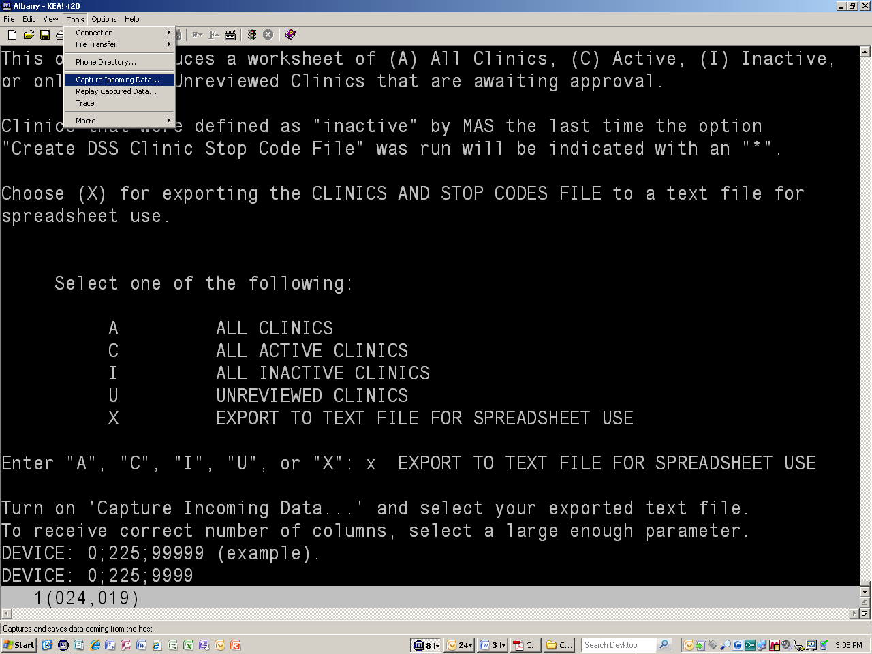
Select a text file name and save it to your desktop. Hit SAVE.

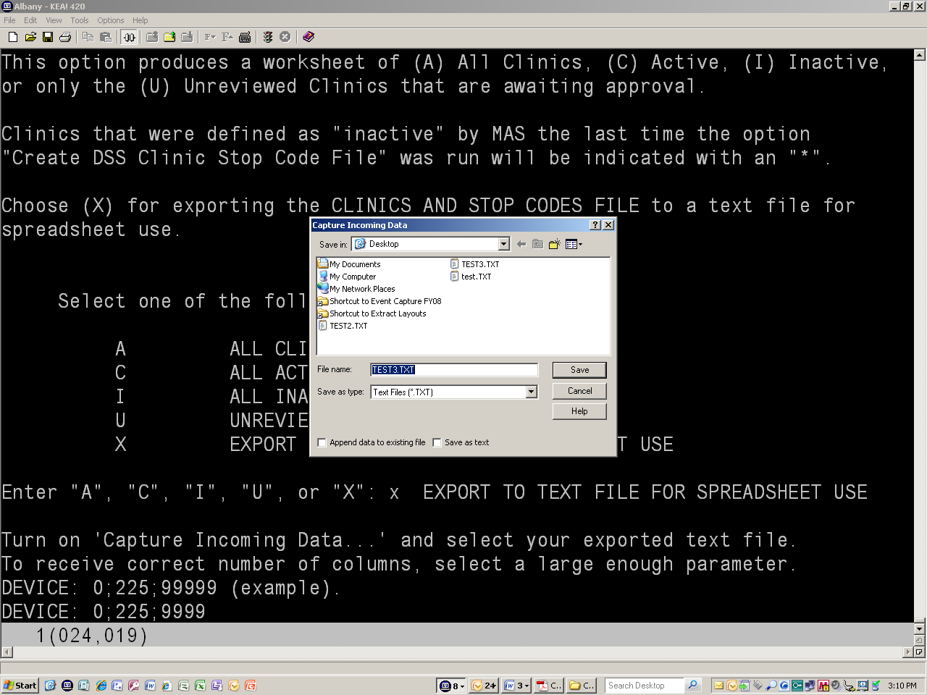
With capturing to a text file ON, select 0;225;9999 for display, hit <RETURN>.

Then, turn capturing OFF. This will save your text file.

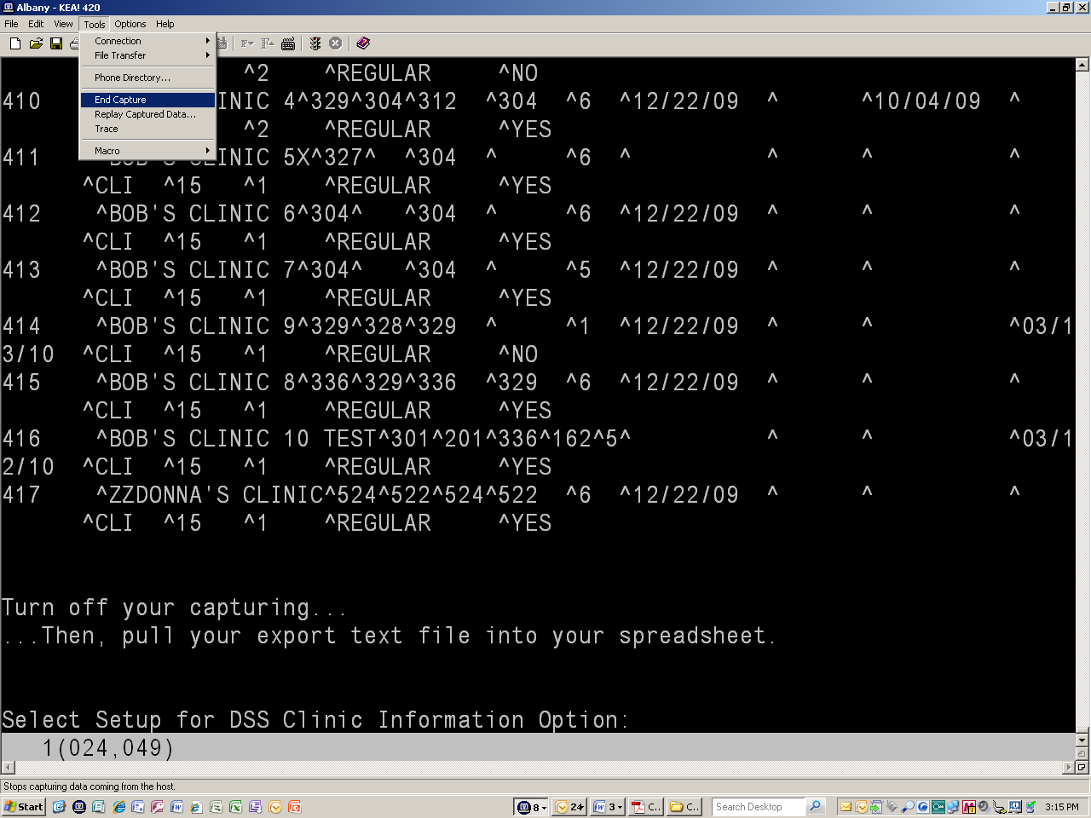
In your directory, pull up your DSS_CLINIC_REVIEW_OUTPUT.xls worksheet and pull in your captured TEST3.TXT file.

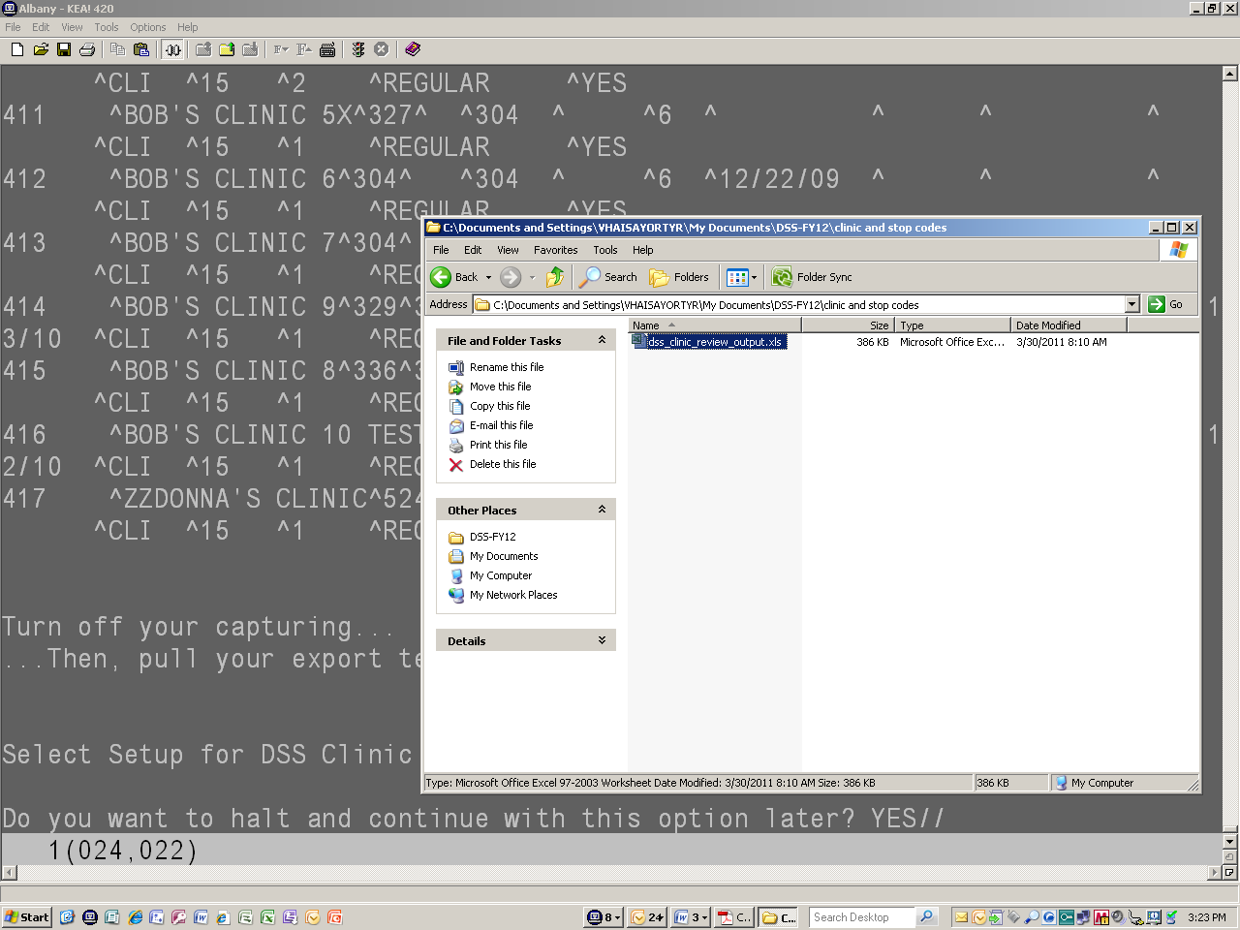
Using ‘Data’, pull in your text file.

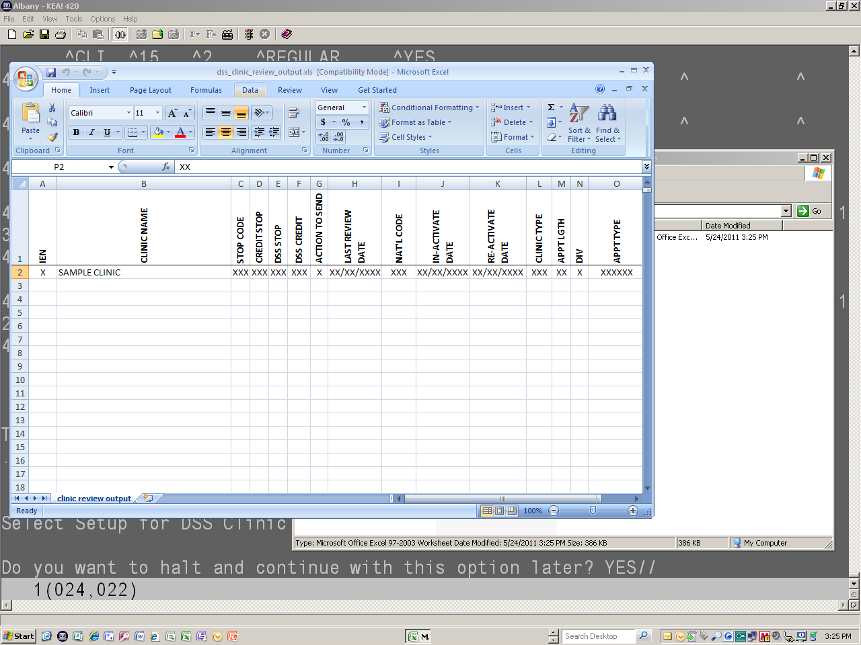
Using ‘From Text’ in your Data Screen, pull in your Text file off your Desktop Directory. Click the ‘Import’ Button.

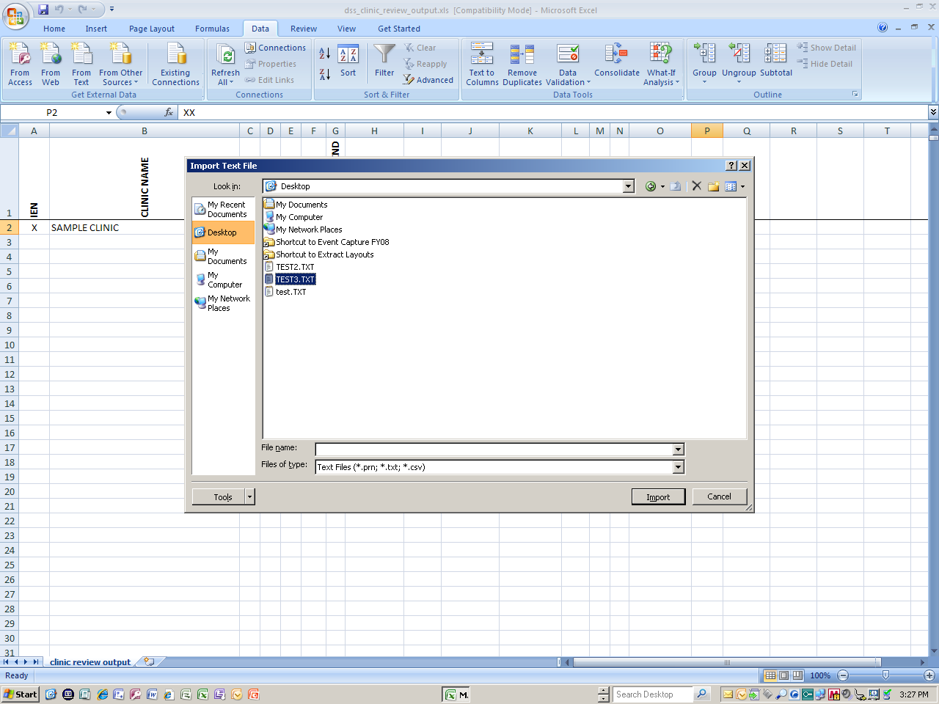
Select ‘Delemited’ and the starting row of your Text file. Then, hit ‘NEXT’.
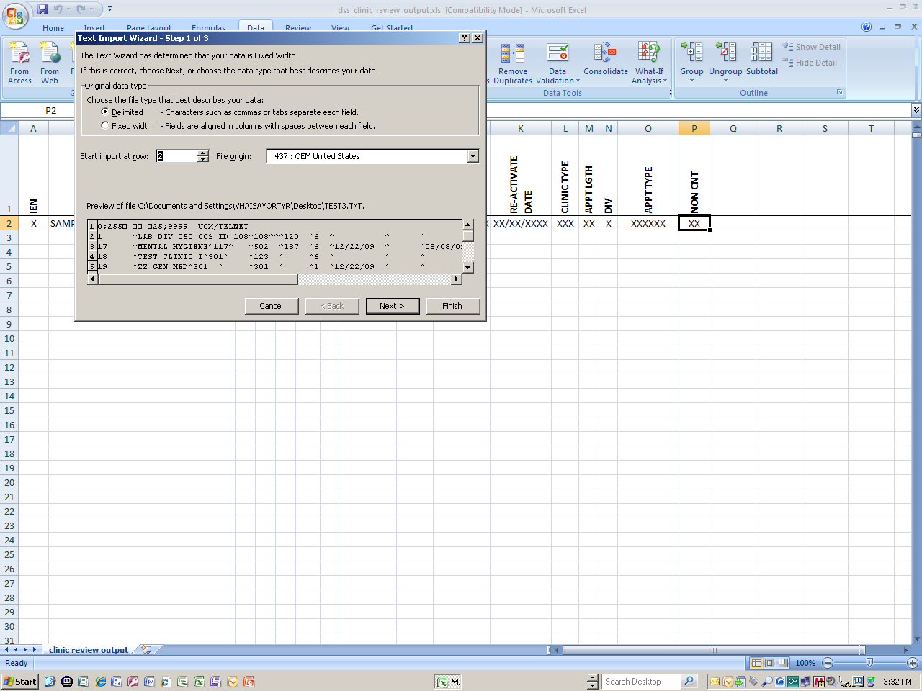
Select the ‘Other’ Button and enter ‘^’ up-arrow as your delimiter. Then, enter ‘NEXT’.
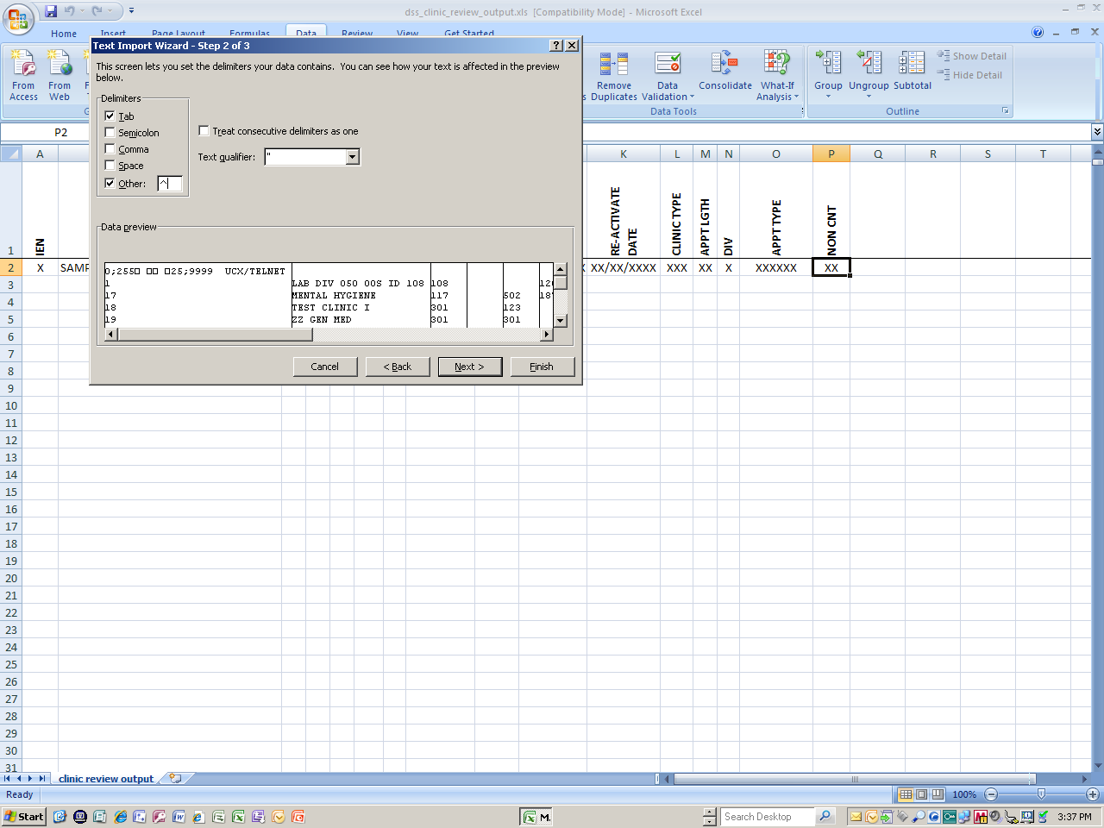
Enter ‘FINISHED’.
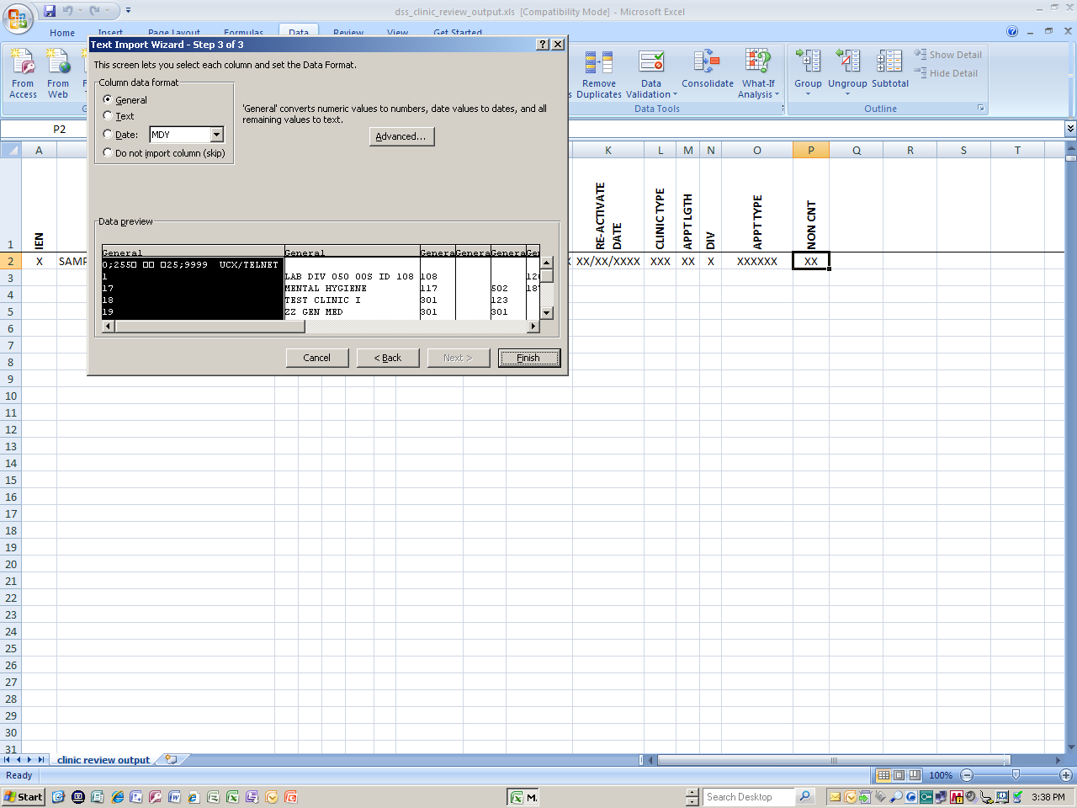
Click on your worksheet where you would like to import your data. Should select column A – row 3.
Then, hit ‘OK’.
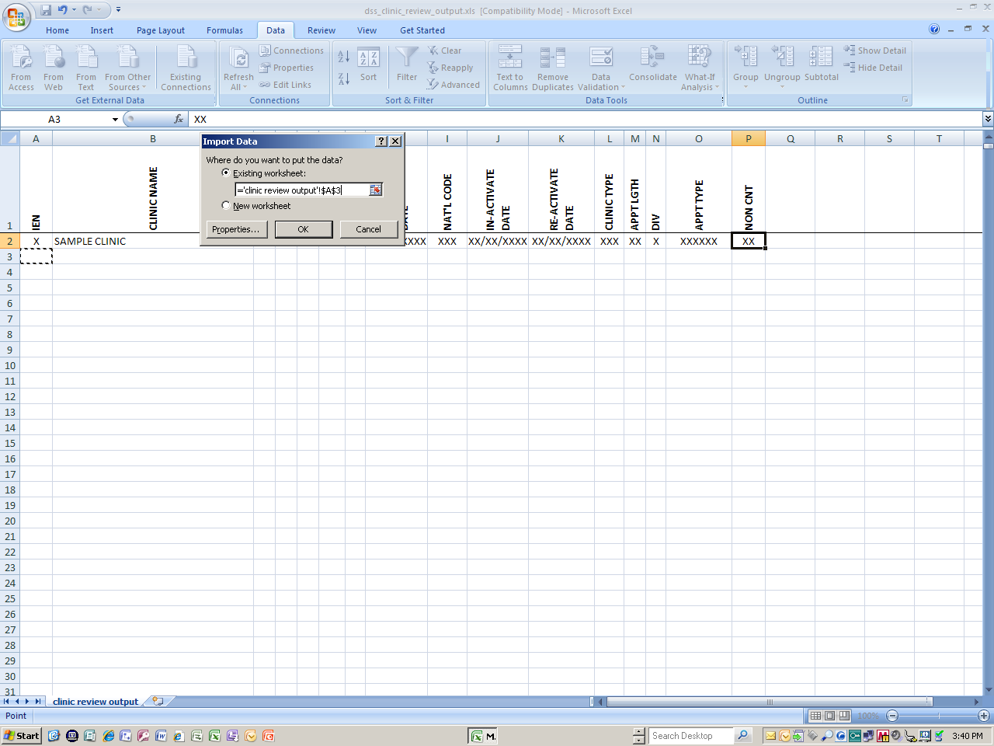
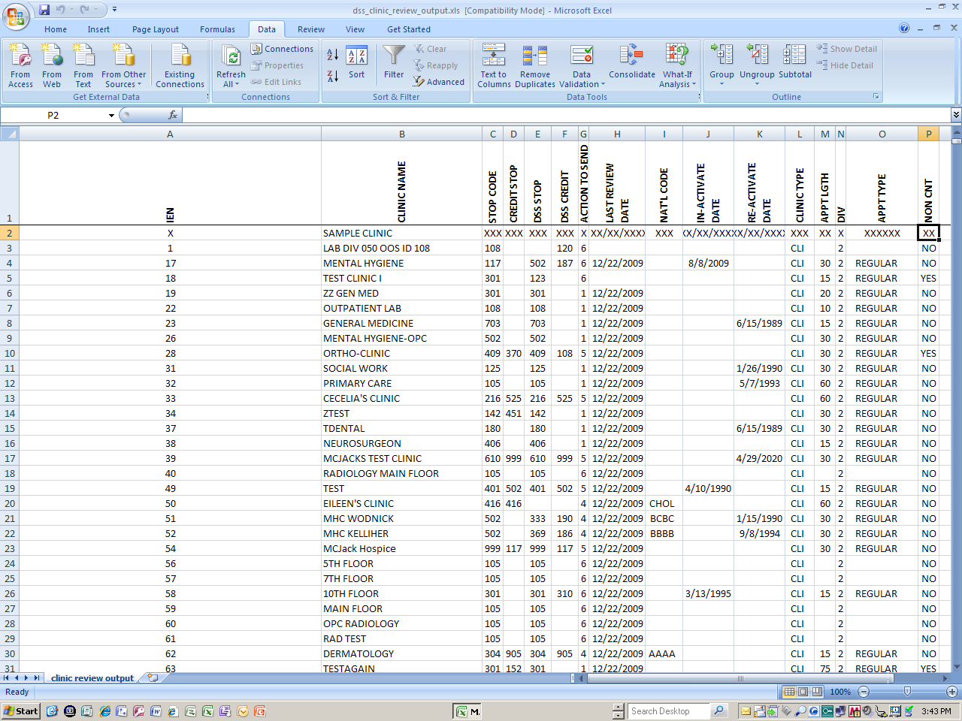
Then, make minor adjustments to align your worksheet.
